



**DBMS**

INNOVATIVE ASSIGNMENT

19BCE253:  KANISHA SHAH

19BCE269:  STUTI PATEL

19BCE299:  MEET VORA

**RESTAURANT MANAGEMENT DATABASE**



**AIM**

The following Restaurant database holds the records of its Employees, chef, waiters/delivery boys, food items, drinks and their customer details. The GUI interface navigates the user through different portals where they can access the details of customers, employees, food items etc.

**DESCRIPTION**

      We have customer, restaurant and delivery sections.

      Restaurant end we have

1. All the food items and drinks the customer can order
2. Track of all the employee details
3. Chef details along with their speciality in a specific cuisine

     Customer end we have

1. Customer details
2. Details for Payment and

      Delivery end to track all the deliveries done

**CHARACTERISTICS**

1. Add Record
2. Delete Record
3. Display Record
4. Update  Record

**EXTERNAL INTERFACE REQUIREMENTS**

1. Front end :      Python
2. Backend   : MySQL

**FUNCTIONAL REQUIREMENTS**

1. User authentication during login
2. Email Verification while sign up

**ER MODEL**

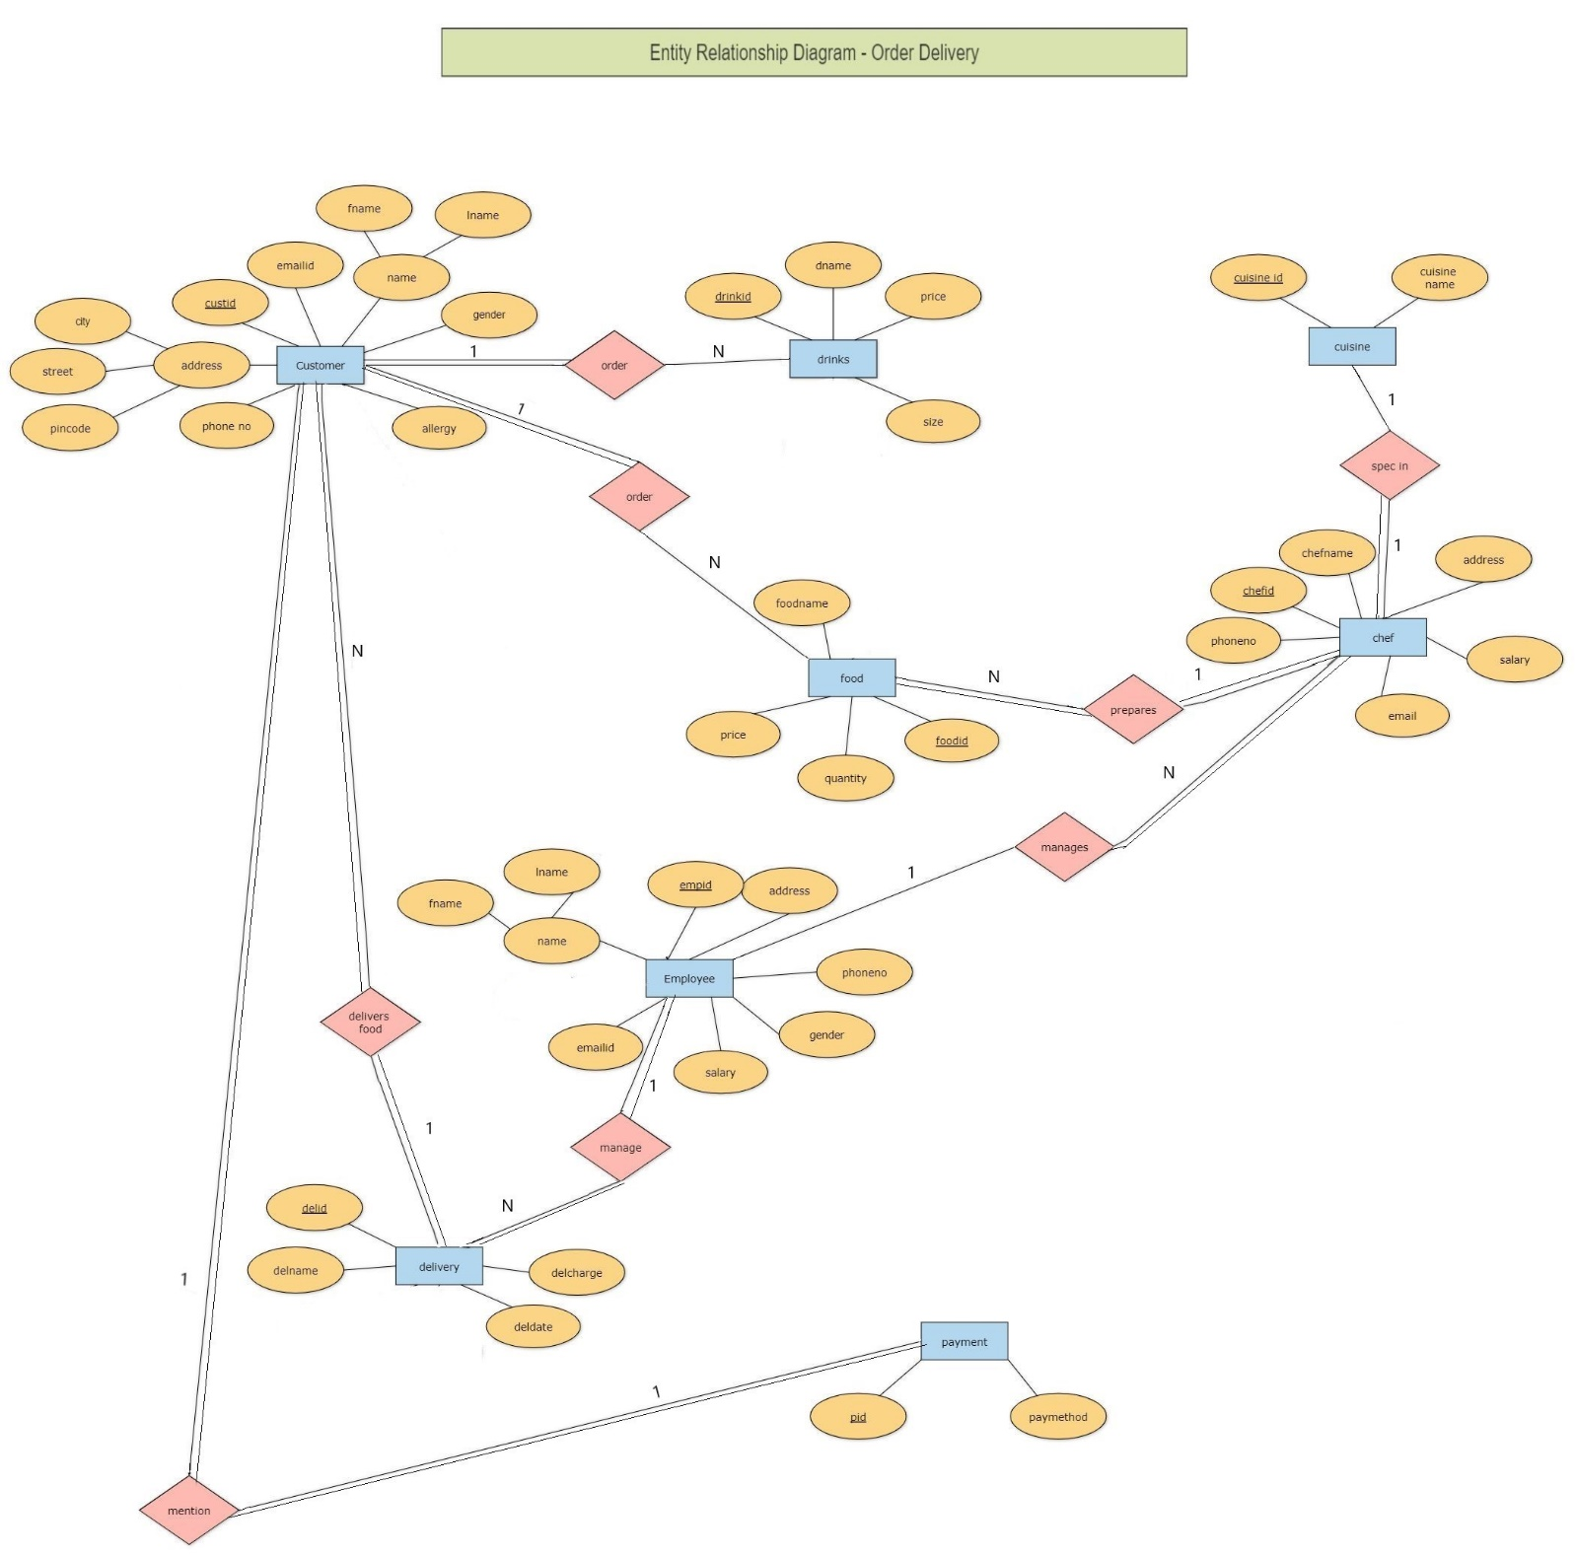

**RELATIONAL MODEL**

|  |  |  |
| --- | --- | --- |
|  | CUSTOMER |  |
| ATTRIBUTES | **DEFAULT VALUE** | **CONSTRAINTS** |
| FNAME |  | NOT NULL |
| LNAME |  | NOT NULL |
| CUSTID |  | PRIMARY KEY |
| EMAILID |  | NOT NULL,  CHECK should contain @ .com |
| CITY | AHMEDABAD |  |
| STREET |  | NOT NULL |
| PINCODE |  | NOT NULL  CHECK count = 6 |
| GENDER |  | NOT NULL  Values (‘M’,’F’,’O’) |
| PHONENO |  | NOT NULL  CHECK count = 10 |
| ALLERGY | NULL |  |

|  |  |  |
| --- | --- | --- |
|  | CUISINE |  |
| ATTRIBUTES | **DEFAULT VALUE** | **CONSTRAINTS** |
| CUISINEID |  | PRIMARY KEY |
| CUISINE NAME |  | NOT NULL |

|  |  |  |
| --- | --- | --- |
|  | EMPLOYEE |  |
| ATTRIBUTES | **DEFAULT VALUE** | **CONSTRAINTS** |
| EMPID |  | PRIMARY KEY |
| FNAME |  | NOT NULL |
| LNAME |  | NOT NULL |
| EMAILID |  | NOT NULL,  CHECK should contain @ .com |
| ADDRESS |  | NOT NULL |
| PHONE NO |  | NOT NULL  CHECK count = 10 |
| GENDER |  | NOT NULL  Values (‘M’,’F’,’O’) |
| SALARY |  | NOT NULL  CHECK Greater than 0 |

|  |  |  |
| --- | --- | --- |
|  | CHEF |  |
| ATTRIBUTES | **DEFAULT VALUE** | **CONSTRAINTS** |
| CHEFID |  | PRIMARY KEY |
| CHEFNAME |  | NOT NULL |
| ADDRESS |  | NOT NULL |
| PHONENO |  | NOT NULL  CHECK count = 10 |
| SPEC |  | Foreign key references ‘**CUISINEID**’ of **CUISINE** table. |
| EMPID |  | Foreign key references ‘**EMPID**’ of **EMPLOYEE** table. |
| EMAIL |  | NOT NULL,  CHECK should contain @ .com |
| SALARY |  | NOT NULL  CHECK Greater than 0 |

|  |  |  |
| --- | --- | --- |
|  | FOOD |  |
| ATTRIBUTES | **DEFAULT VALUE** | **CONSTRAINTS** |
| FOODID |  | PRIMARY KEY |
| FOODNAME |  | NOT NULL |
| PRICE |  | NOT NULL  CHECK Greater than 0 |
| QUANTITY |  | NOT NULL  CHECK Greater than 0 |
| CUISINEID |  | Foreign key references ‘**CUISINEID**’ of **CUISINE** table. |
| CHEFID |  | Foreign key references ‘**CHEFID**’ of **CHEF** table. |

|  |  |  |
| --- | --- | --- |
|  | DRINKS |  |
| ATTRIBUTES | **DEFAULT** | **CONSTRAINT** |
| DRINKID |  | PRIMARY KEY |
| DNAME |  | NOT NULL |
| PRICE |  | NOT NULL,  CHECK can’t be 0 |
| SIZE |  | Values(‘large’, ’medium’, ’small’) |

|  |  |  |
| --- | --- | --- |
|  | DELIVERY |  |
| ATTRIBUTES | **DEFAULT** | **CONSTRAINT** |
| DELID |  | PRIMARY KEY |
| DELNAME |  | NOT NULL |
| CUSTID |  | Foreign key references ‘**CUSTID**’ of **Customer** table. |
| EMPID |  | Foreign key references ‘**EMPID**’ of **Employee** table. |
| DELCHARGE |  | NOT NULL  CHECK can’t be 0 |
| DELDATE |  | NOT NULL |

|  |  |  |
| --- | --- | --- |
|  | ORDER |  |
| ATTRIBUTES | **DEFAULT** | **CONSTRAINT** |
| ORDID |  | PRIMARY KEY |
| TOTALCOST |  | NOT NULL  CHECK can’t be 0 |
| FOODID |  | Foreign key references ‘**FOODID**’ of **Food** table. |
| DRINKID |  | Foreign key references ‘**DRINKID**’ of **Drink** table. |
| DELID |  | Foreign key references ‘**DELID**’ of **Delivery** table. |

|  |  |  |
| --- | --- | --- |
|  | PAYMENT |  |
| ATTRIBUTES | **DEFAULT** | **CONSTRAINT** |
| PID |  | PRIMARY KEY |
| PAYMETHOD |  | Values (‘credit card’, ’cash’, ’debit card’, ’Paytm’) |
| CUSTID |  | Foreign key references ‘**CUSTID**’ of **Customer** table. |
| ORDID |  | Foreign key references ‘**ORDID**’ of **Order** table. |

**QUERIES**

1. SELECT Fname FROM Employee GROUP BY empid HAVING AVG(salary) BETWEEN 5000 AND 150000;

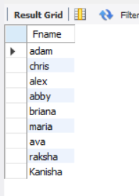

1. SELECT Employee.empid,fname,salary,deldate,delcharge from delivery INNER JOIN employee on Employee.empid=delivery.empid where deldate>('2017-1-1');

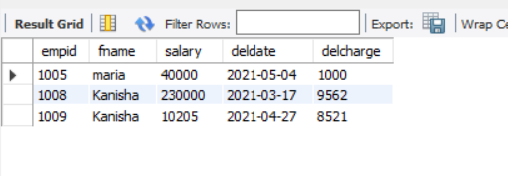

1. select c.* from chef c where salary >1000 && spec >= '11';



1. select c.Fname, o.food,o.drinkid from restaurant_management.order o , customer c, delivery d where c.custid=d.custid and o.Delid = d.Delid;

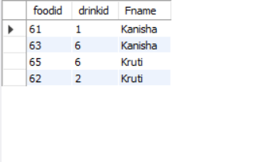

1. select chefname, cuisinename from chef, cuisine c where chef.spec=c.cuisineid;

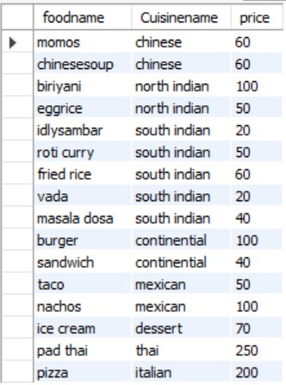

1. select foodname, Cuisinename, price from food f, cuisine c where f.cuisineid=c.cuisineid;

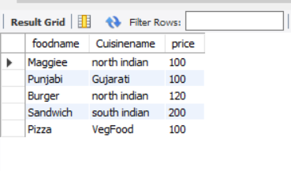

1. select fname, lname, gender, salary from employee where salary=(select max(salary) from employee group by gender having gender='F');

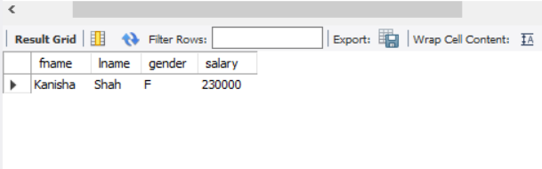

1. SELECT concat(concat(Fname,' '), lname) as Name FROM EMPLOYEE WHERE fname LIKE 'a%';

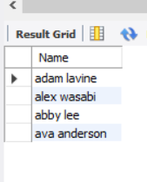

1. CREATE VIEW Salary AS SELECT chefid, SUM(employee.salary) FROM CHEF JOIN employee ON Chef.chefid = employee.empid GROUP BY Chef.chefid

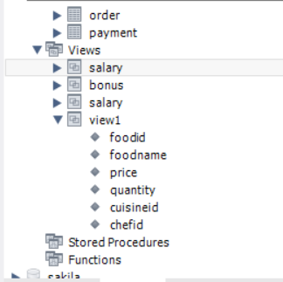

1. select o.ordid,fname,lname,foodname,dname, paymethod from customer c, payment p restaurant_management.order o , food f, drinks d where c.custid=p.custid and p.ordid=o.ordid and o.foodid=f.foodid and o.drinkid=d.drinkid ;

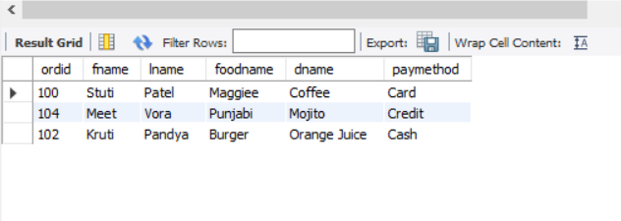

**RELATIONAL MODEL**

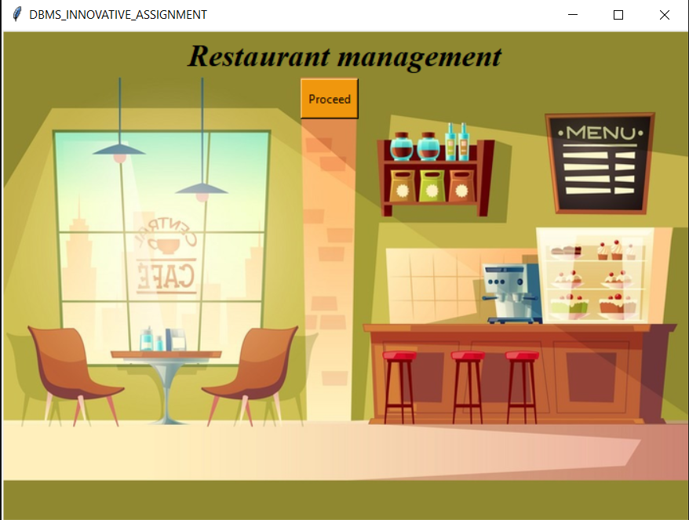

First page of Restaurant Database Management using GUI Python Tkinter.

User clicks the proceed button, to manipulate the data.

The user has to enter correct password and user id in order to access the database.

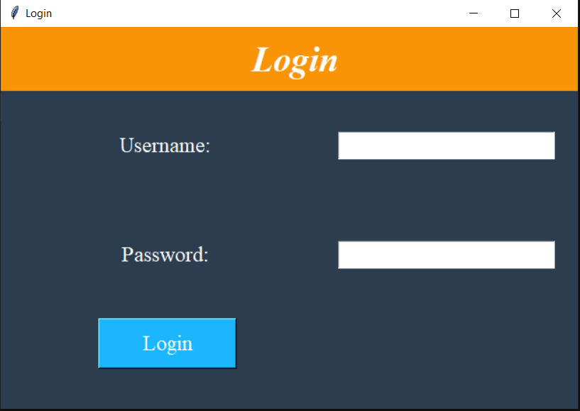

The username does not exist, hence raises error.

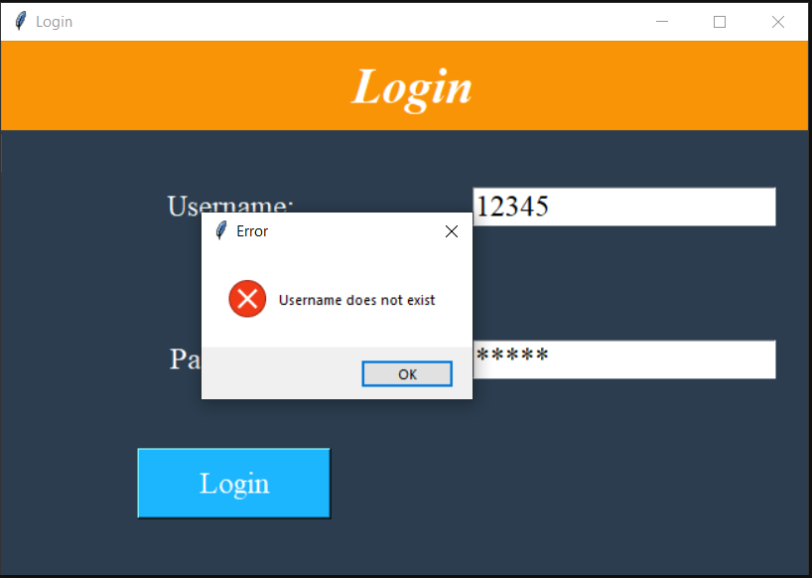

The password is incorrect, hence raises error.

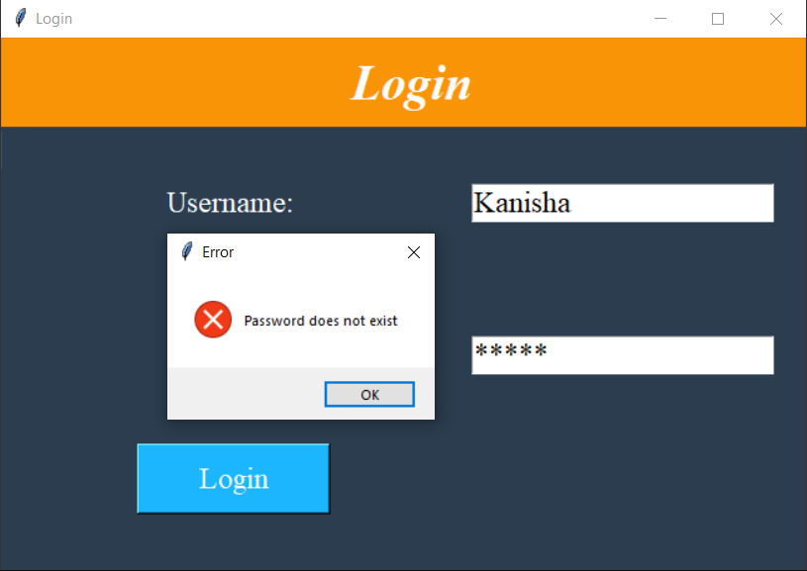

On correct details provided, user gets access to the database, he has to choose from any of the following button inorder to access that record.

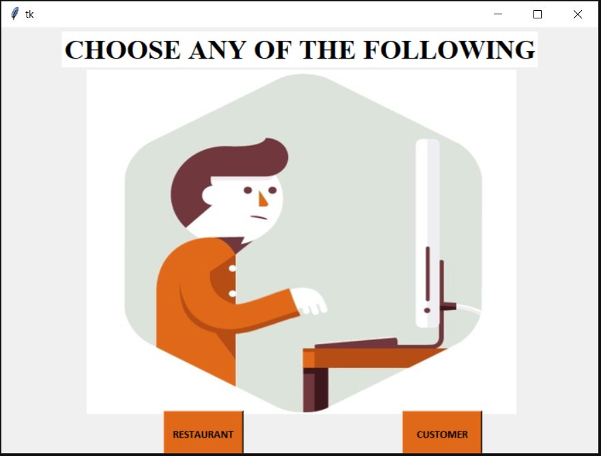

On selecting restaurant the folowing page opens and user can select any of the following to manipulate the respective data.

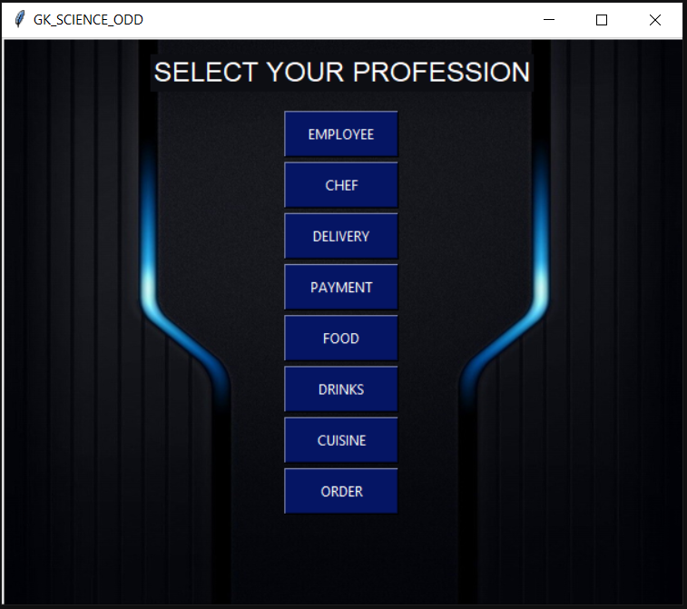

**CUSTOMER:**

On clicking customer the following GUI window opens, where user can add update delete the data and few buttons provided here.

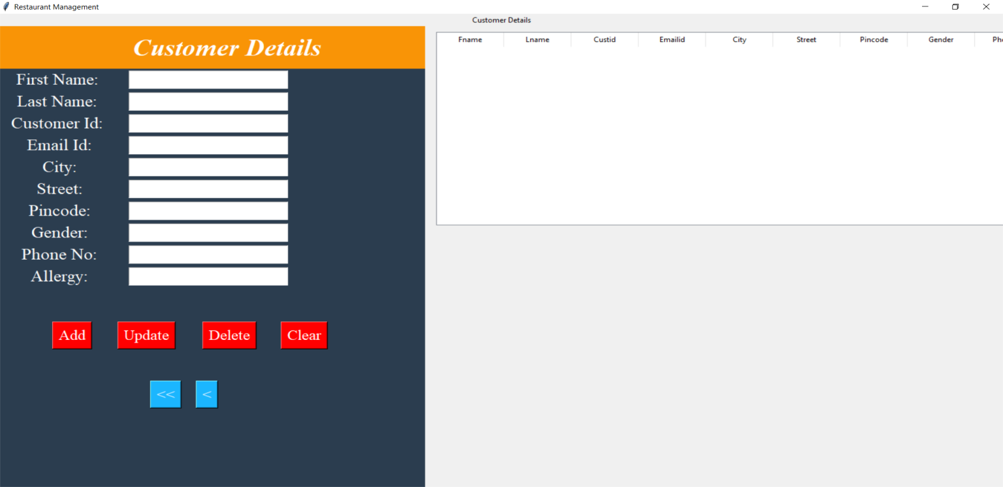

Some of the constraint violations leads to raise error when trying to add, update or delete.

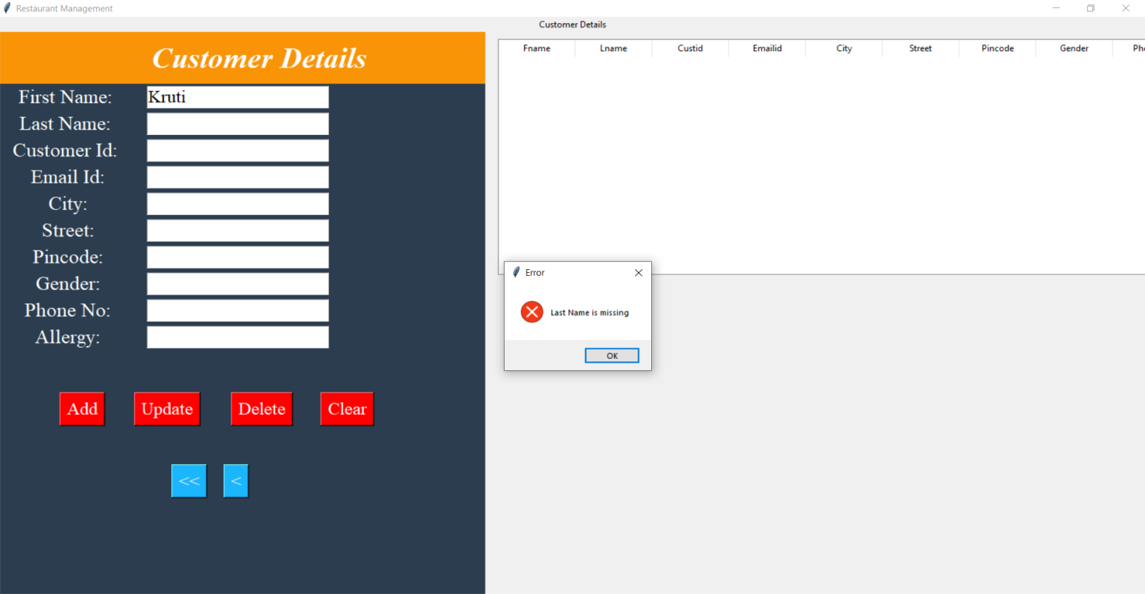

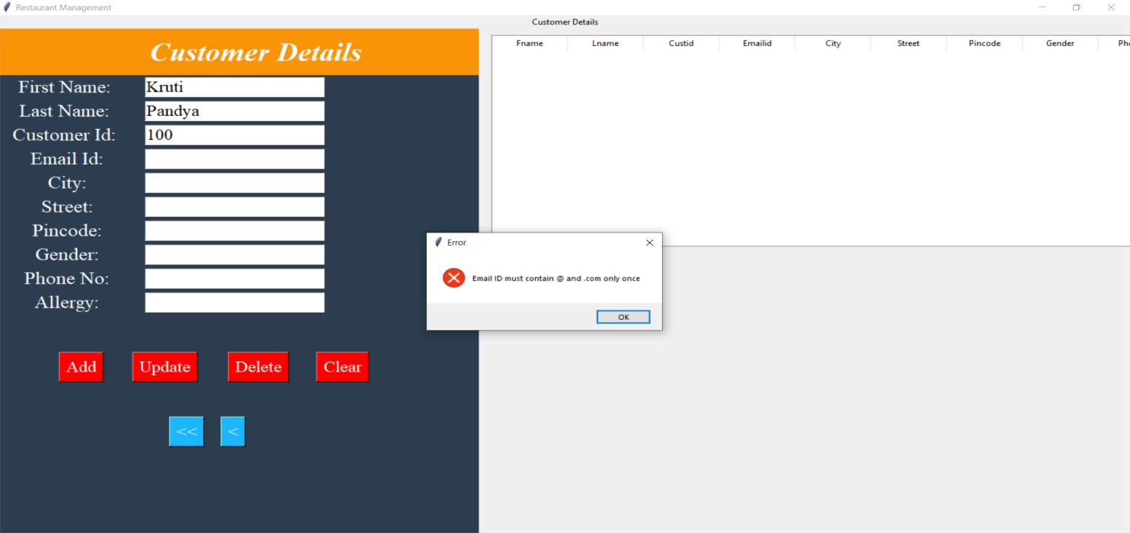

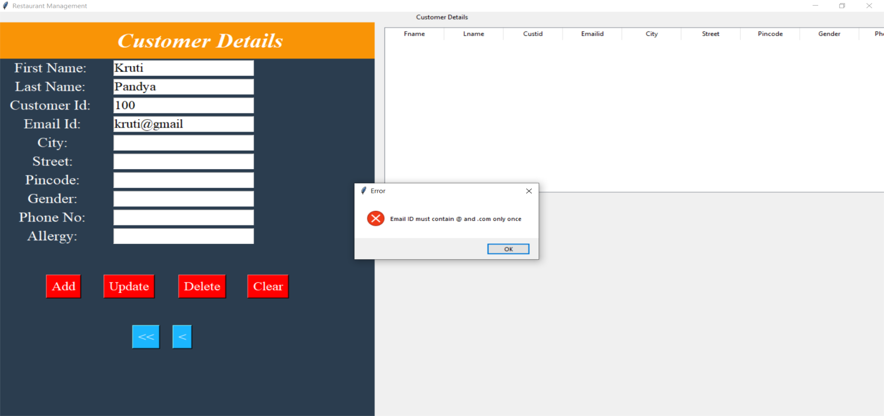

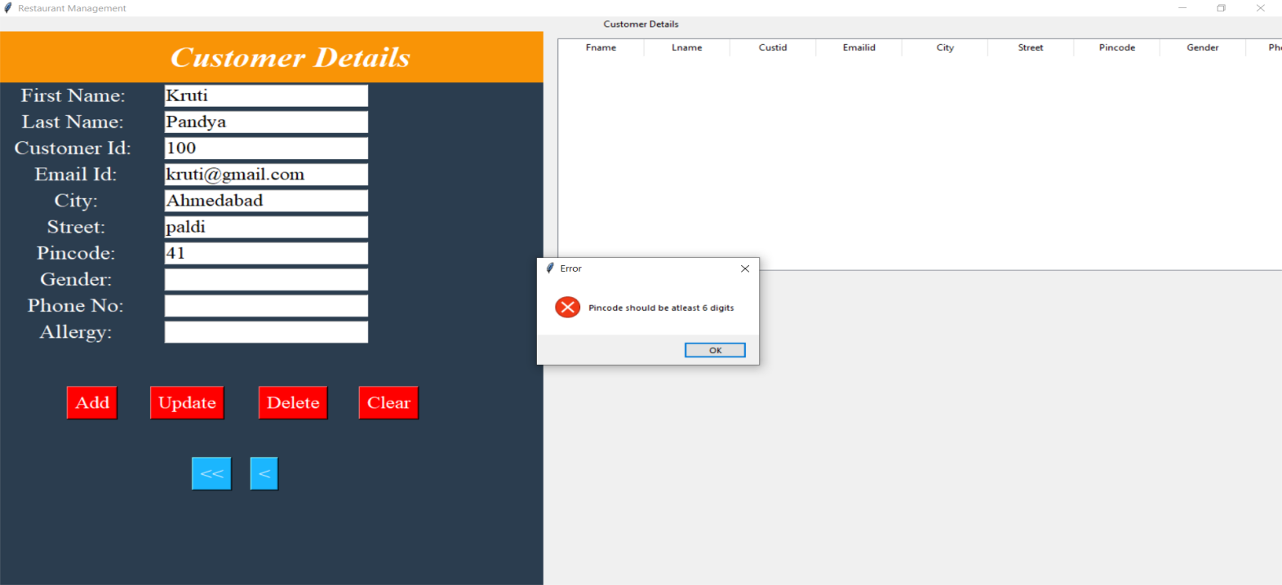

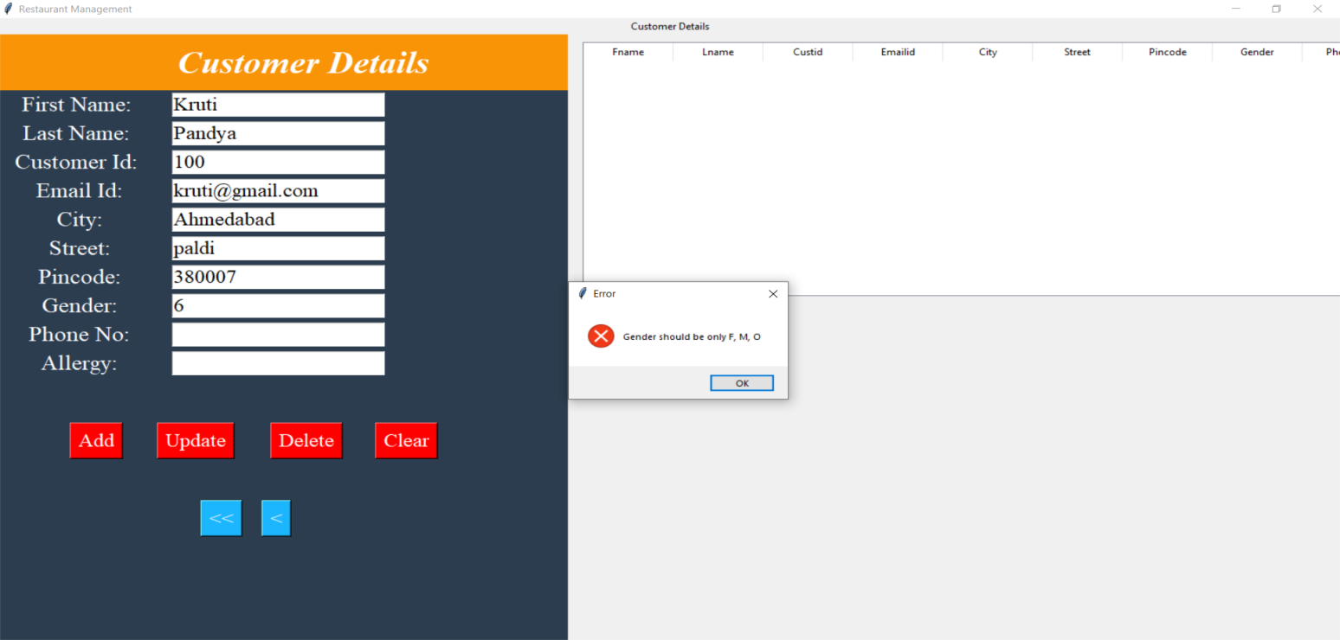

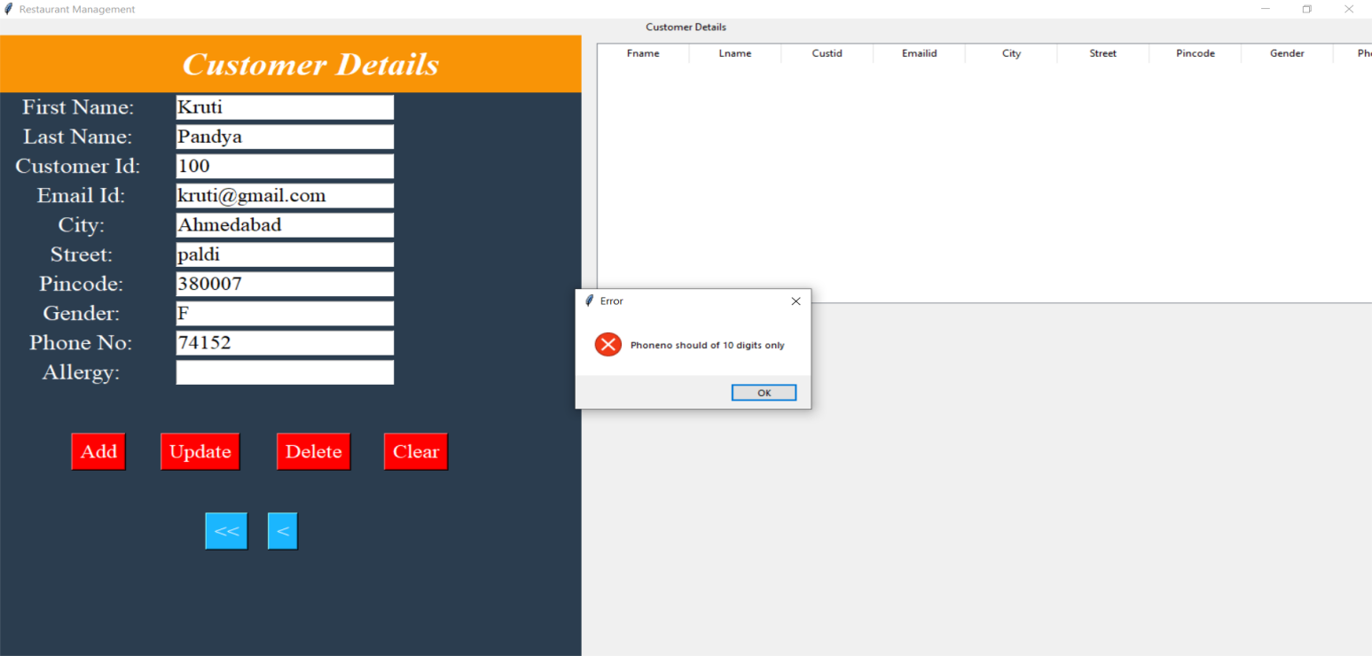

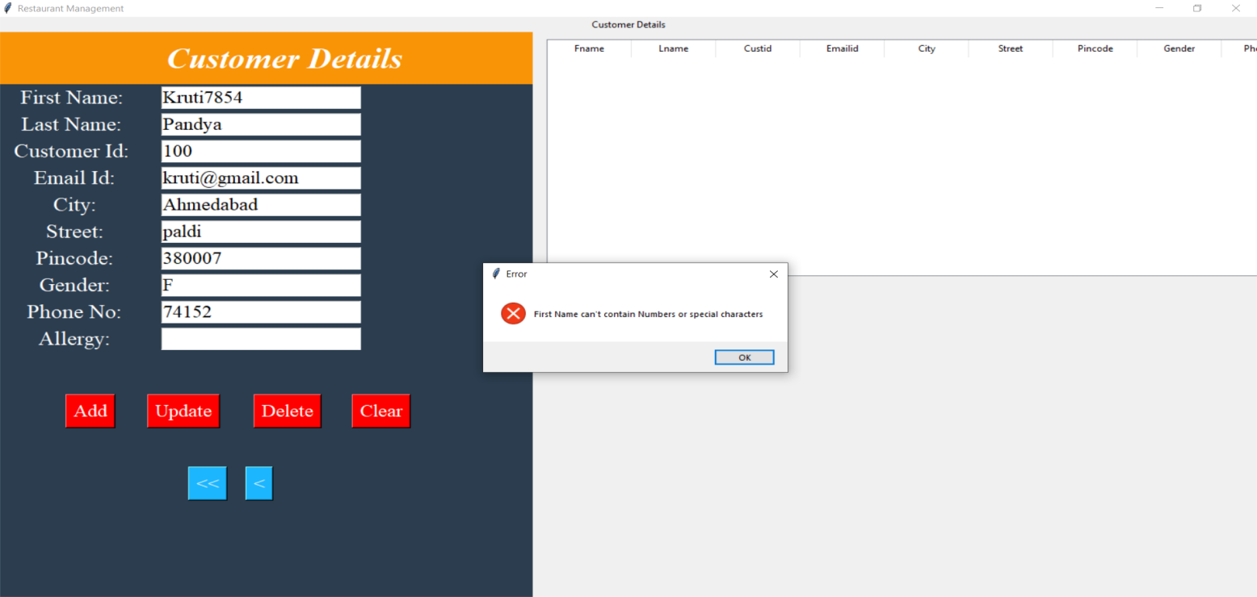

Add operation executed successfully.

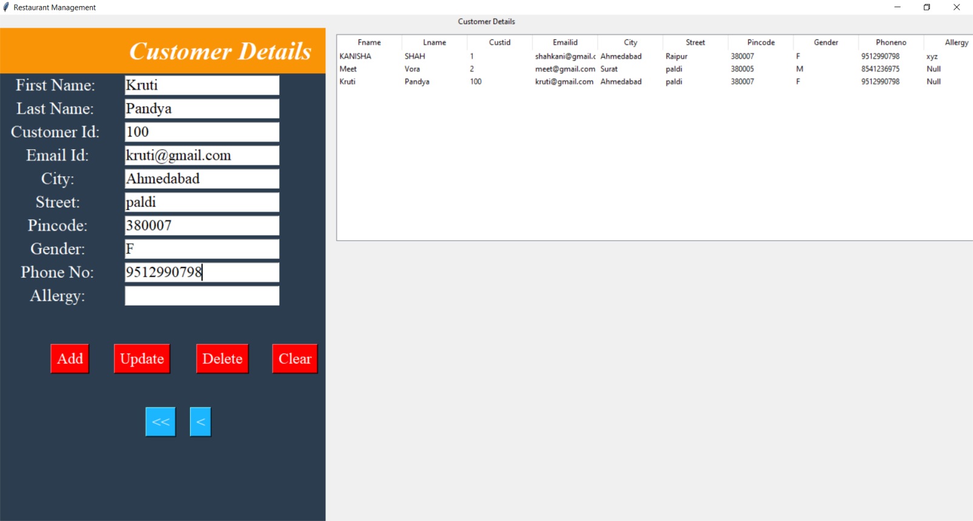

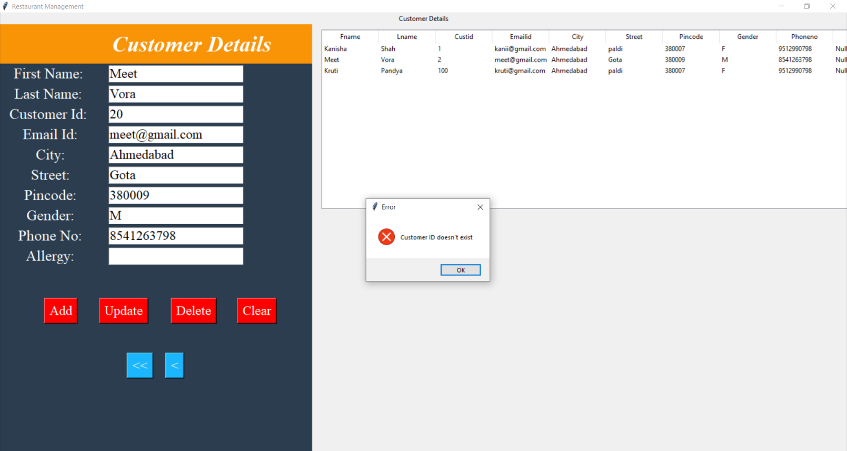

As you can see the update has been made in the MySQL workspace.

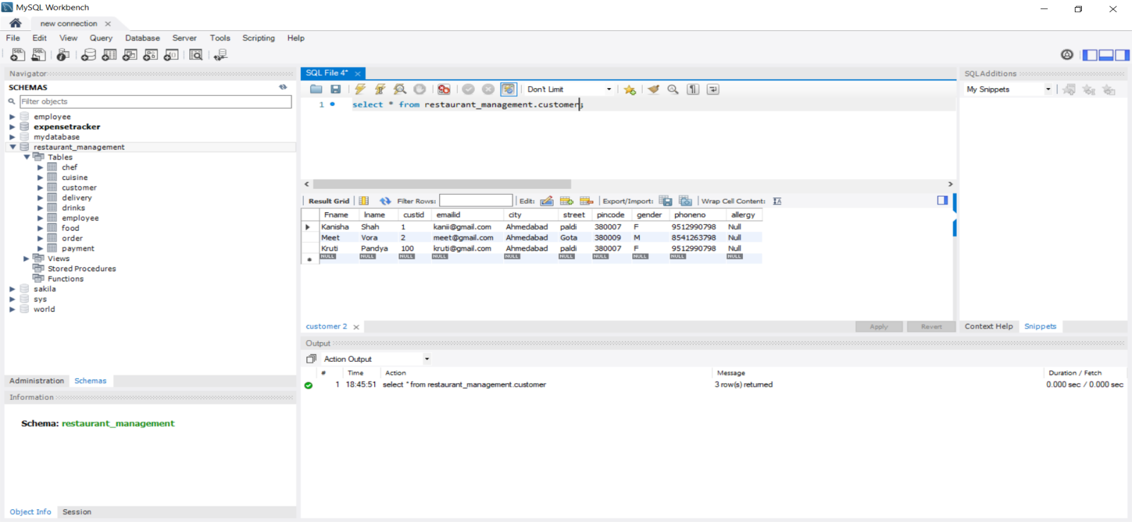

Updated the name of Meet Vora to Meet Sheth

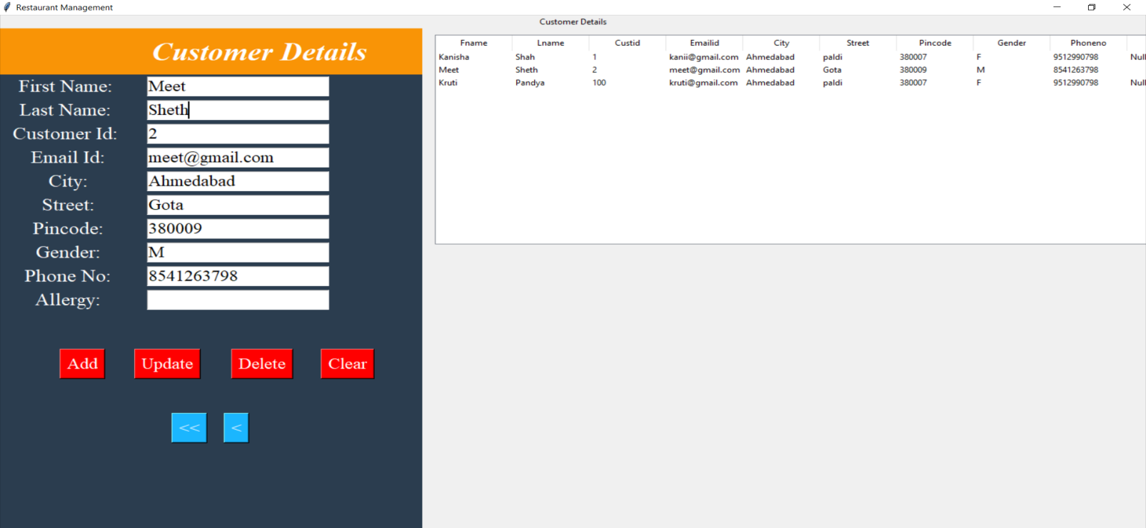

Delete operation , Meet Sheth’s record has been deleted

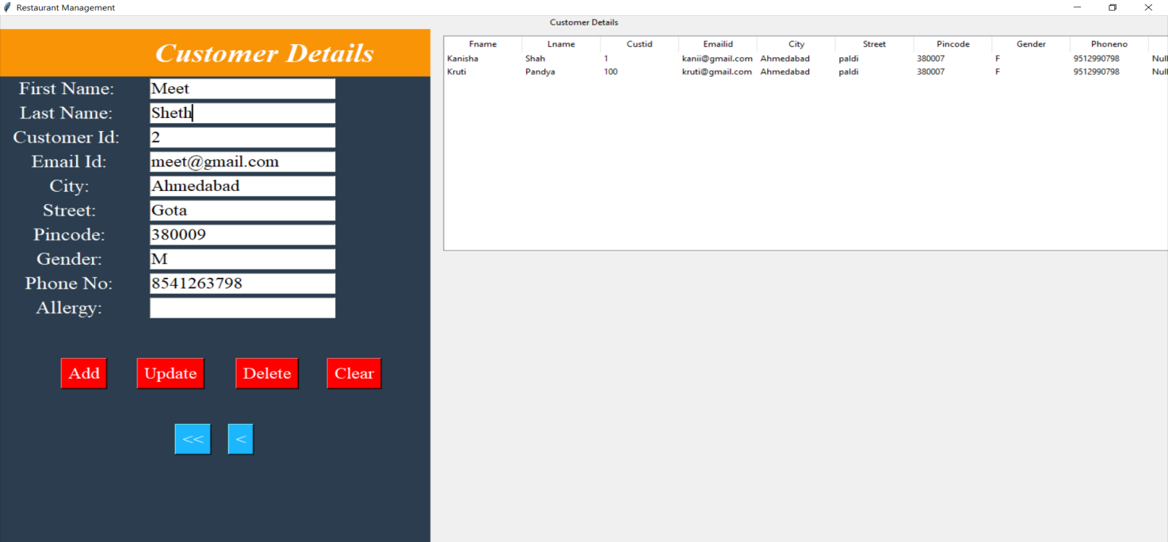

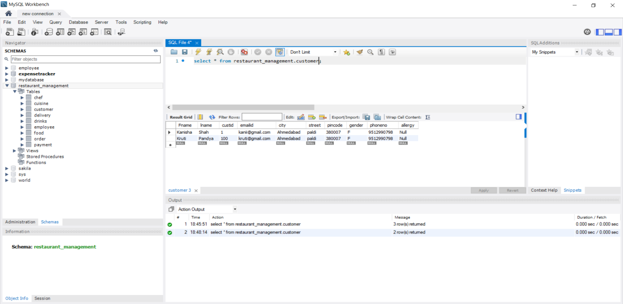

**EMPLOYEE:**

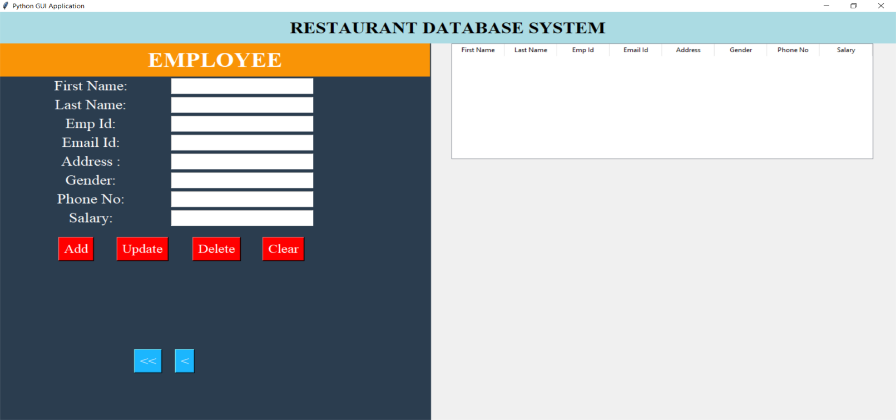

Constraint violation

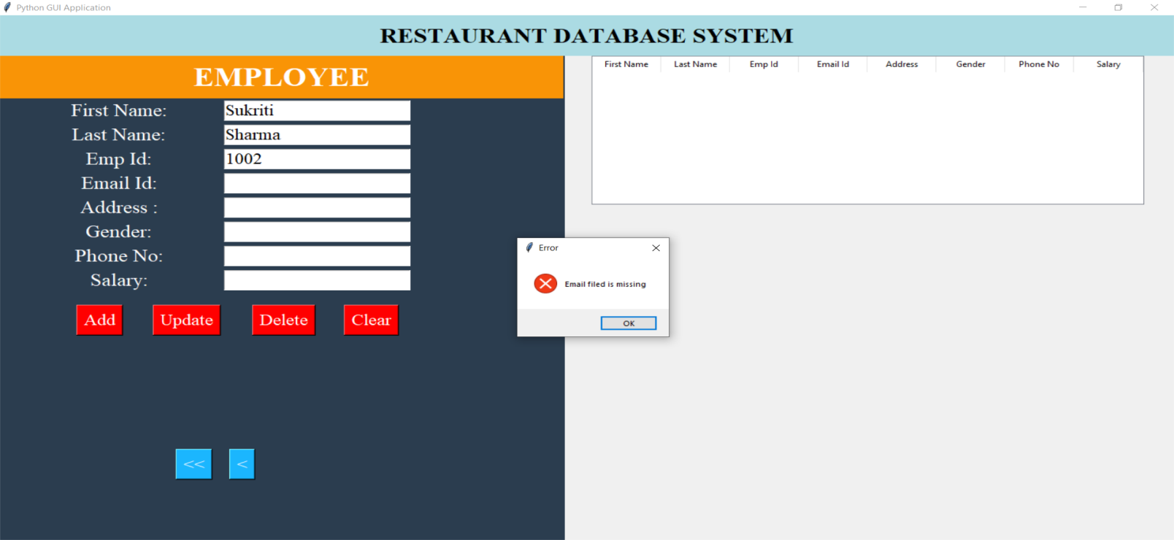

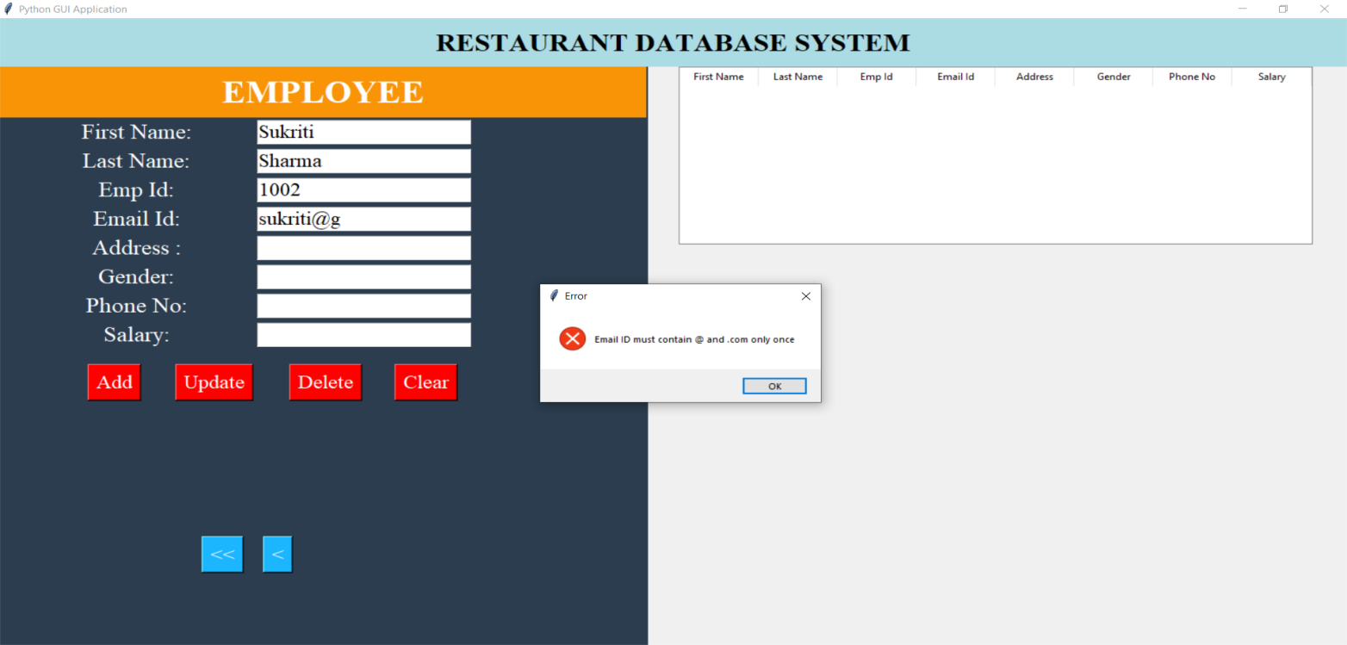

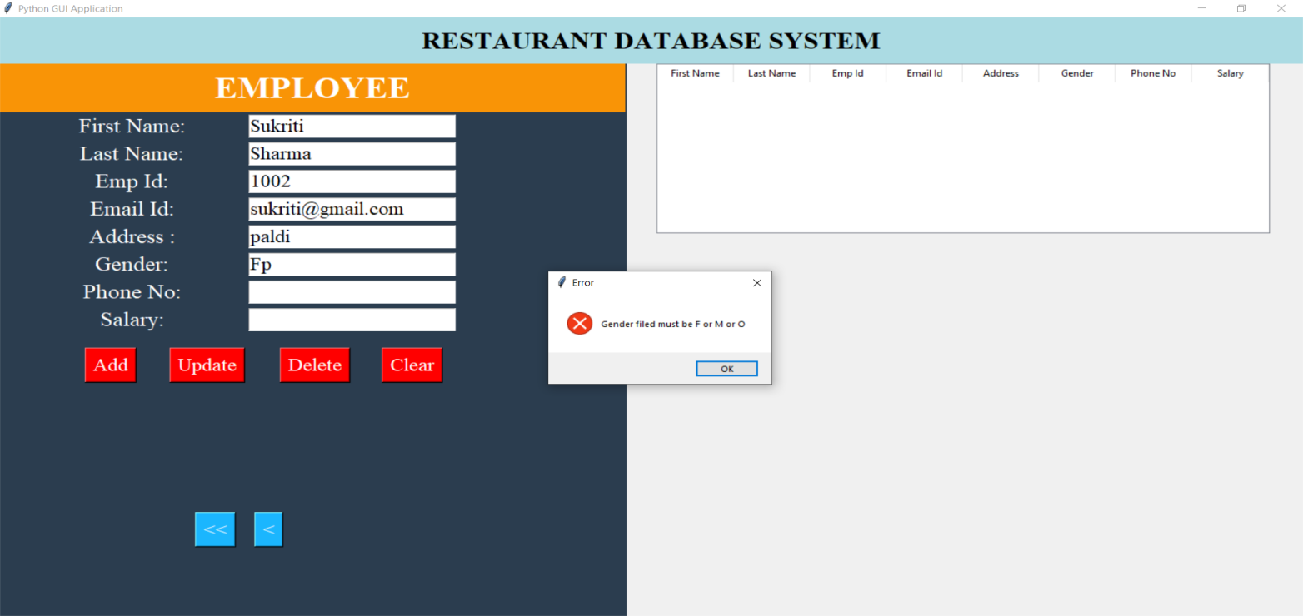

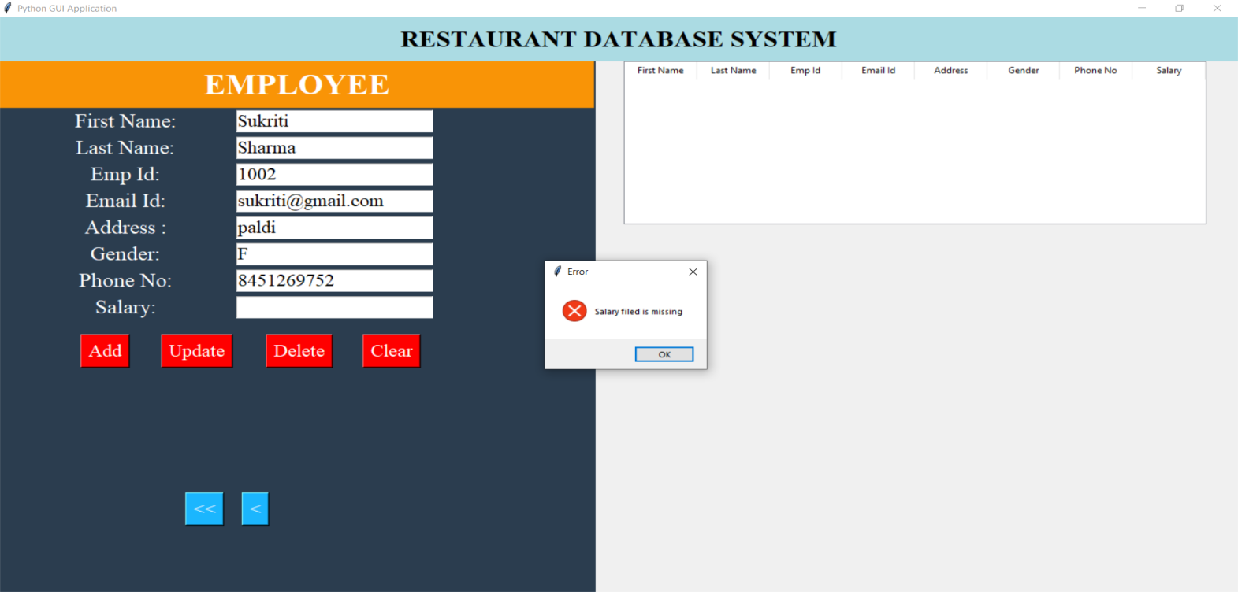

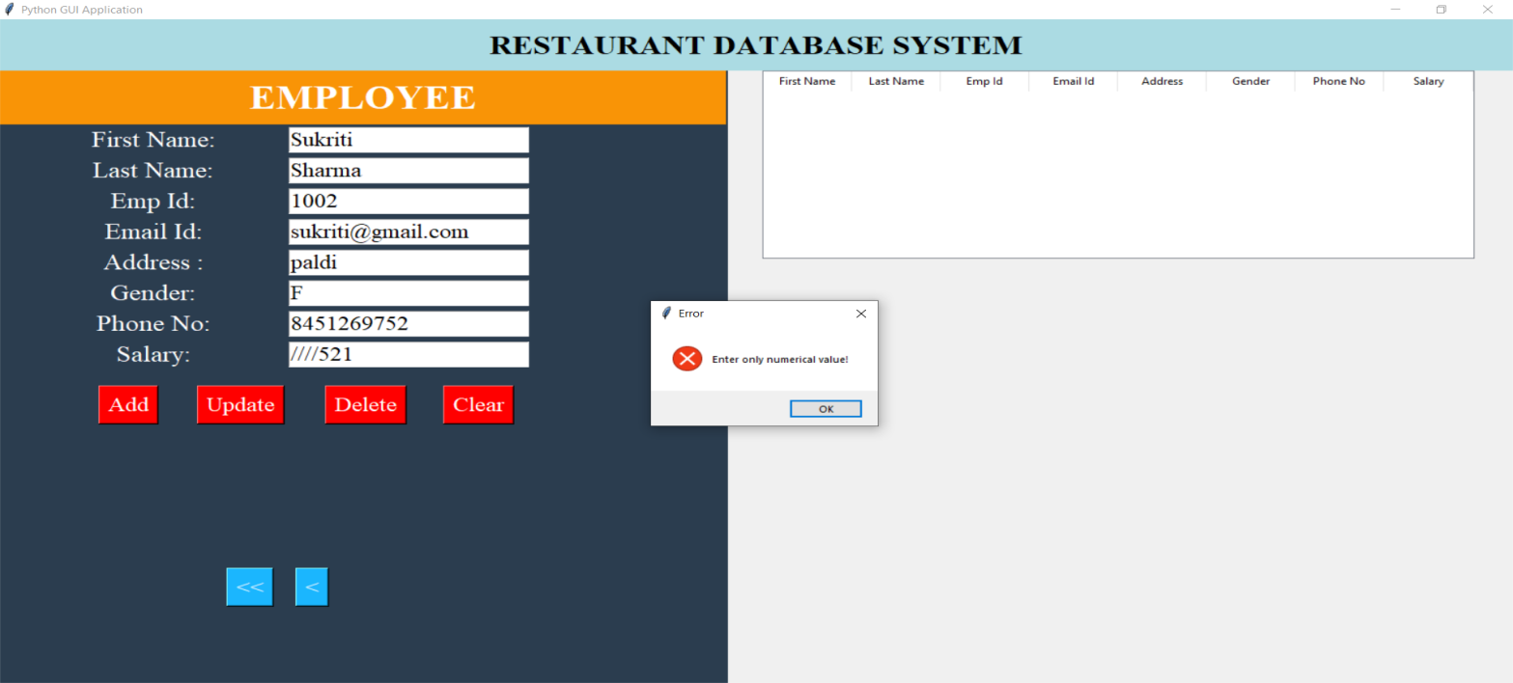

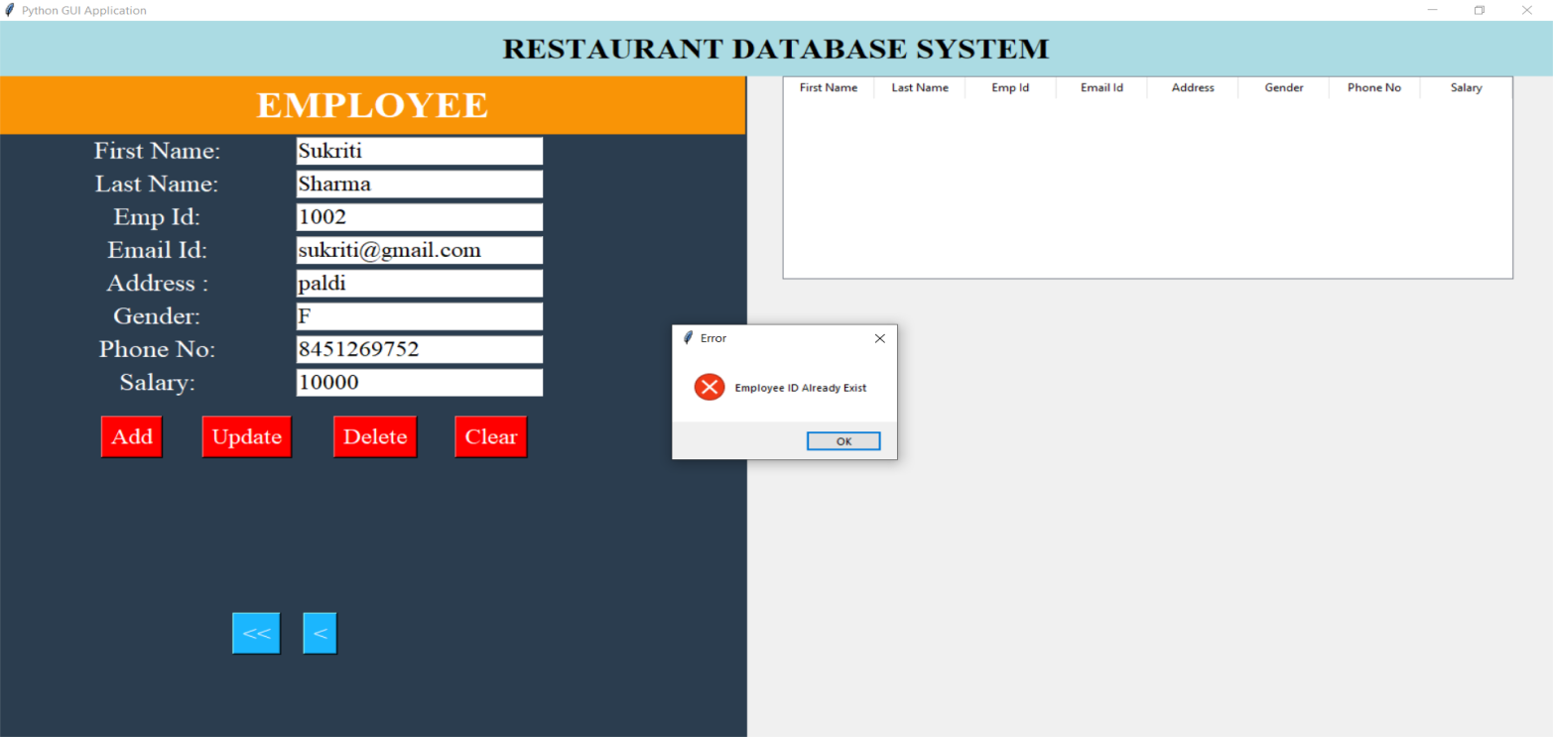

Added the information in database

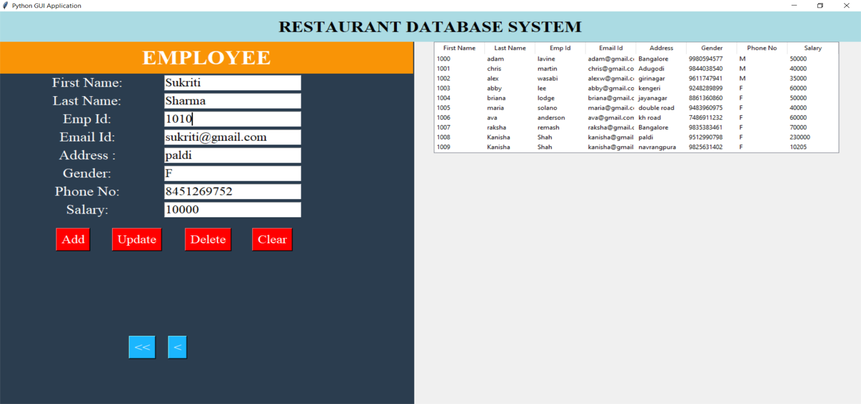

Last name changed to Godaliya using Update

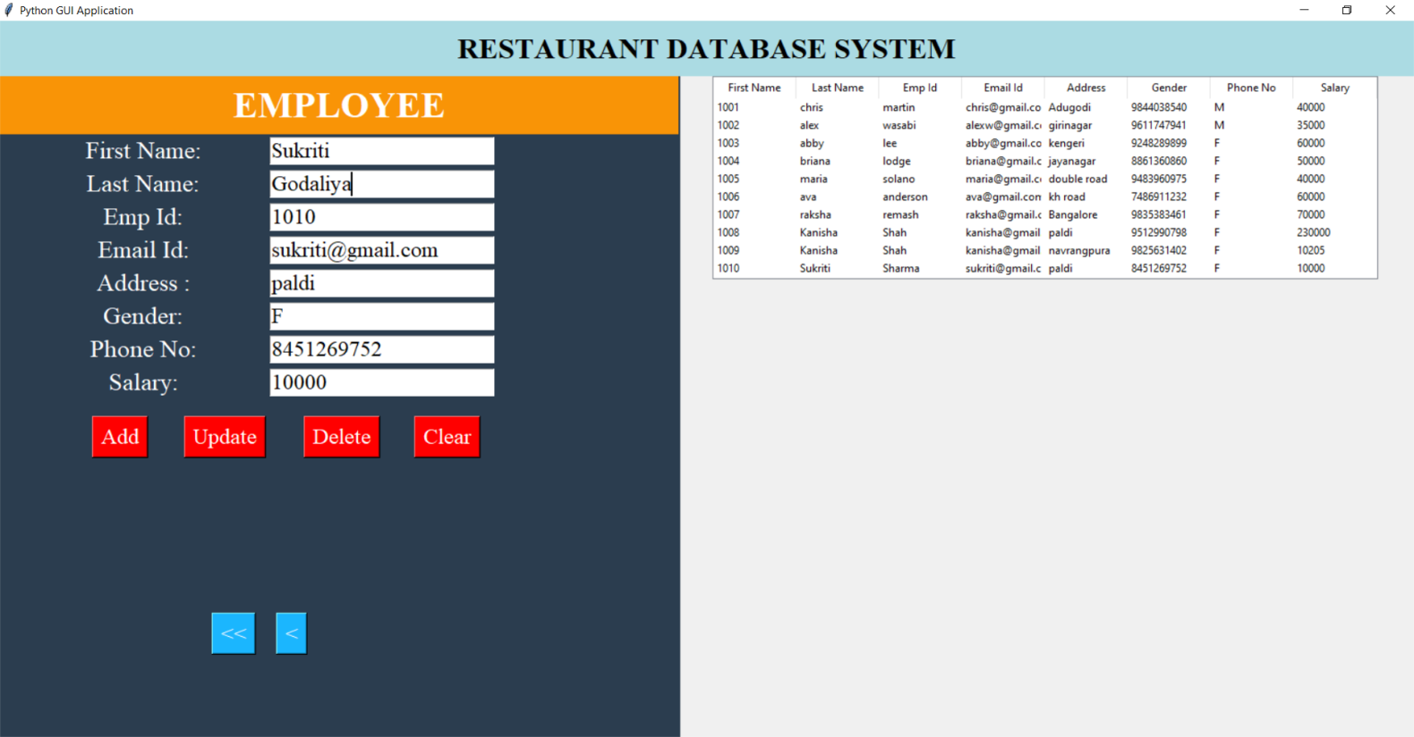

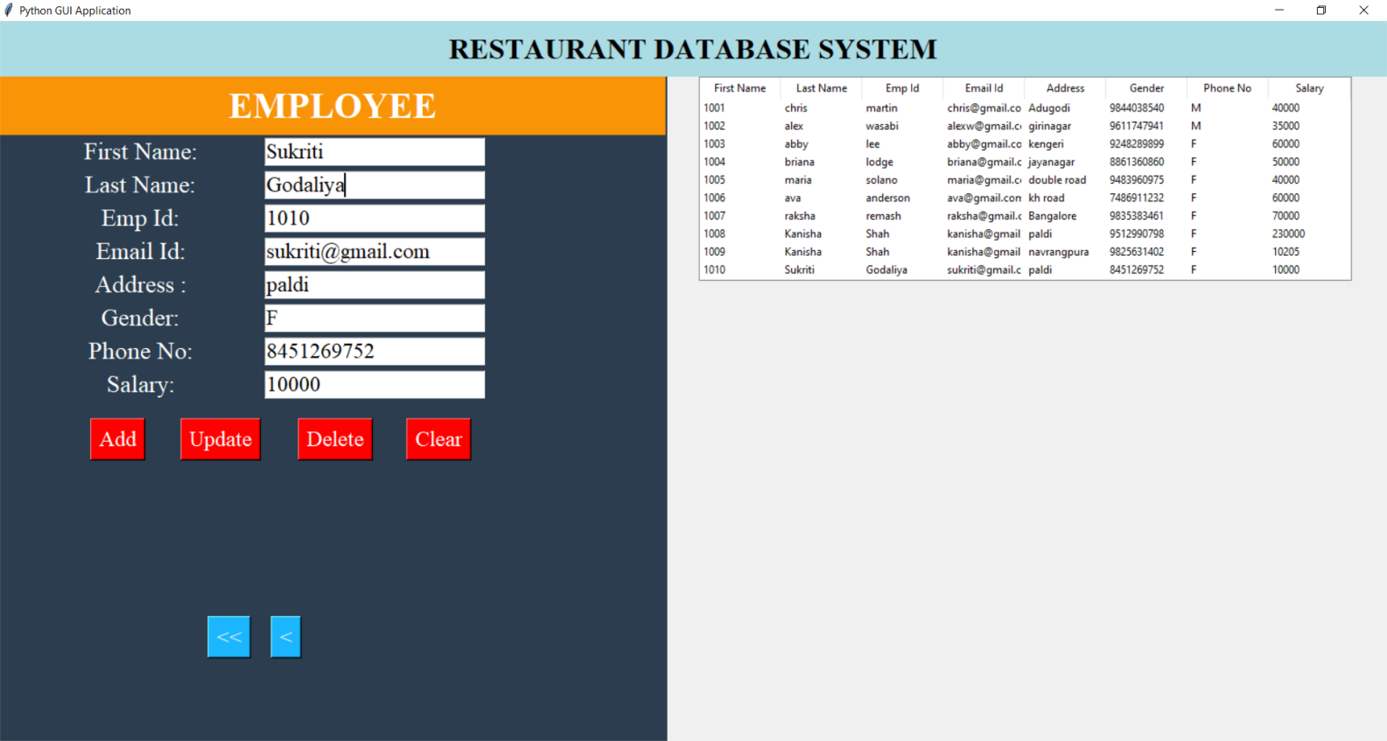

Reflection seen in the SQL workspace

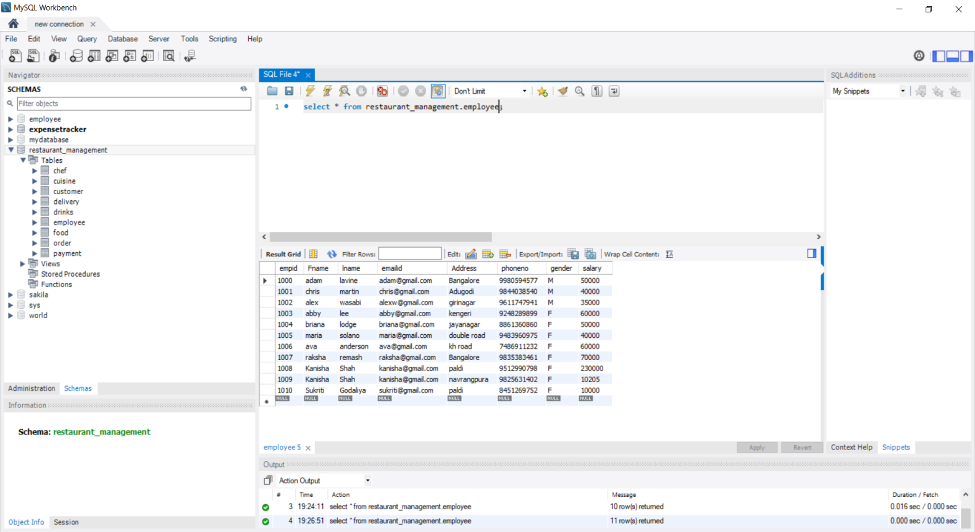

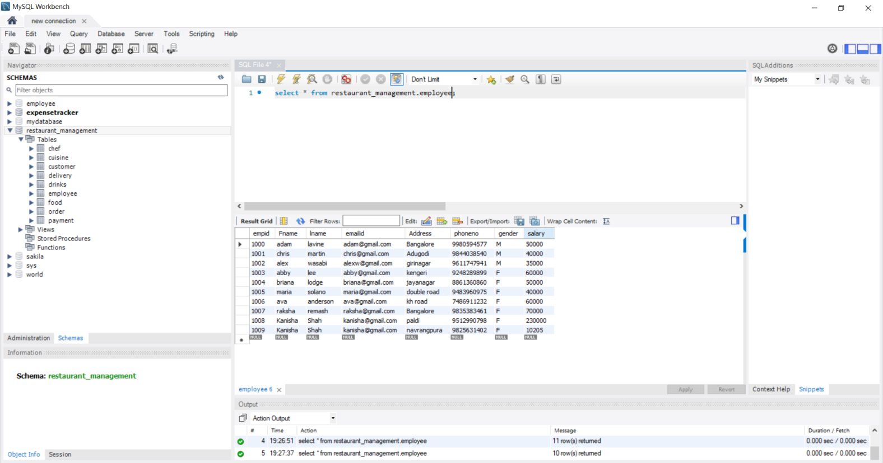

**1010 ID DELETED SUCCESSFULLY, SO RAISES ERROR WHEN YOU TRY TO ACCESS**

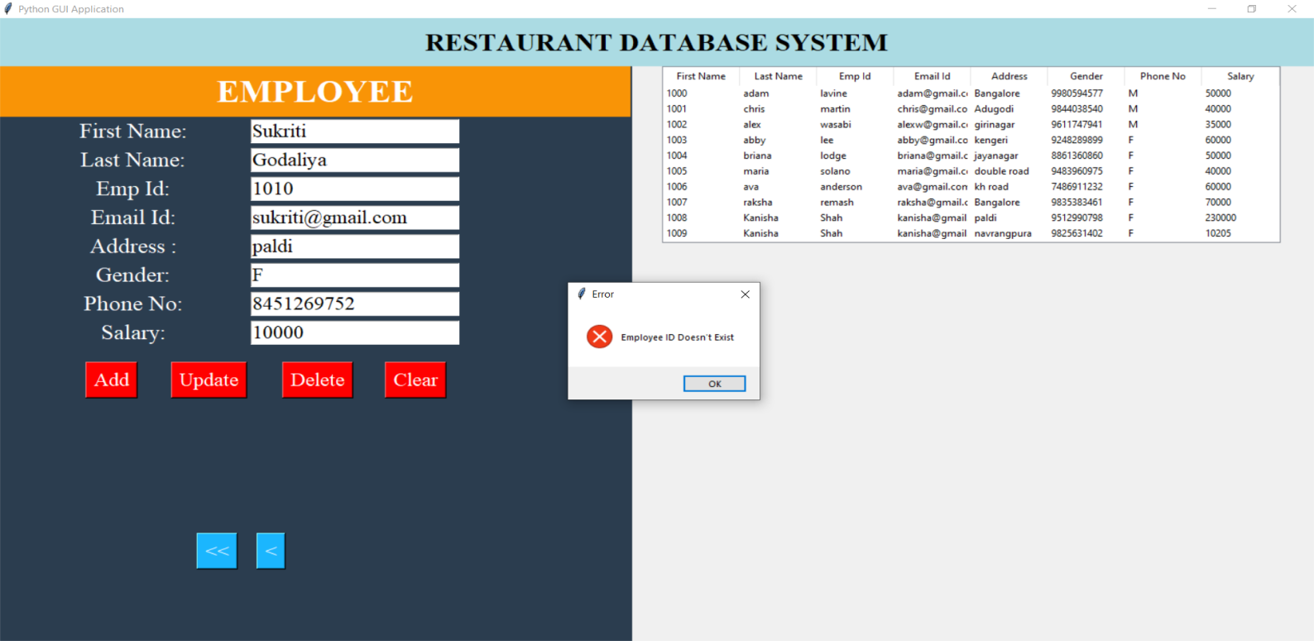

**CLEAR BUTTON CLEARS THE SCREEN**

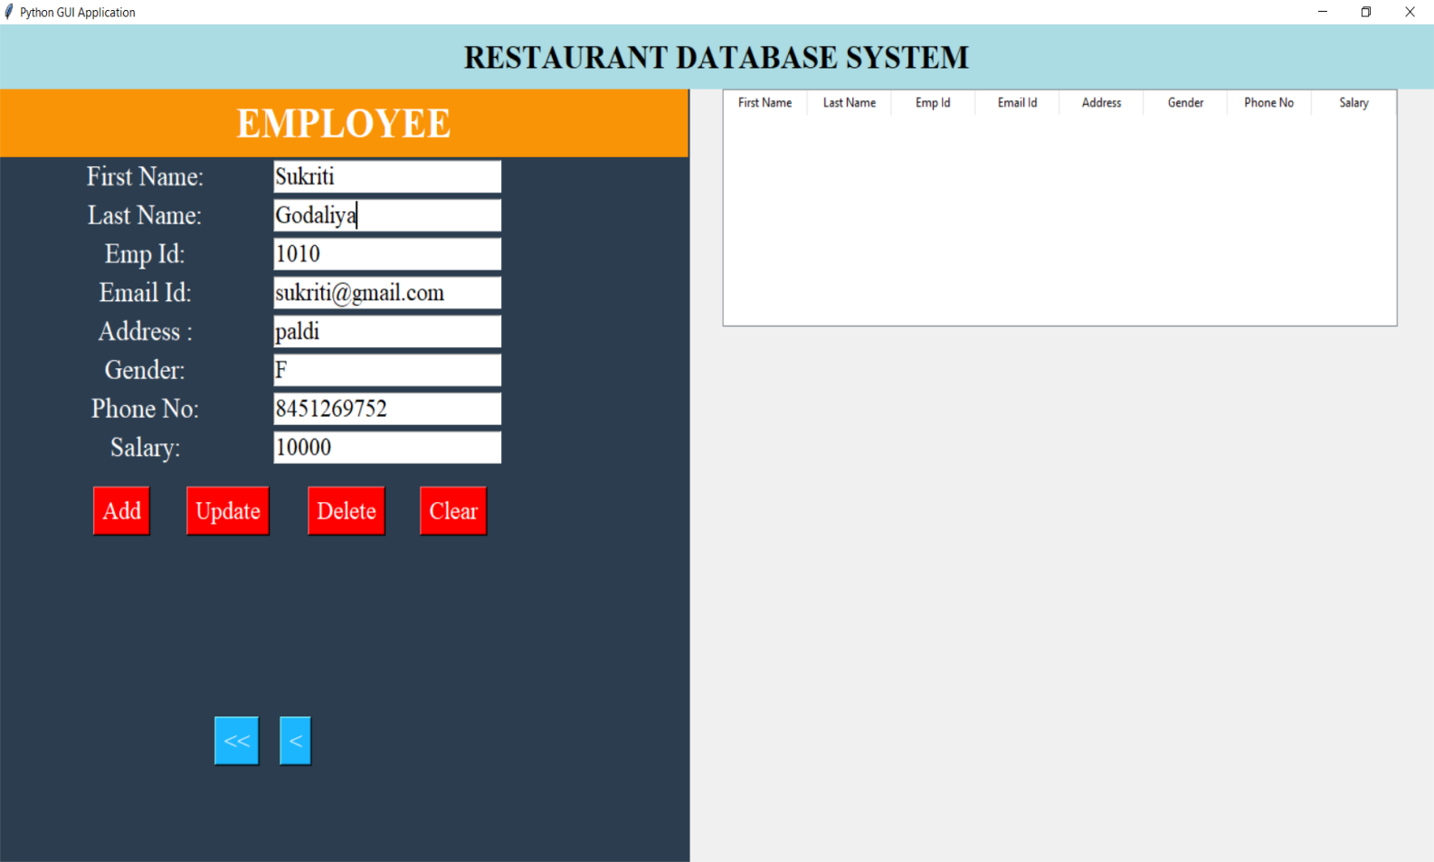

**CHEF:**

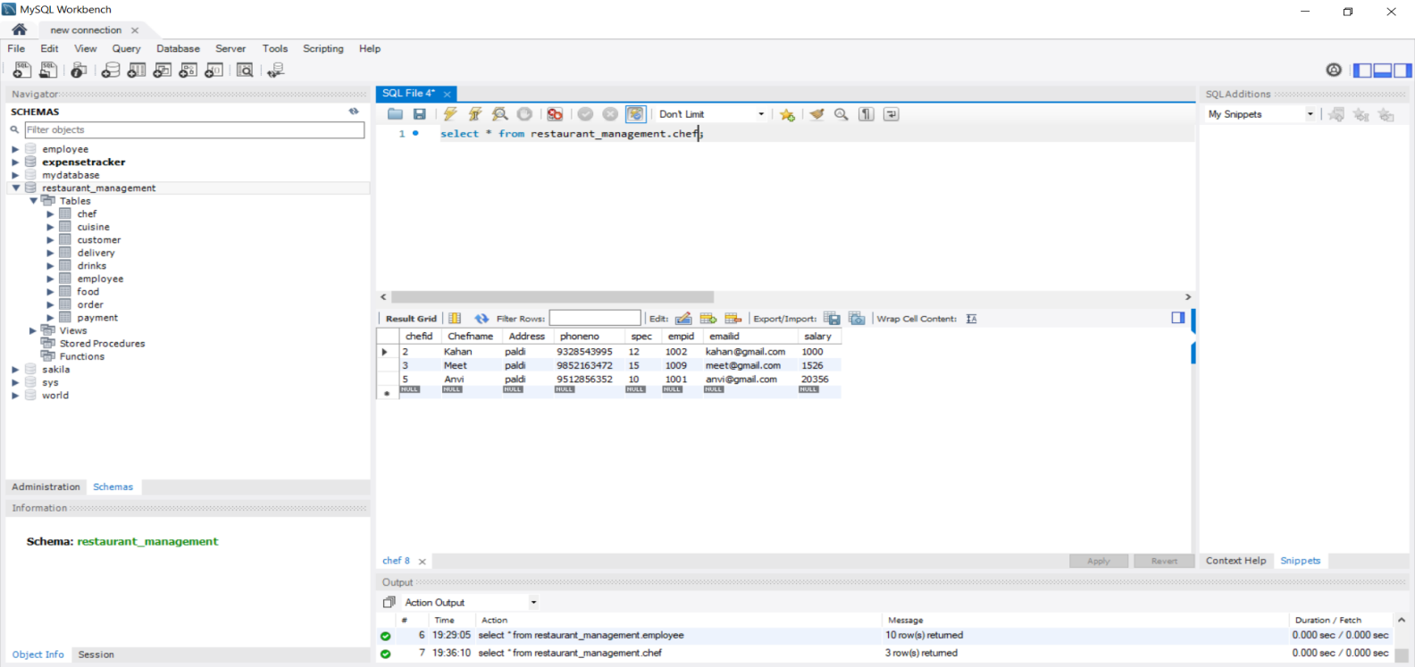

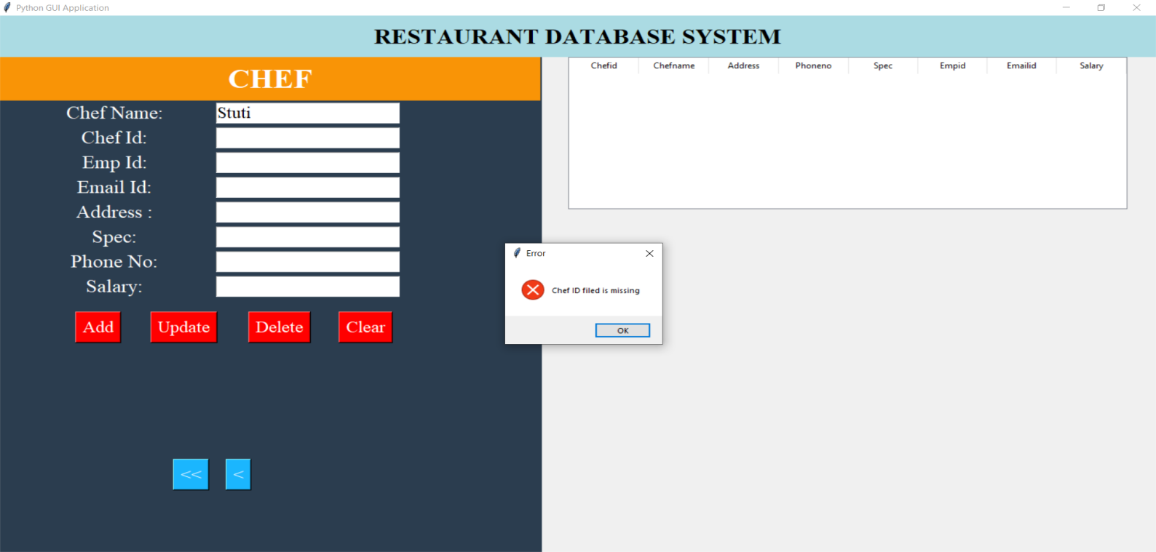

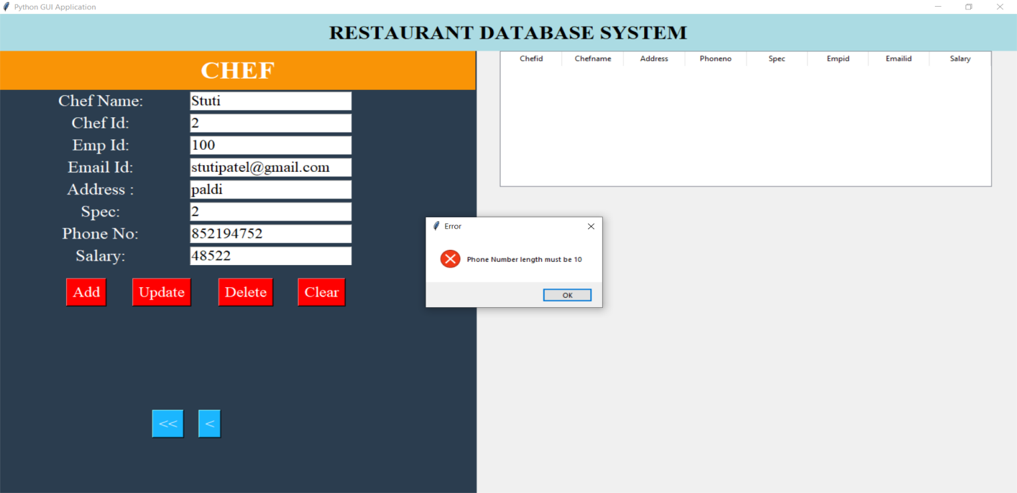

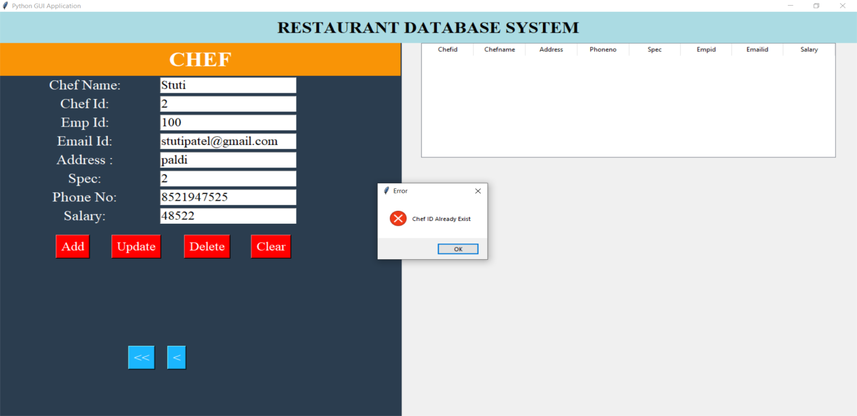

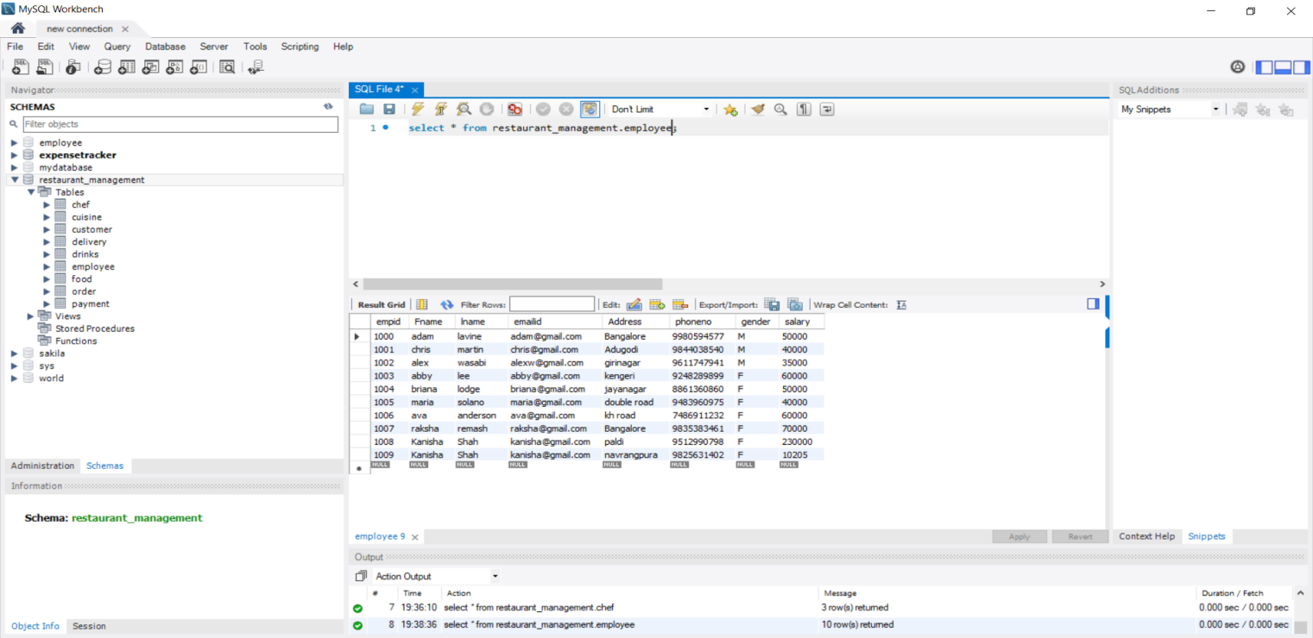

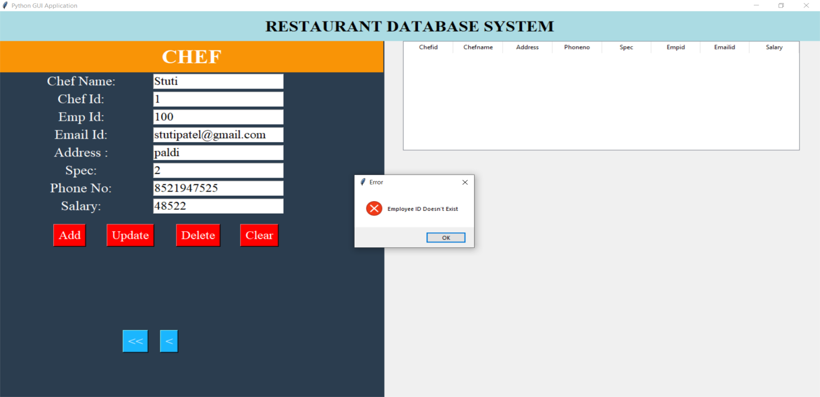

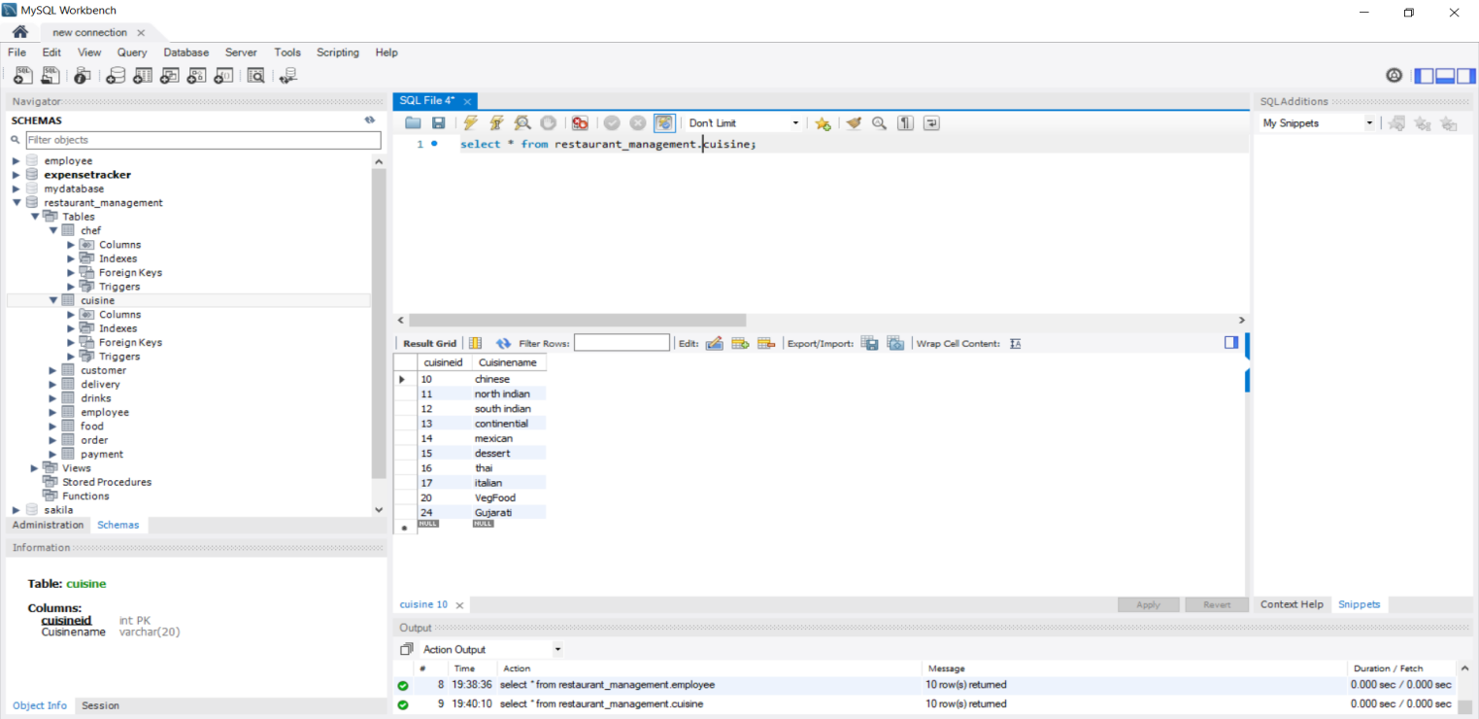

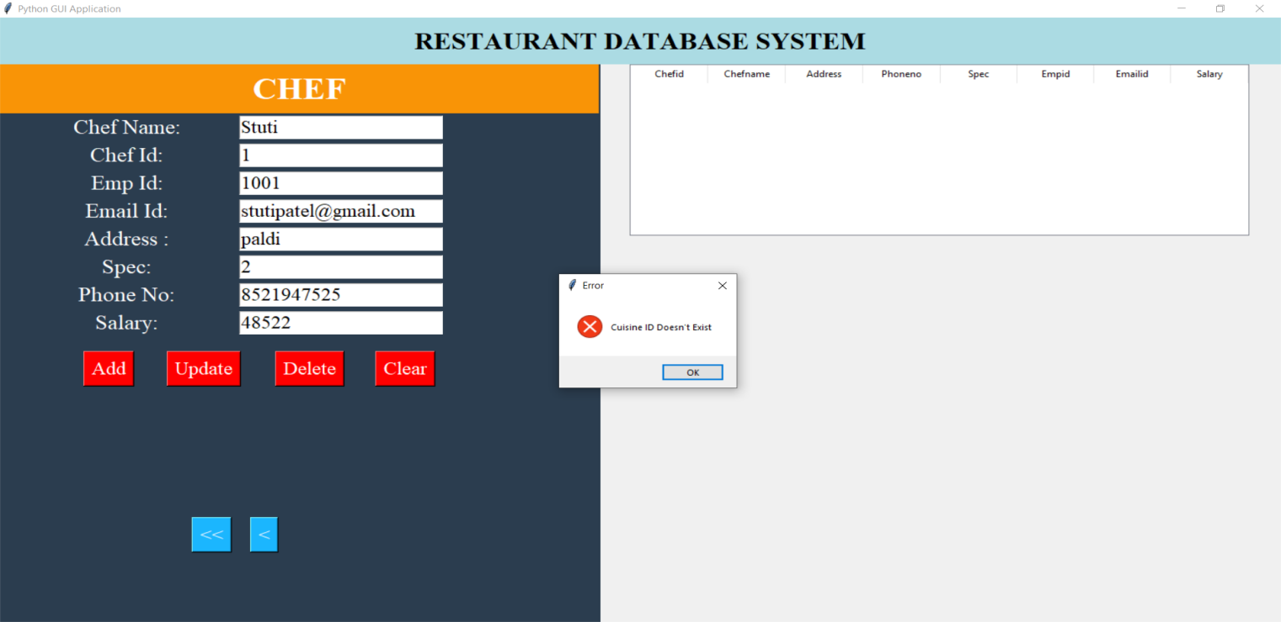

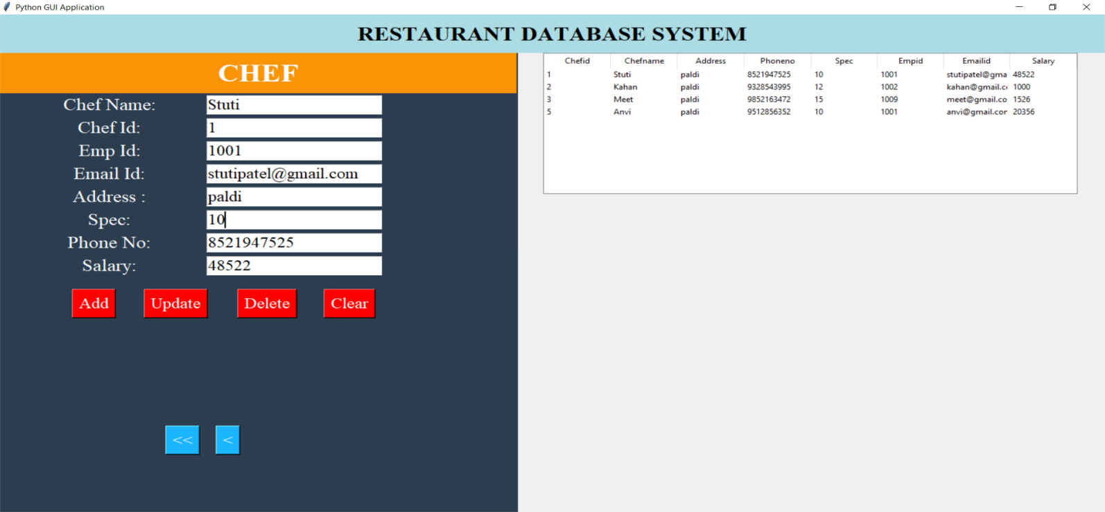

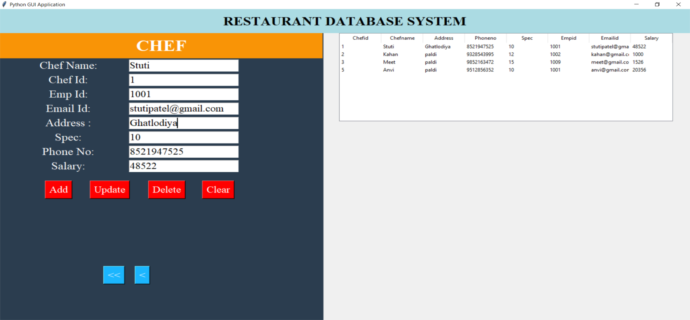

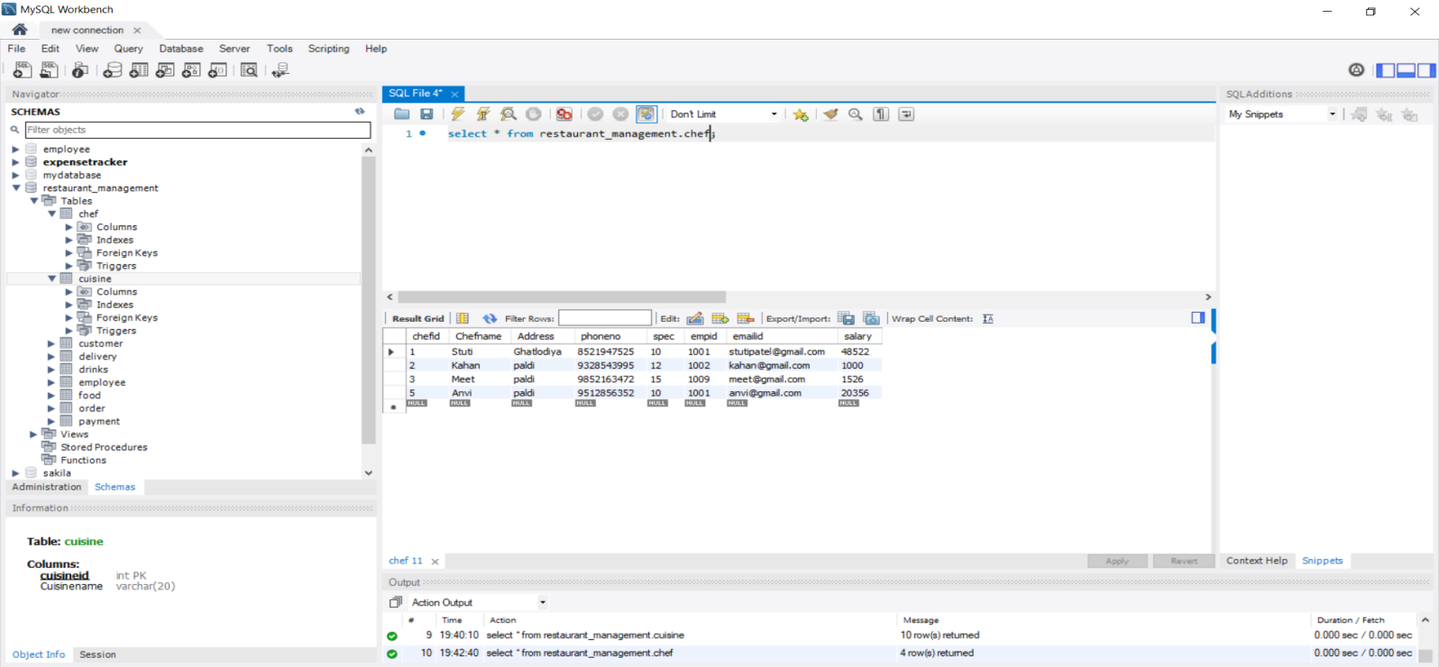

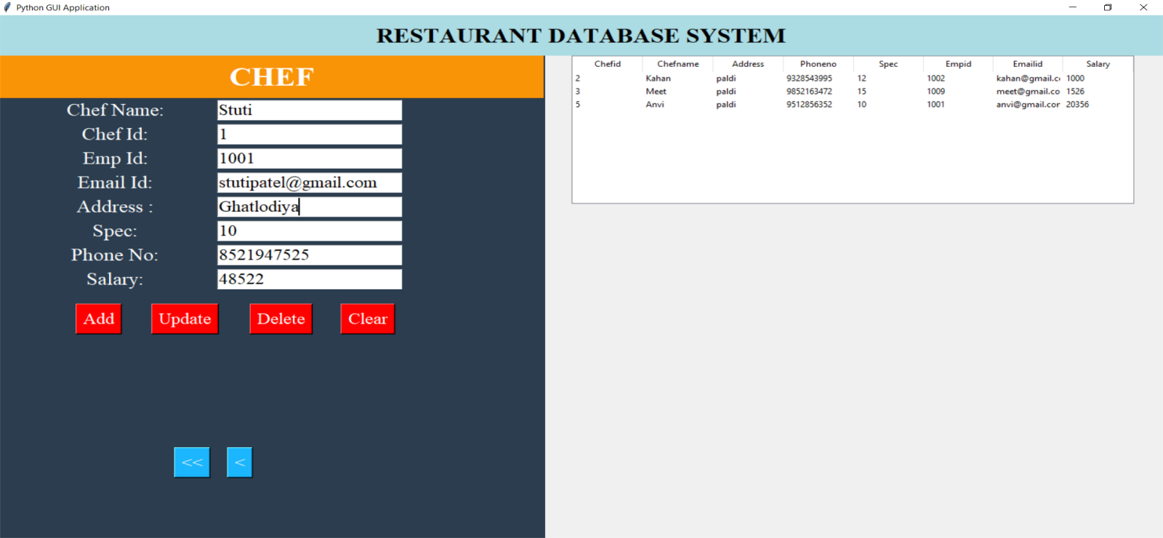

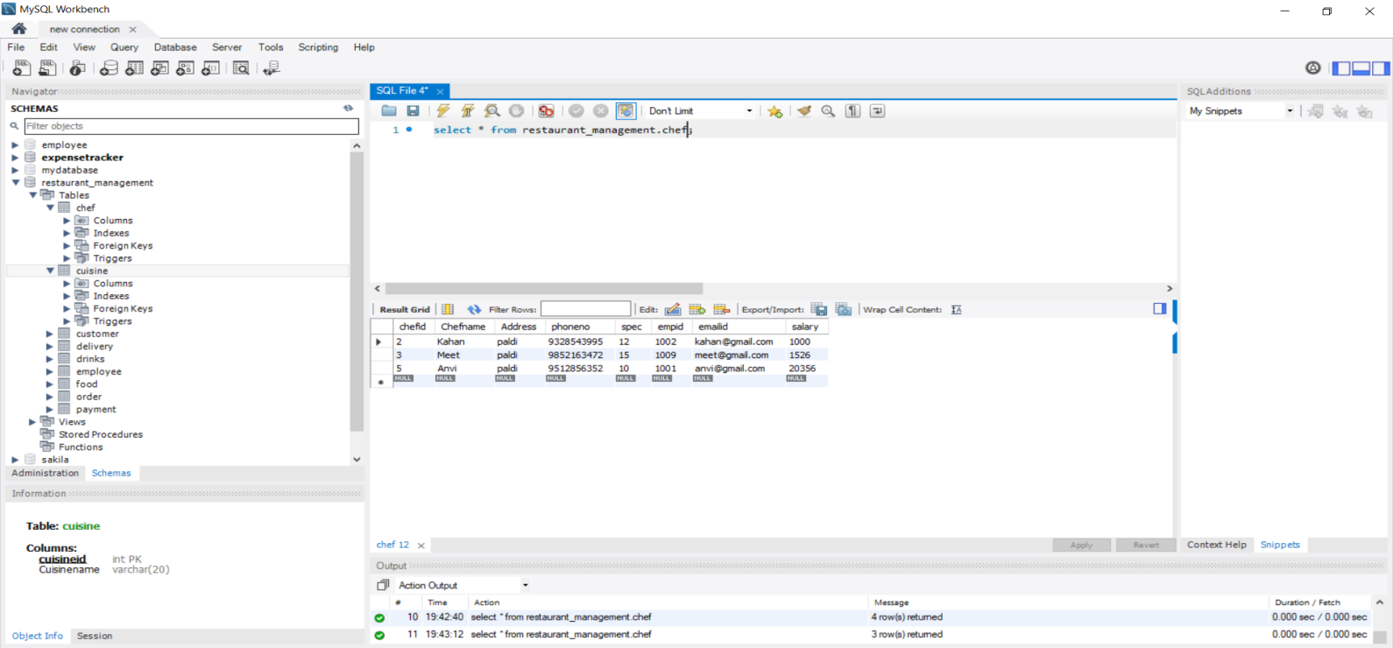

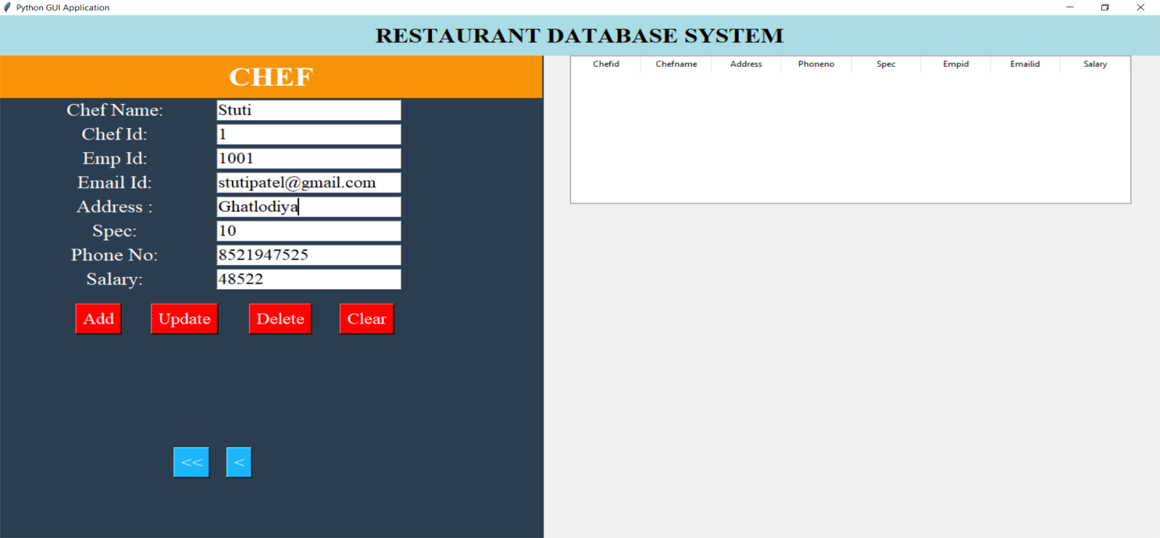

**DELIVERY:**

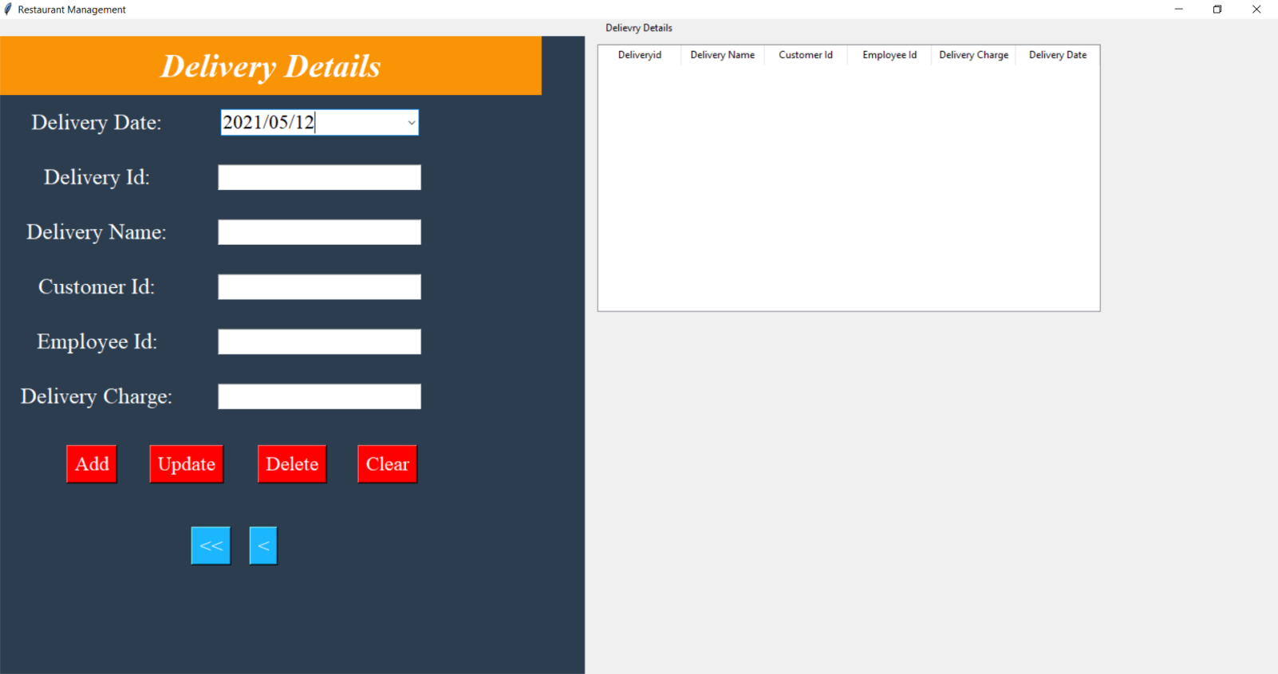

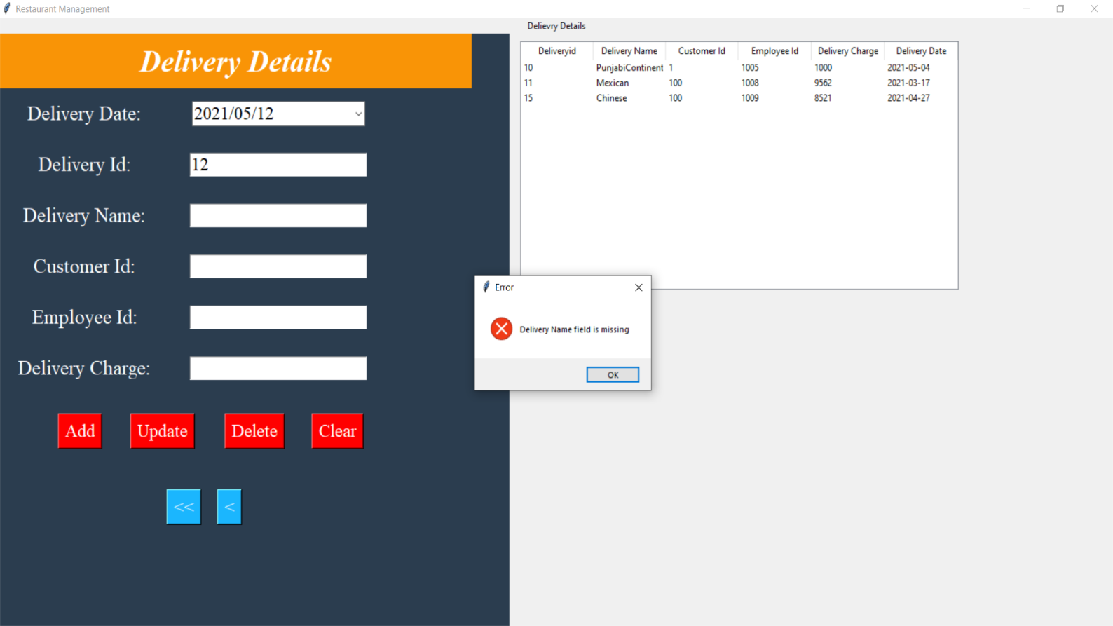

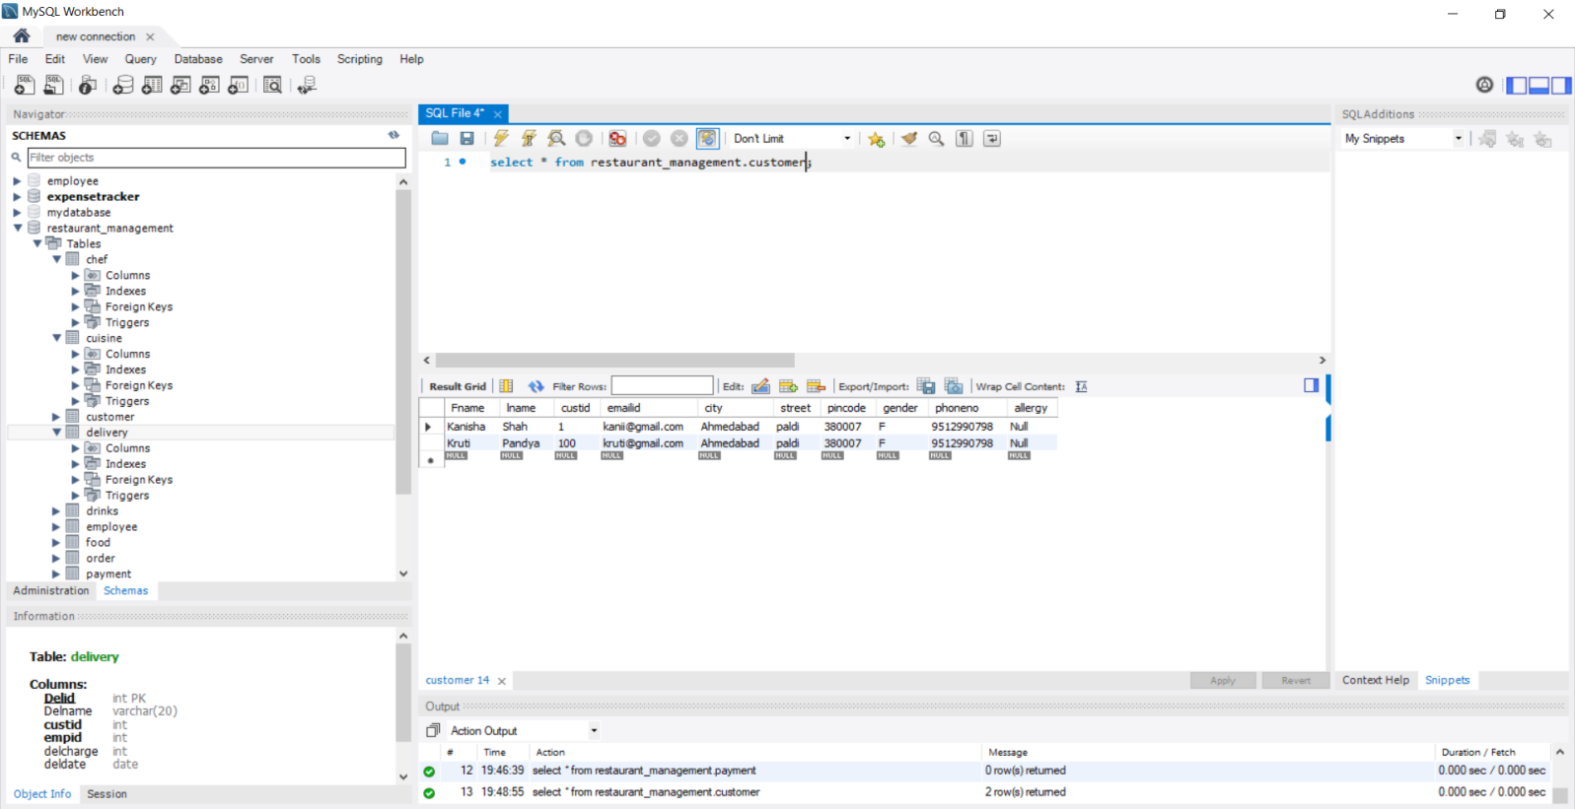

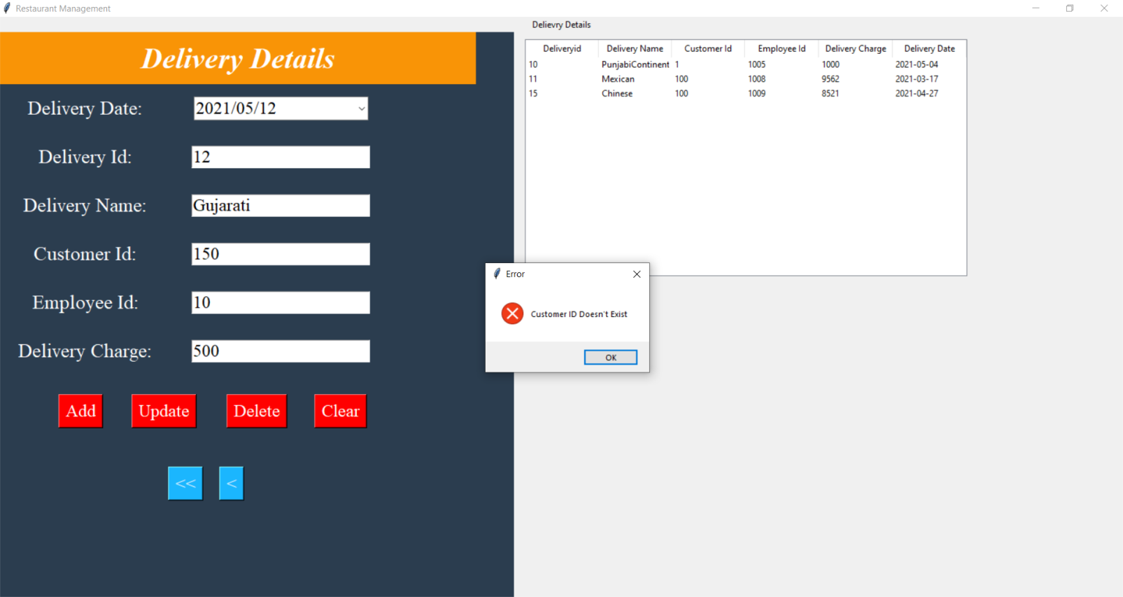

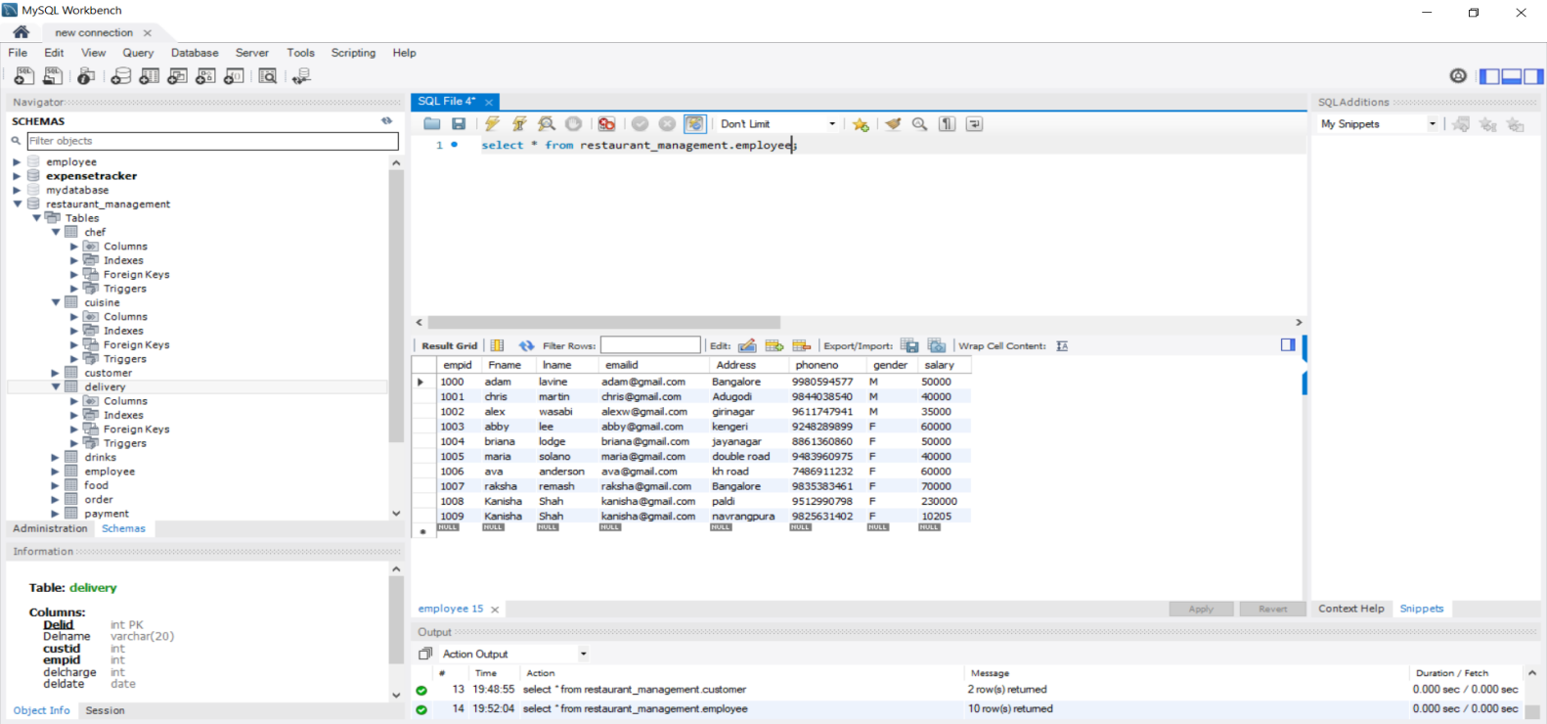

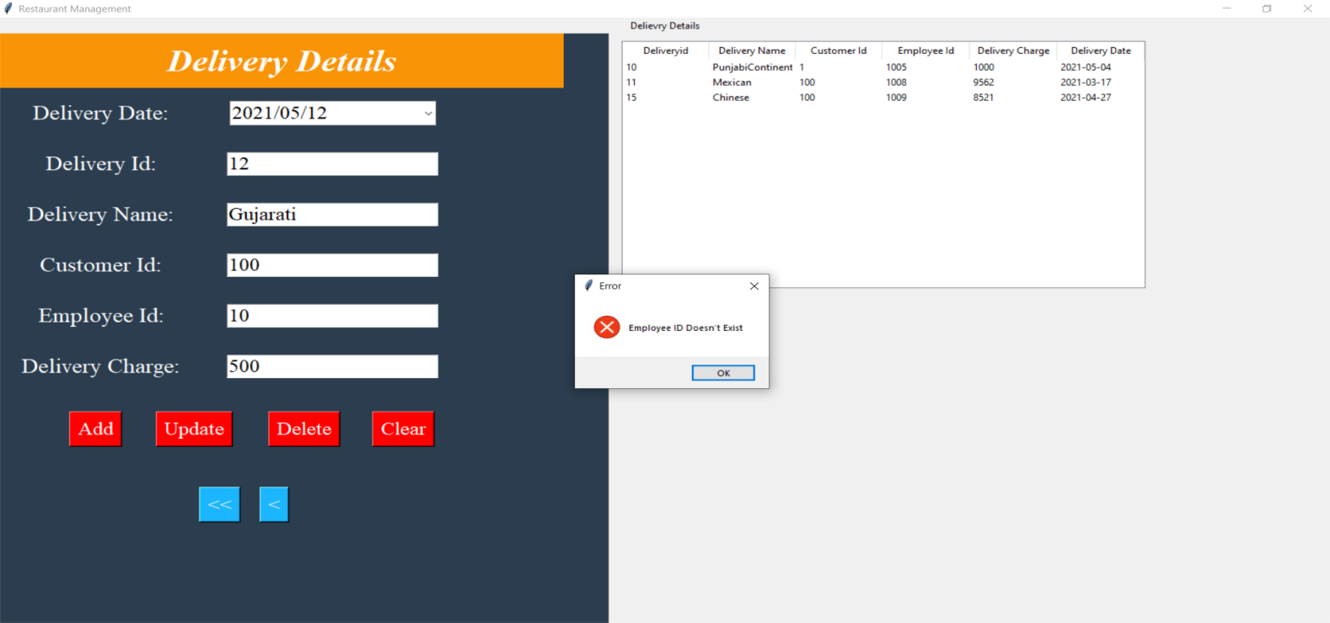

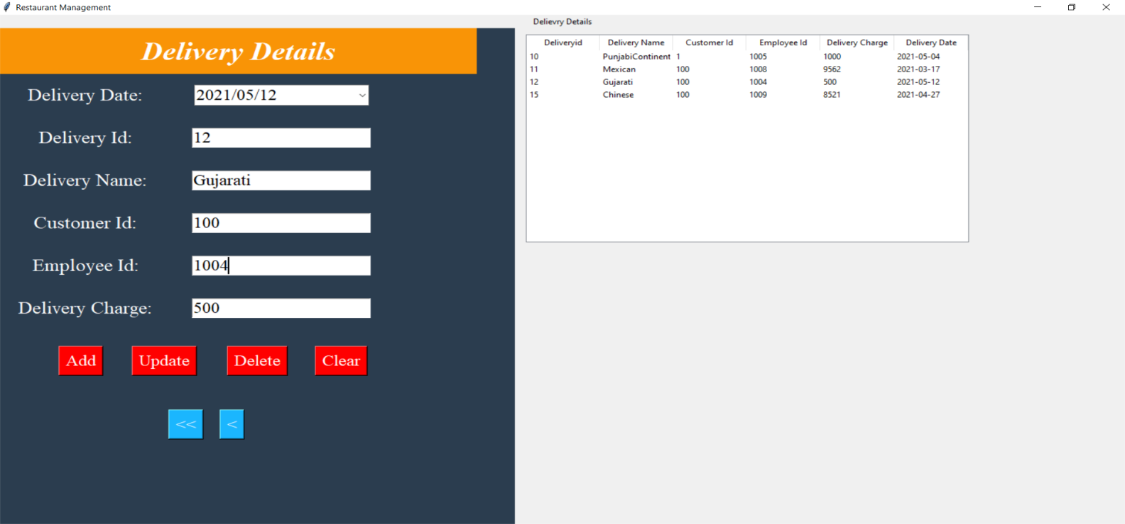

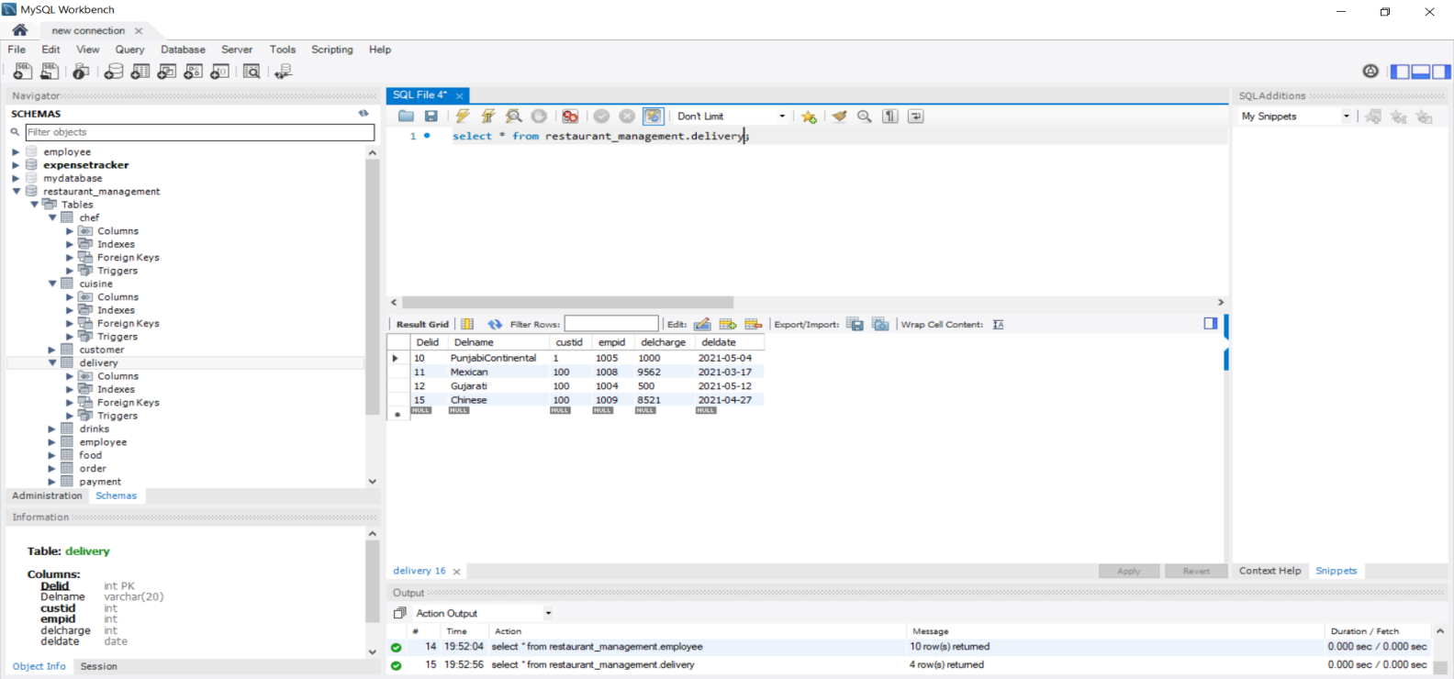

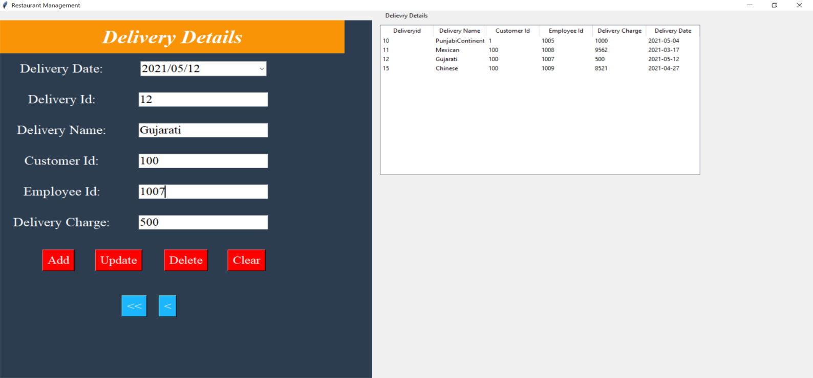

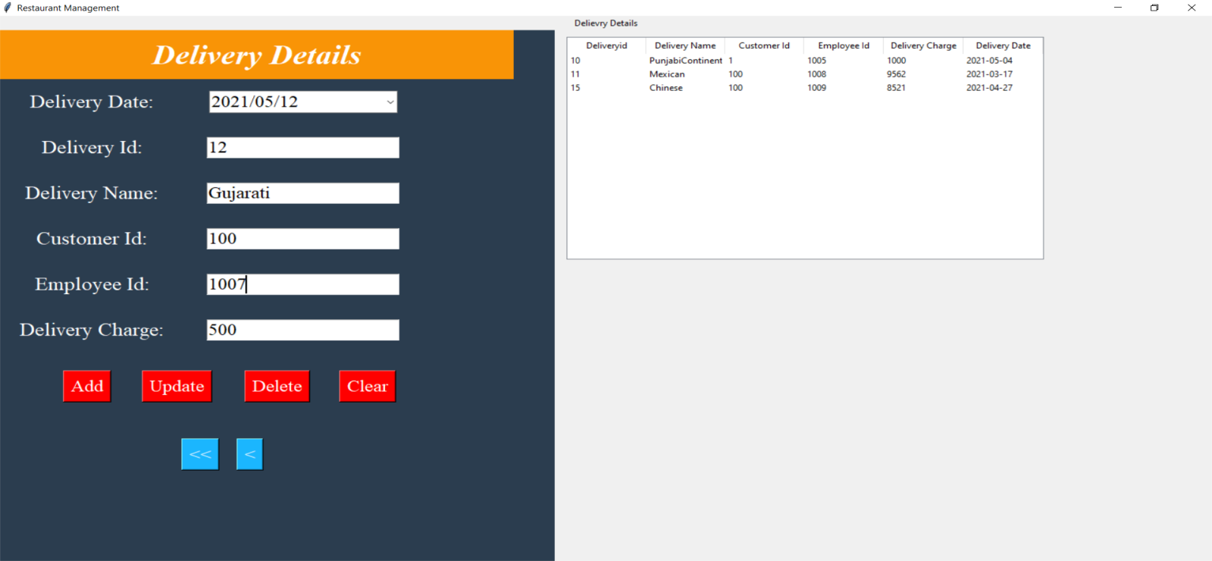

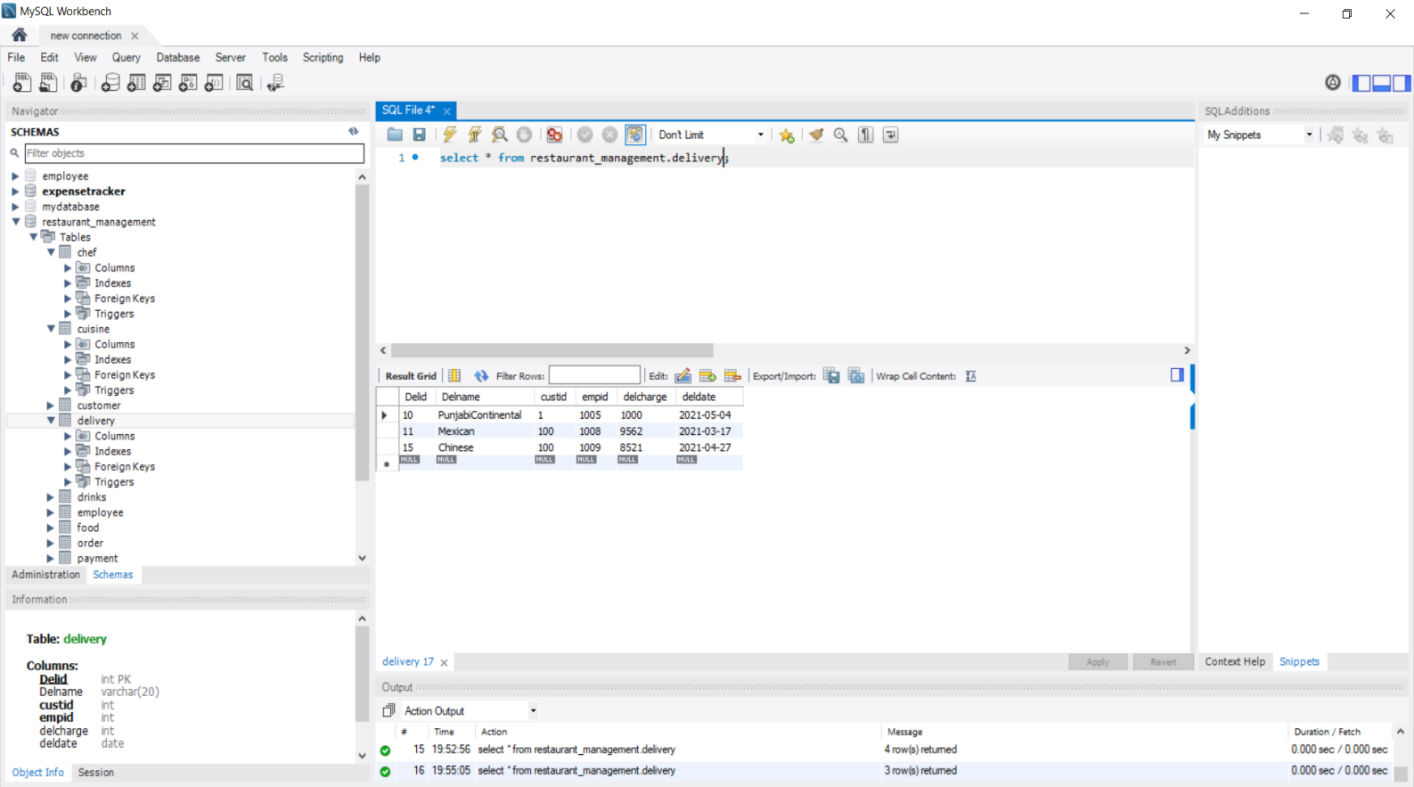

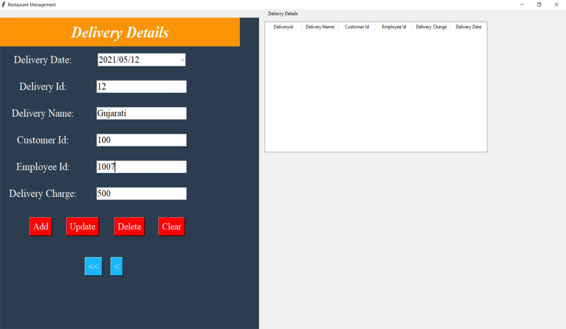

**FOOD:**

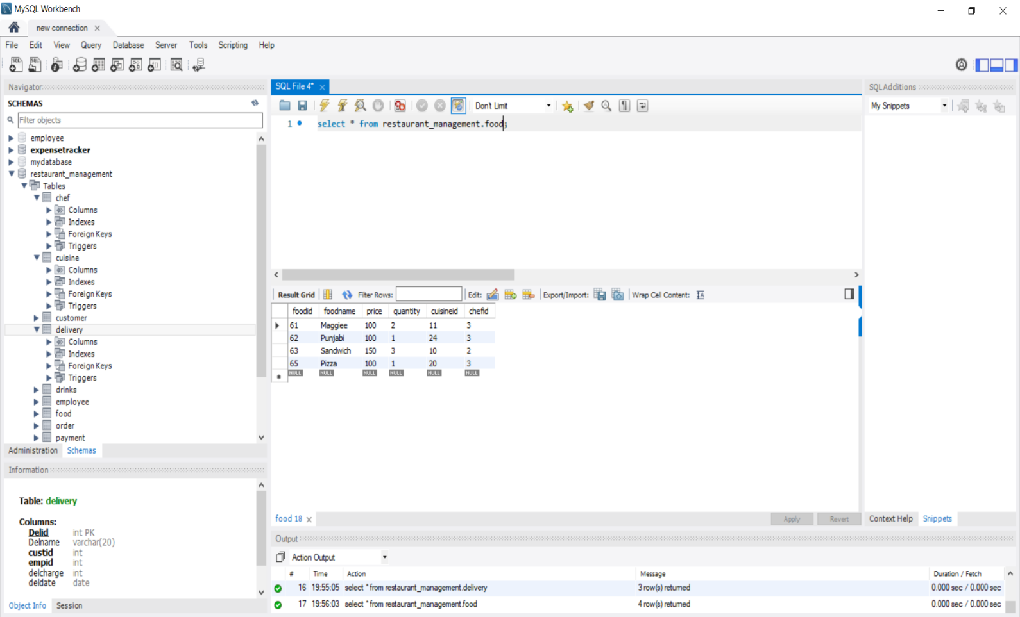

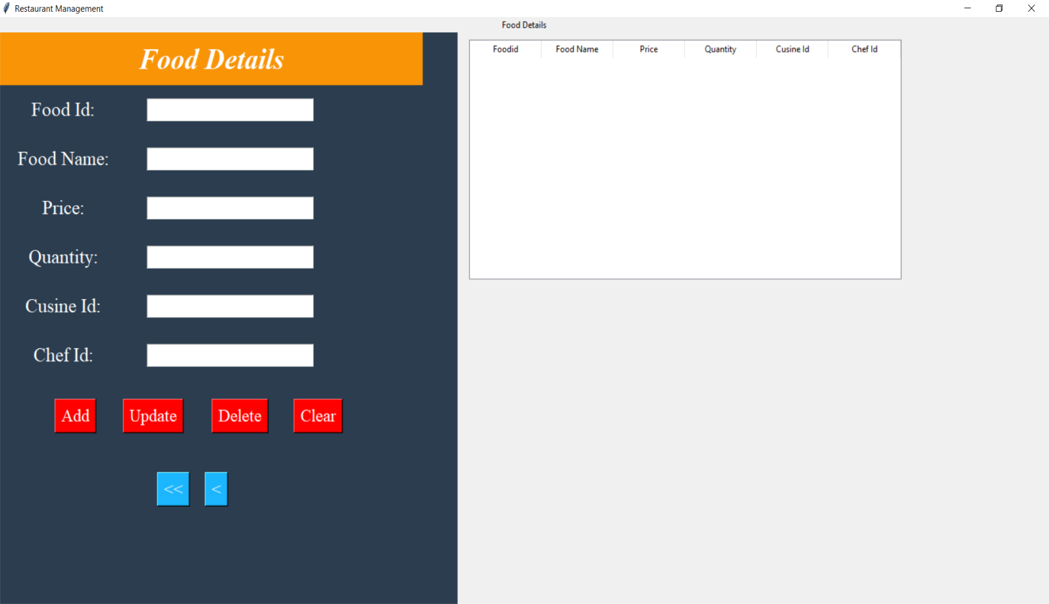

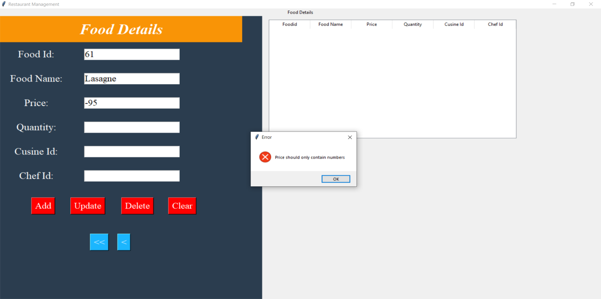

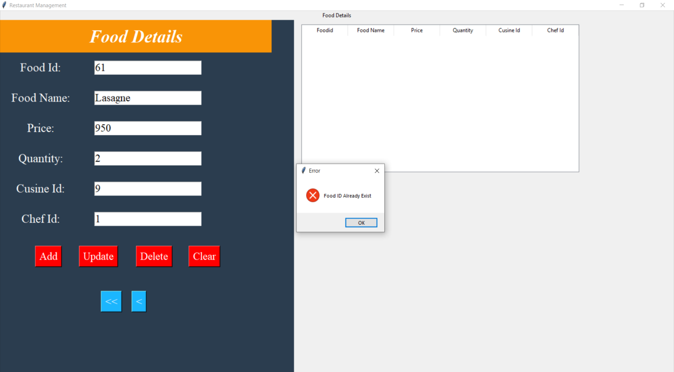

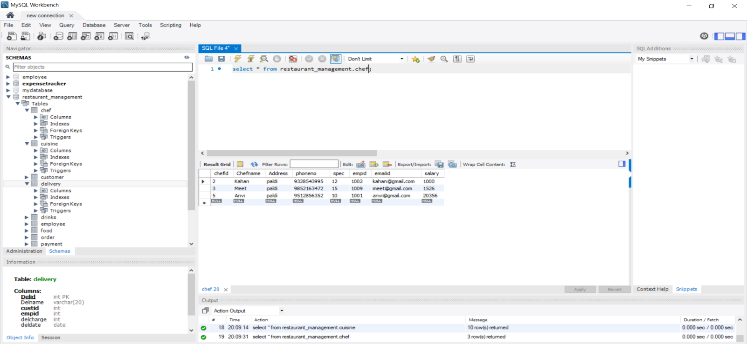

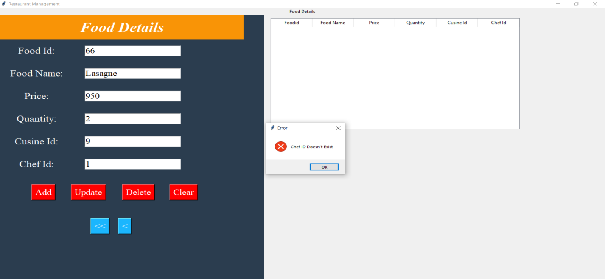

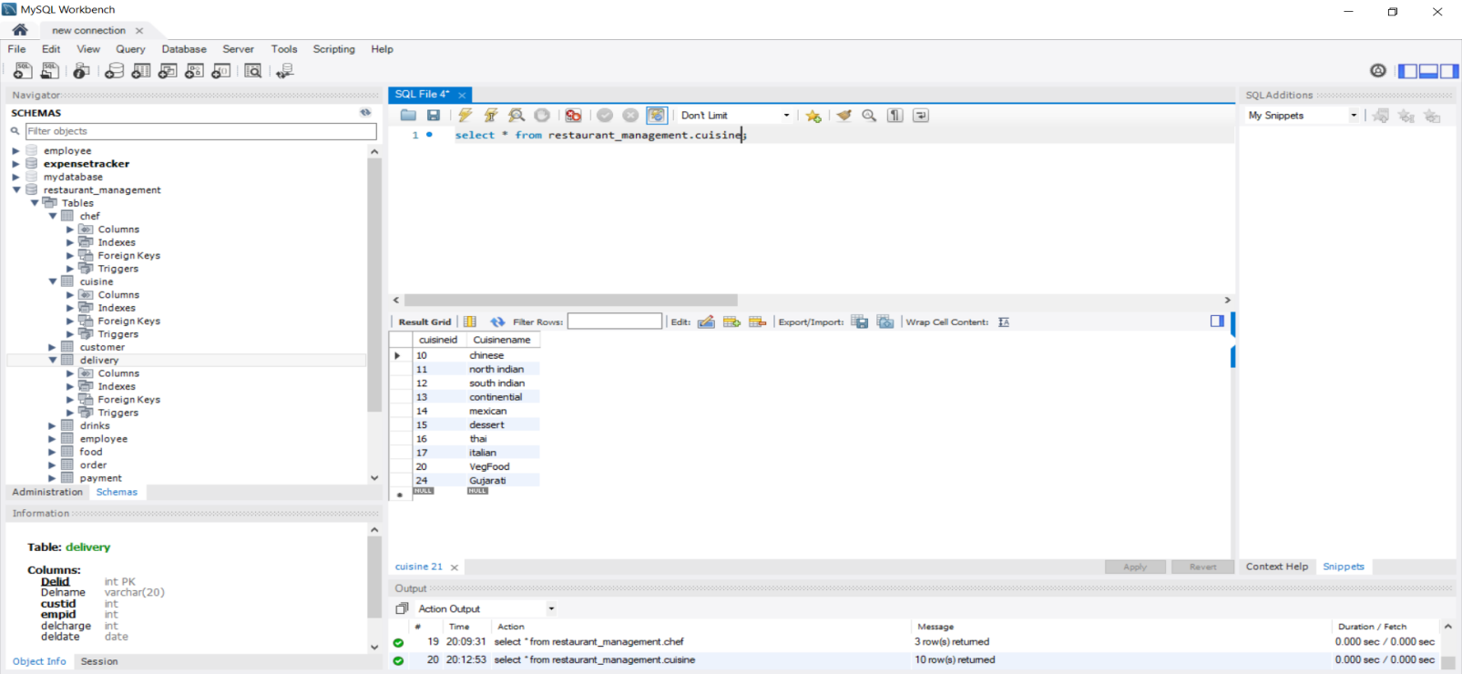

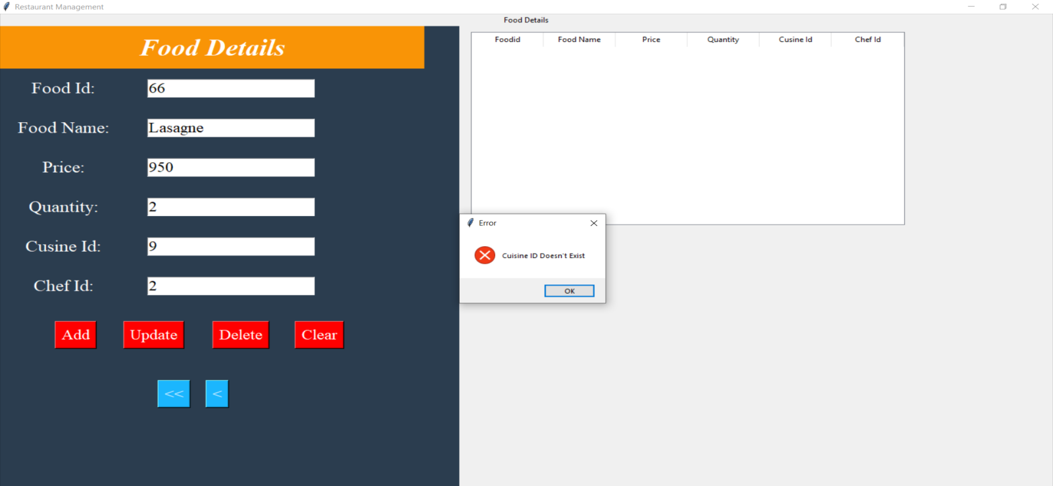

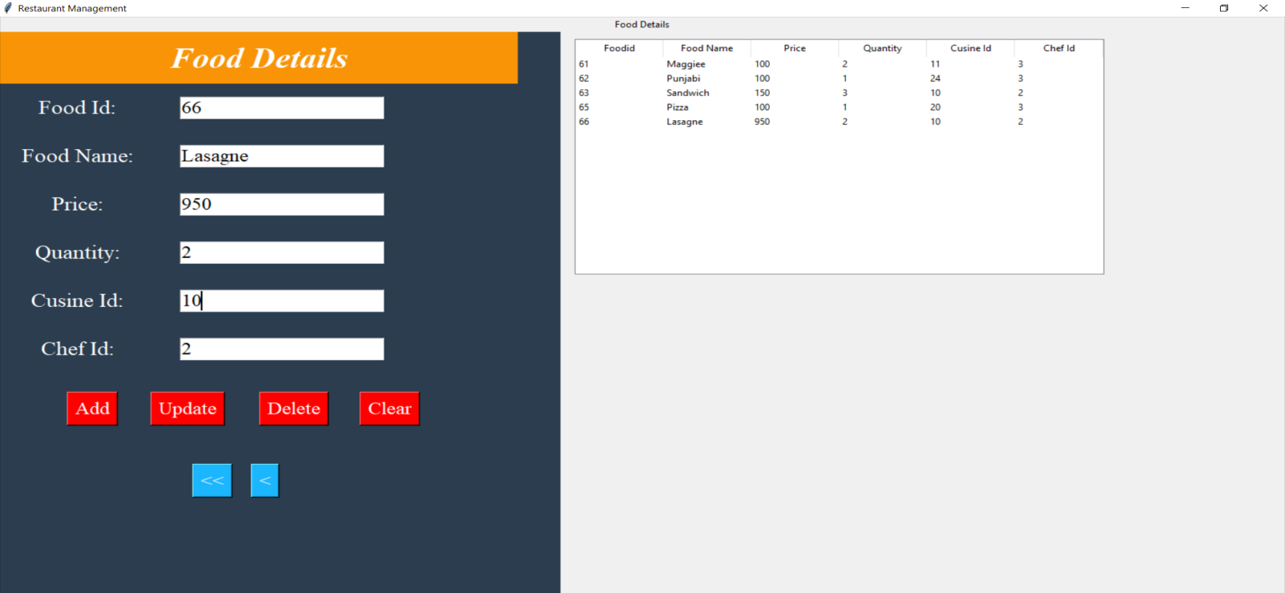

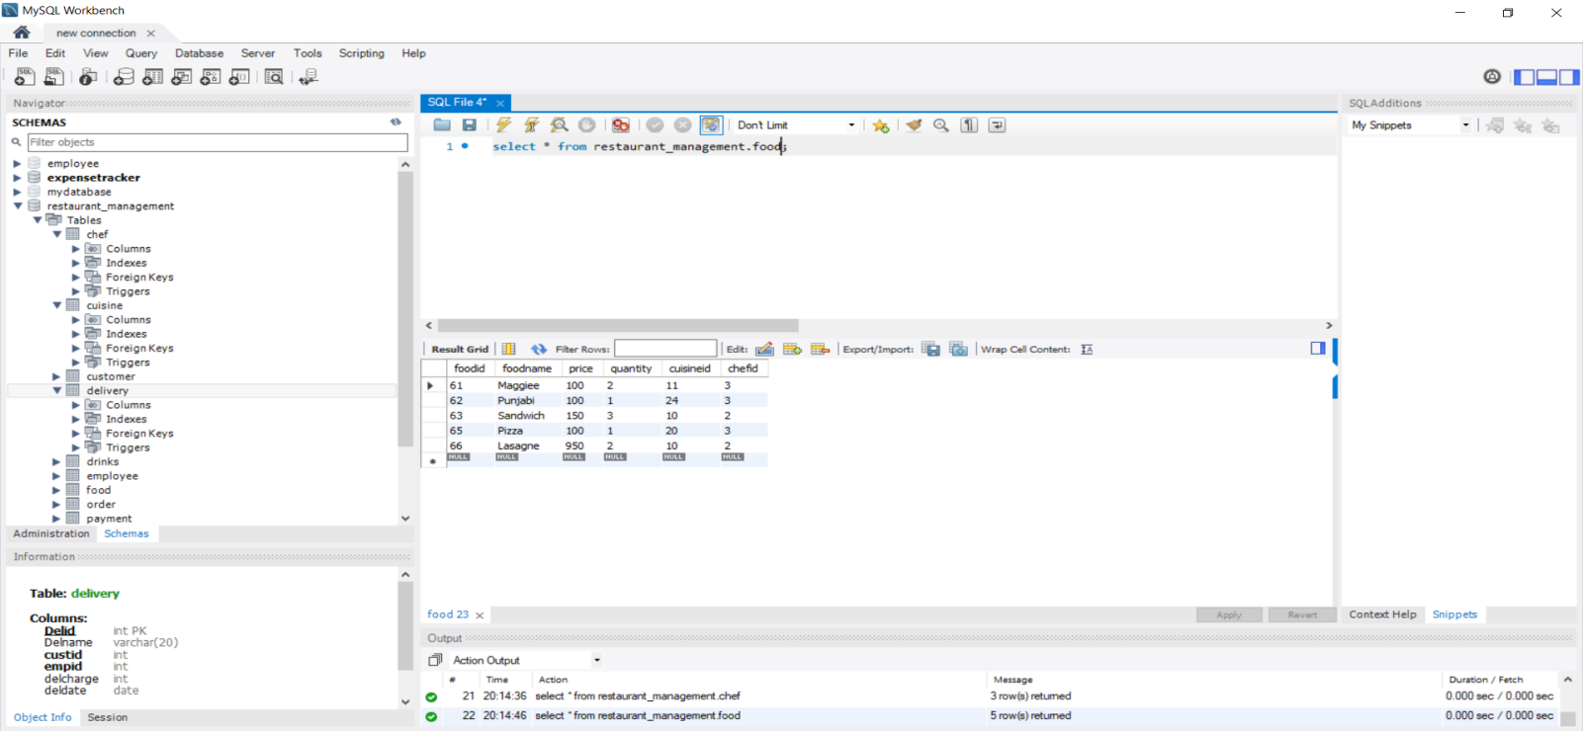

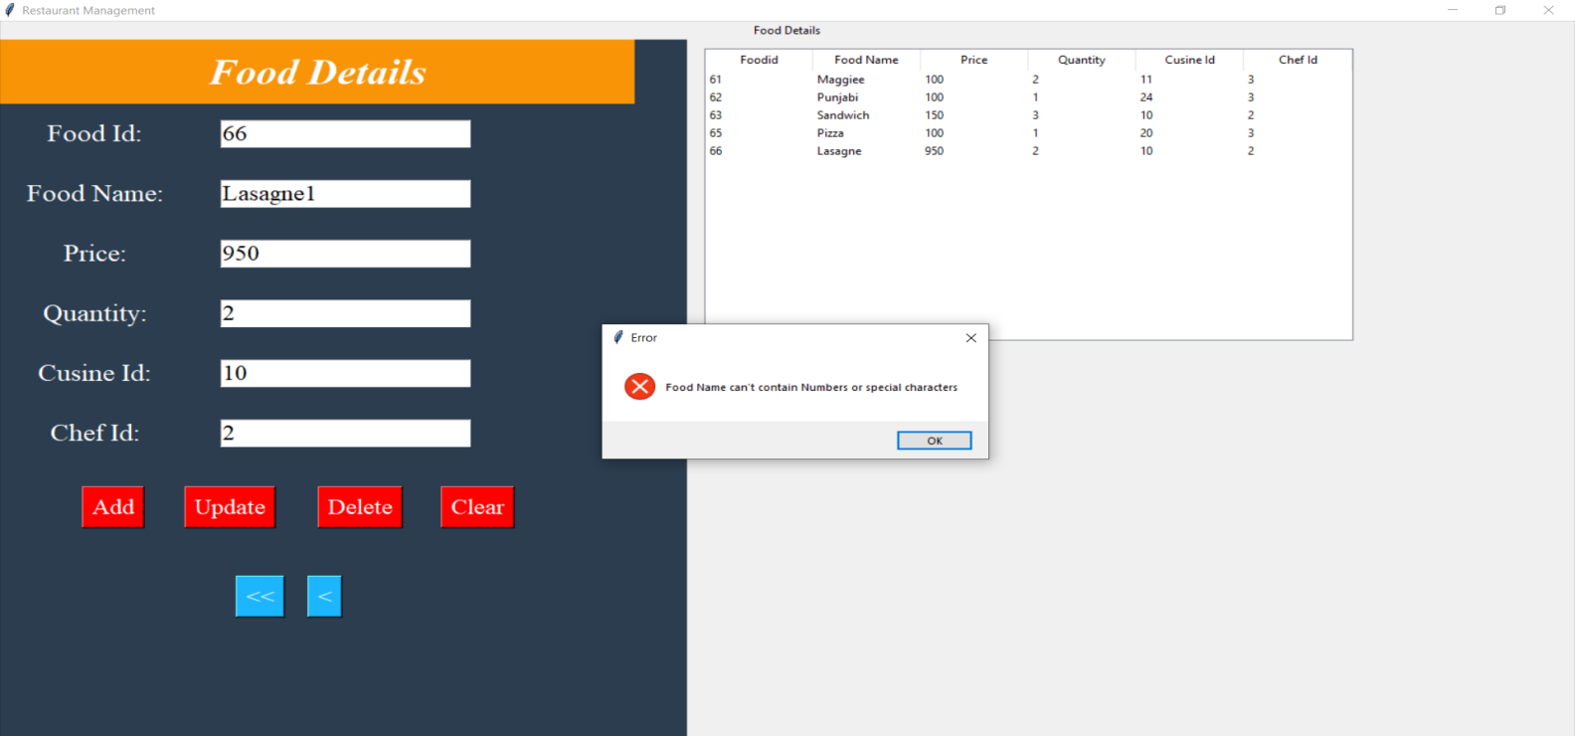

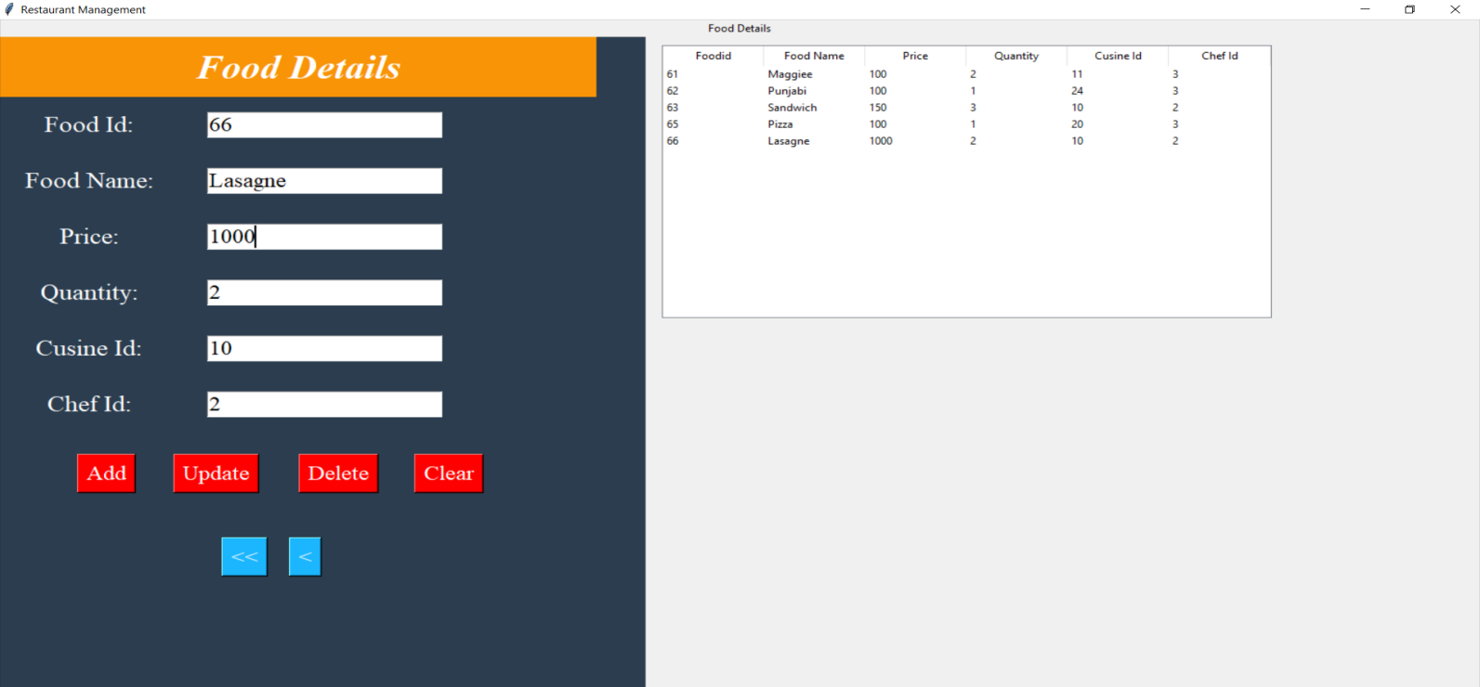

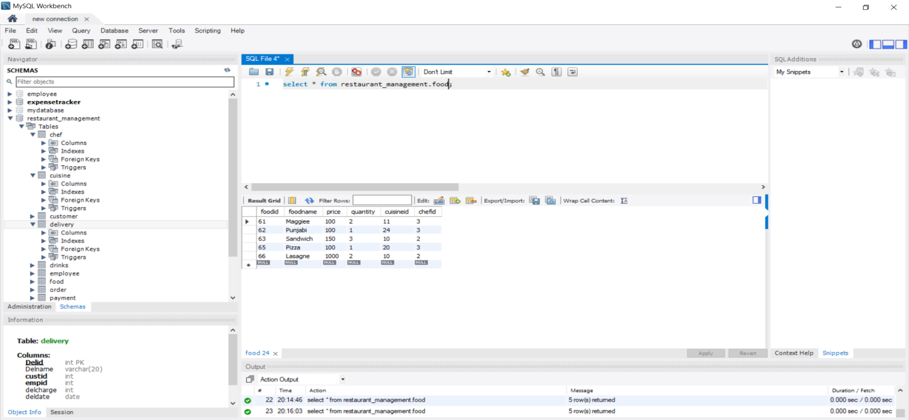

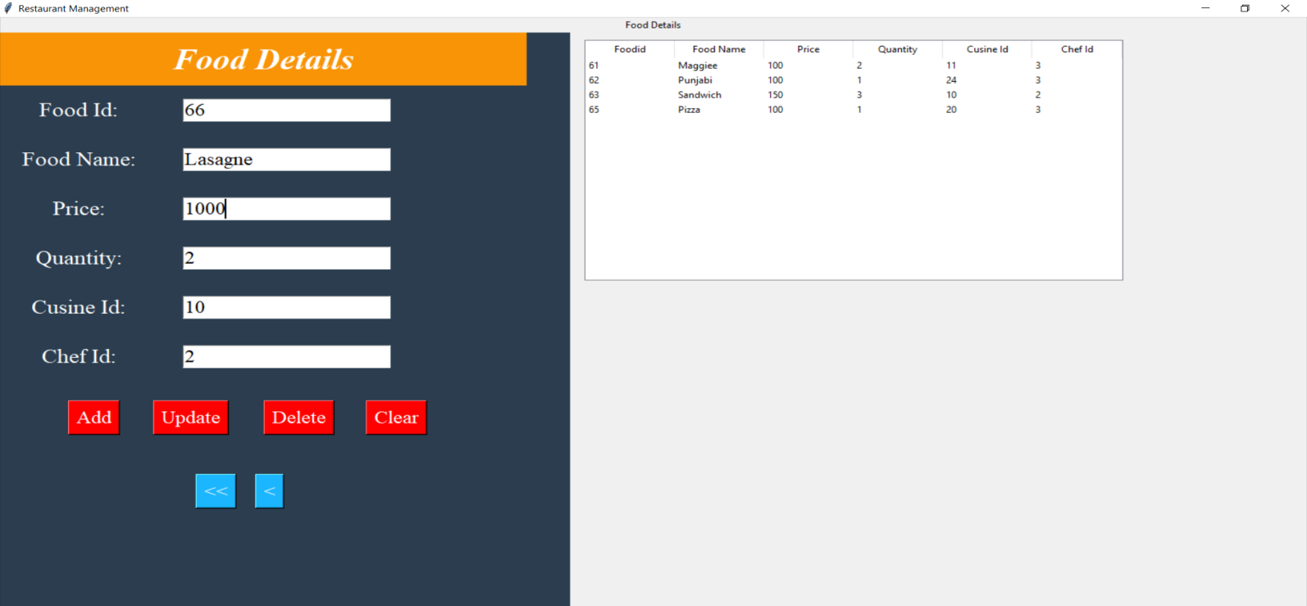

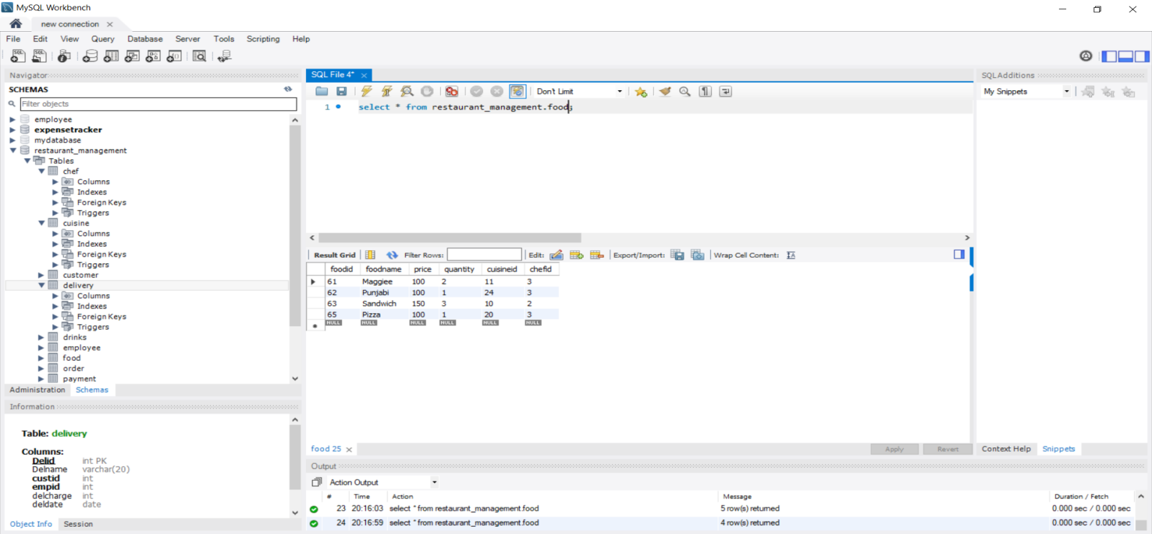

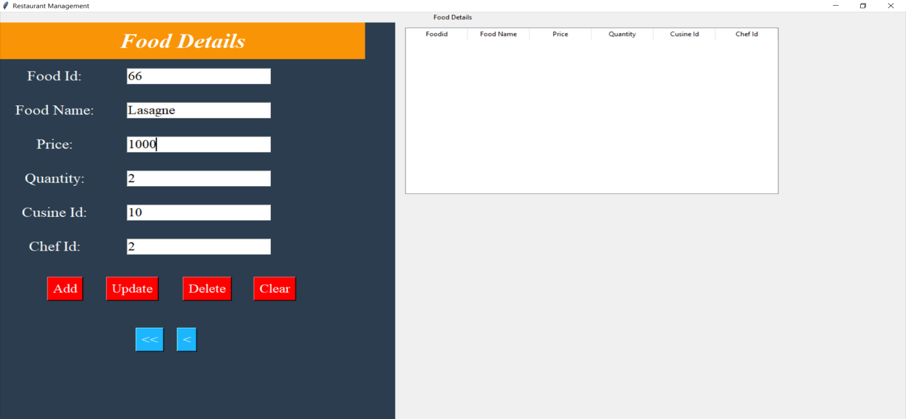

**DRINK:**

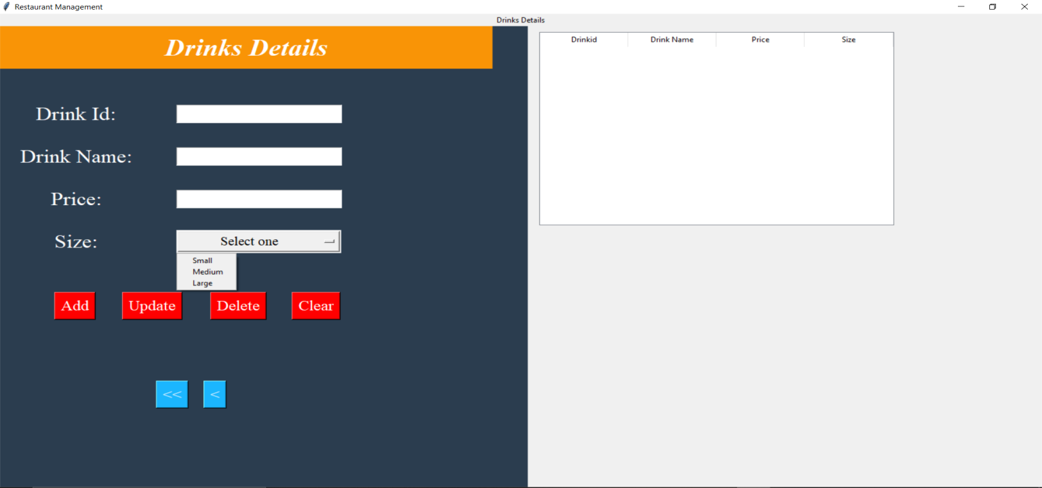

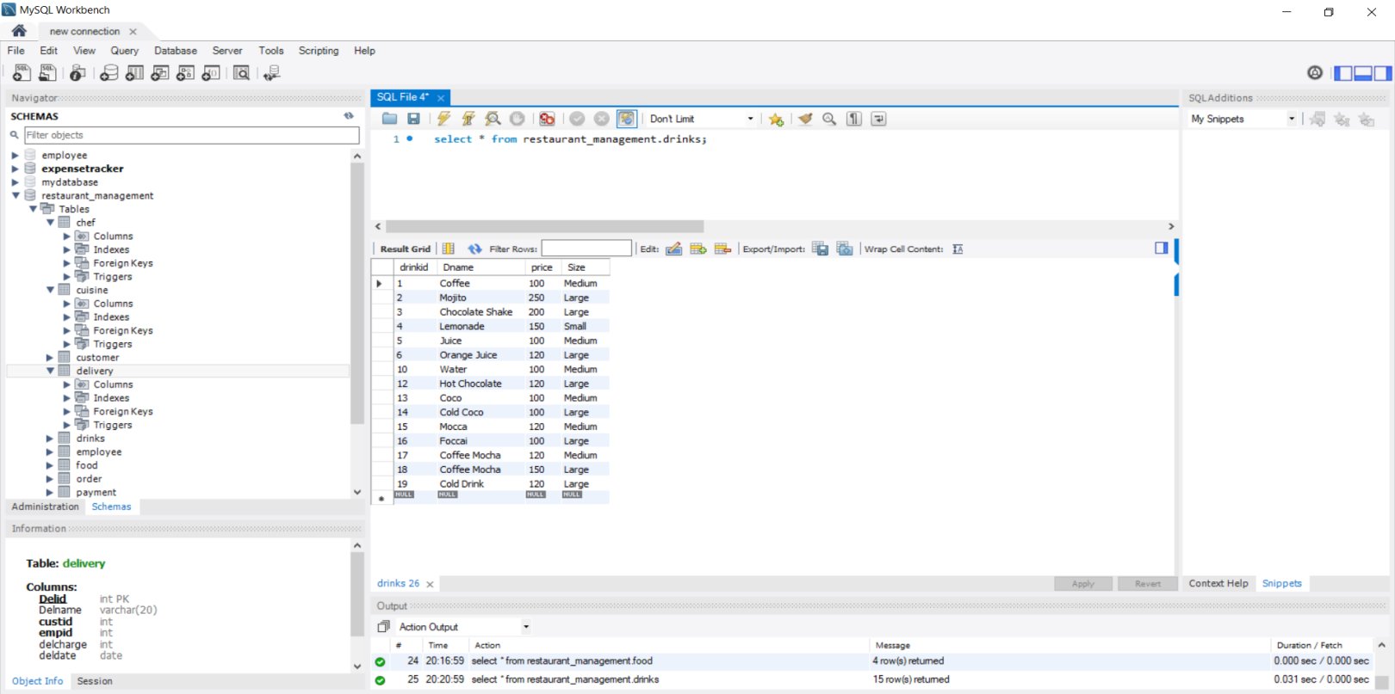

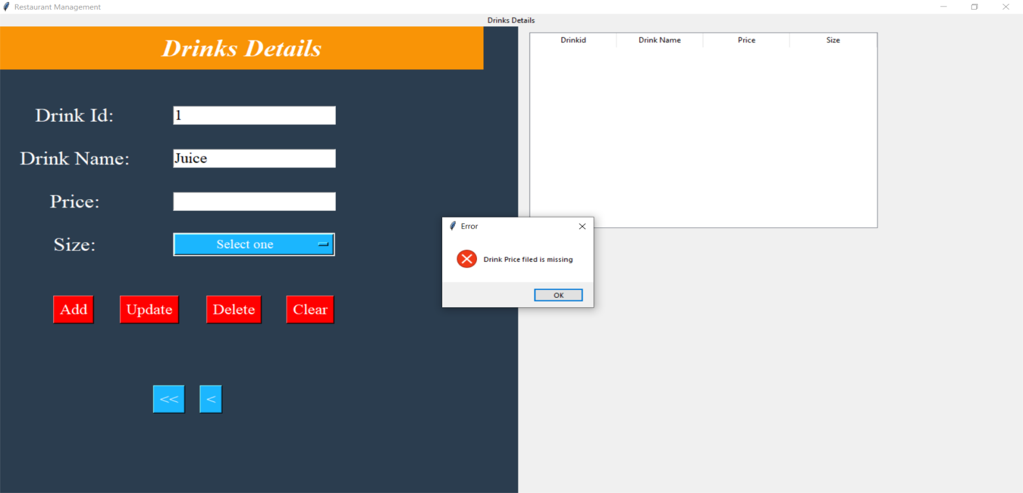

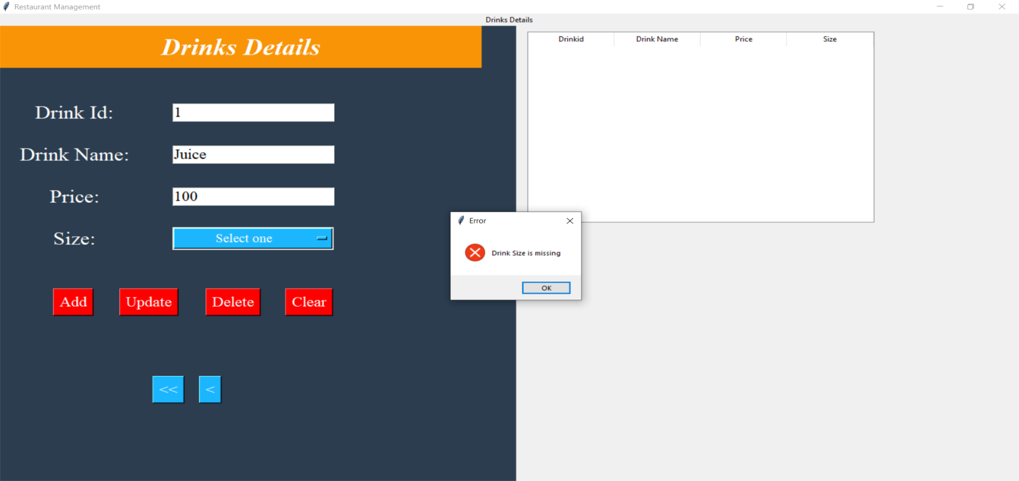

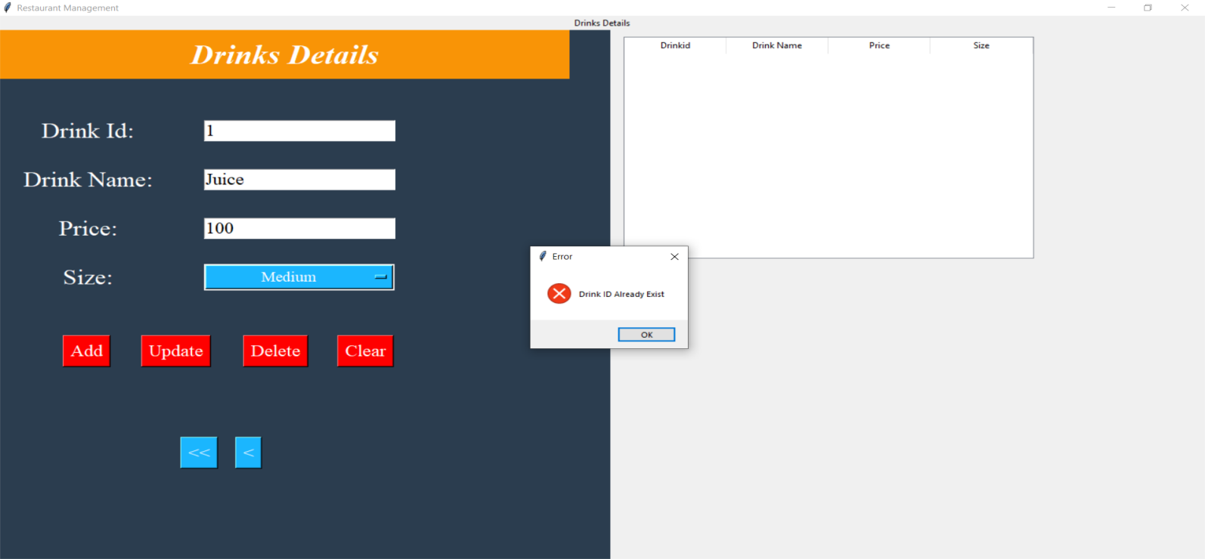

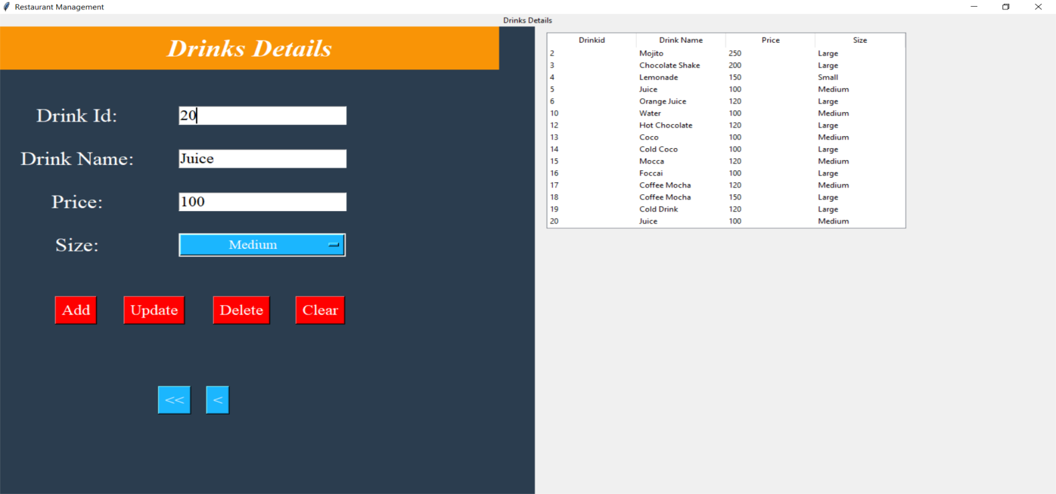

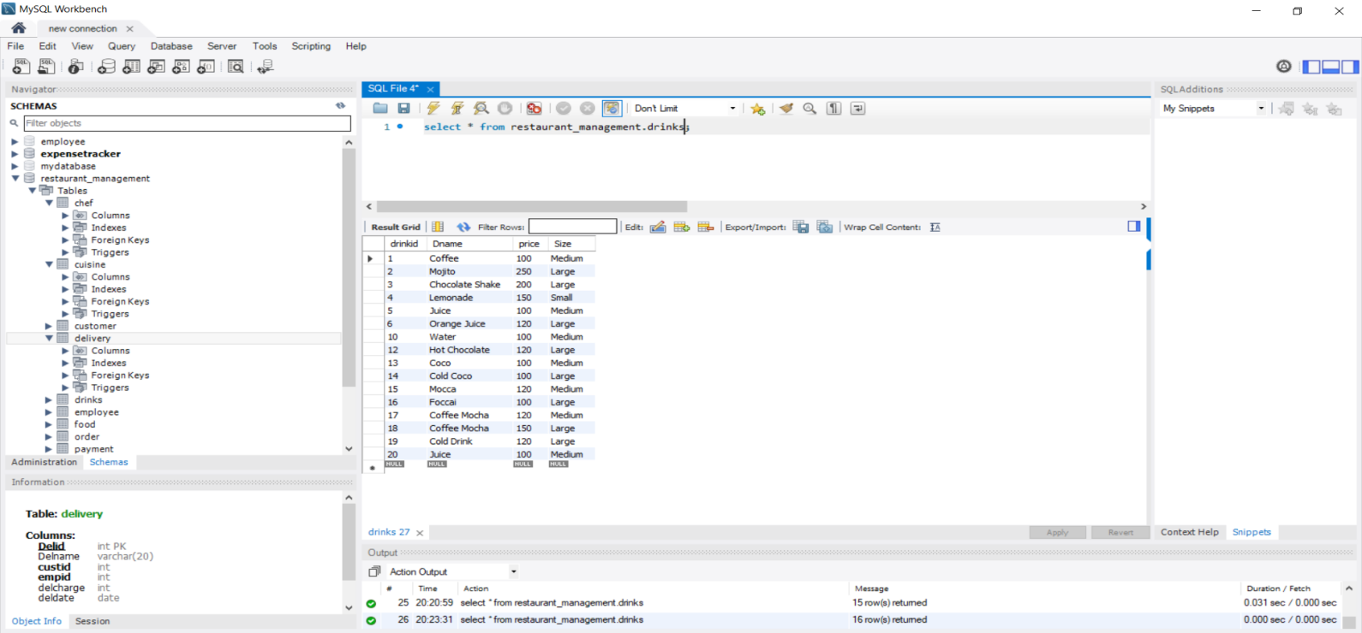

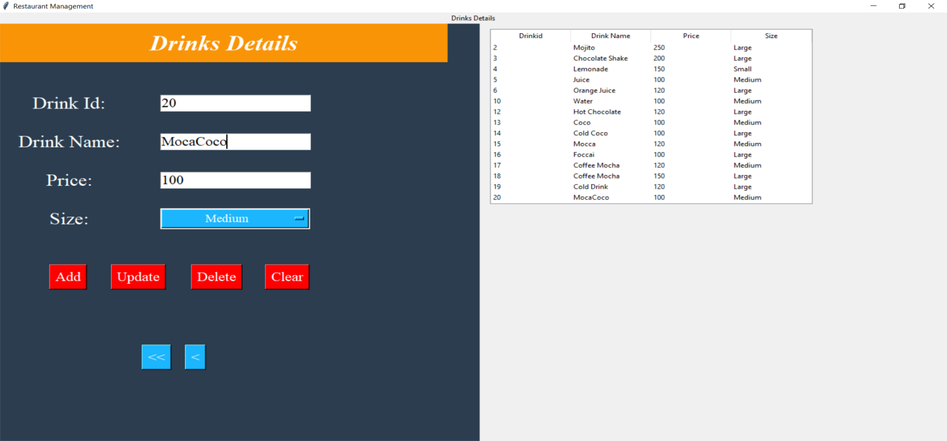

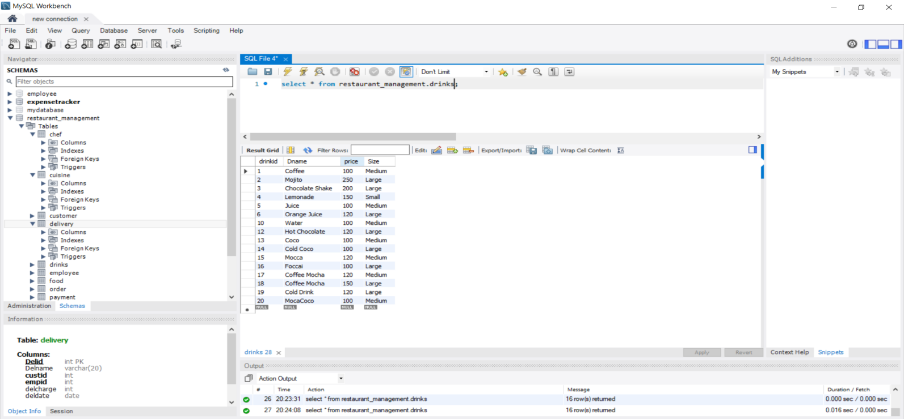

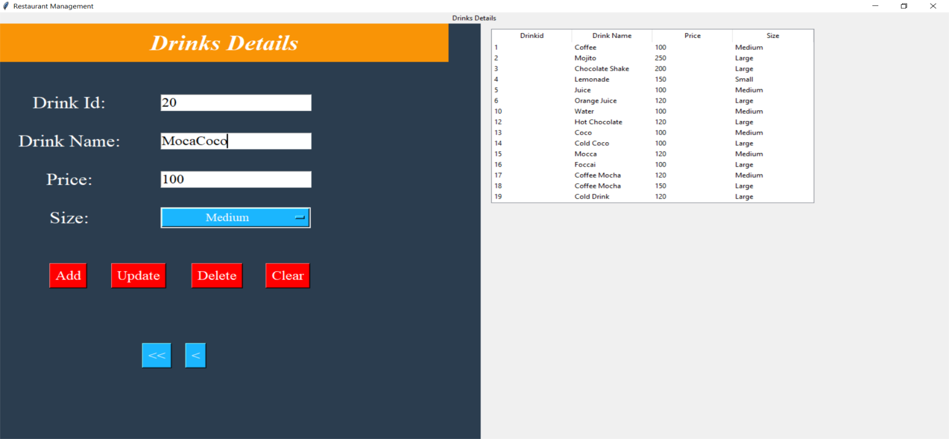

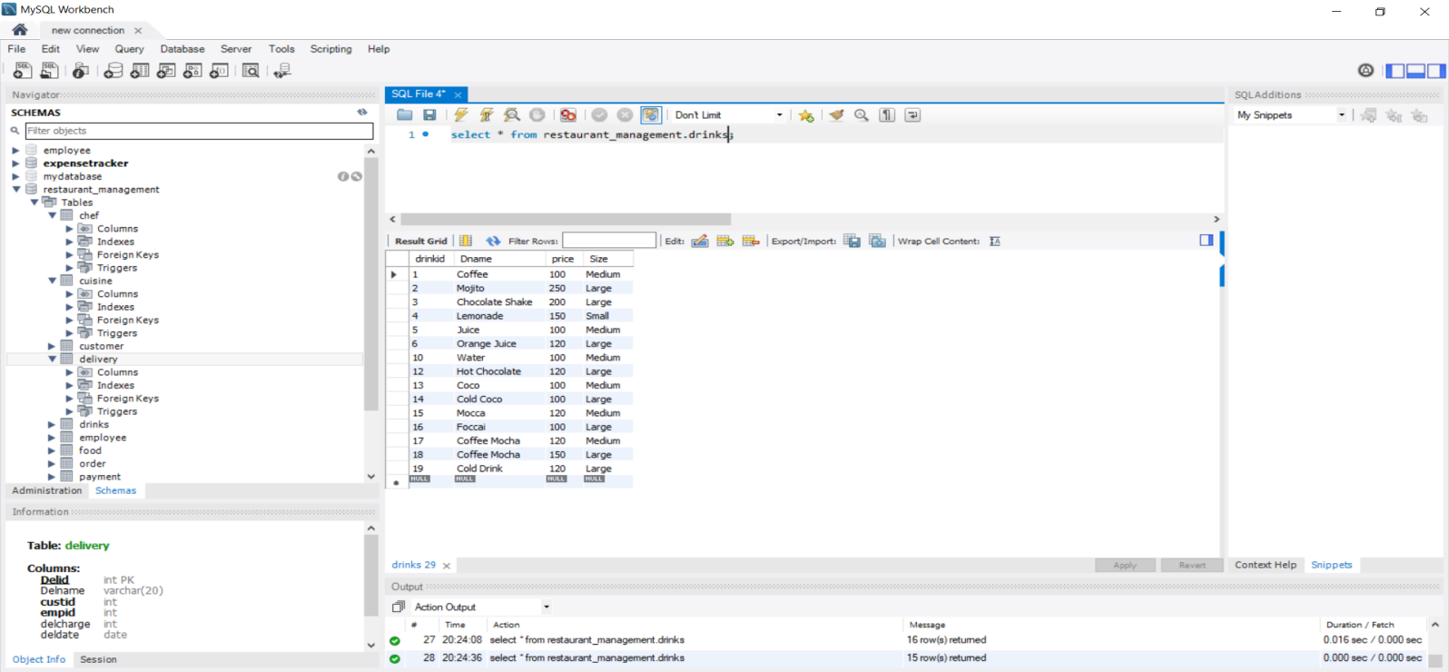

**CUISINE:**

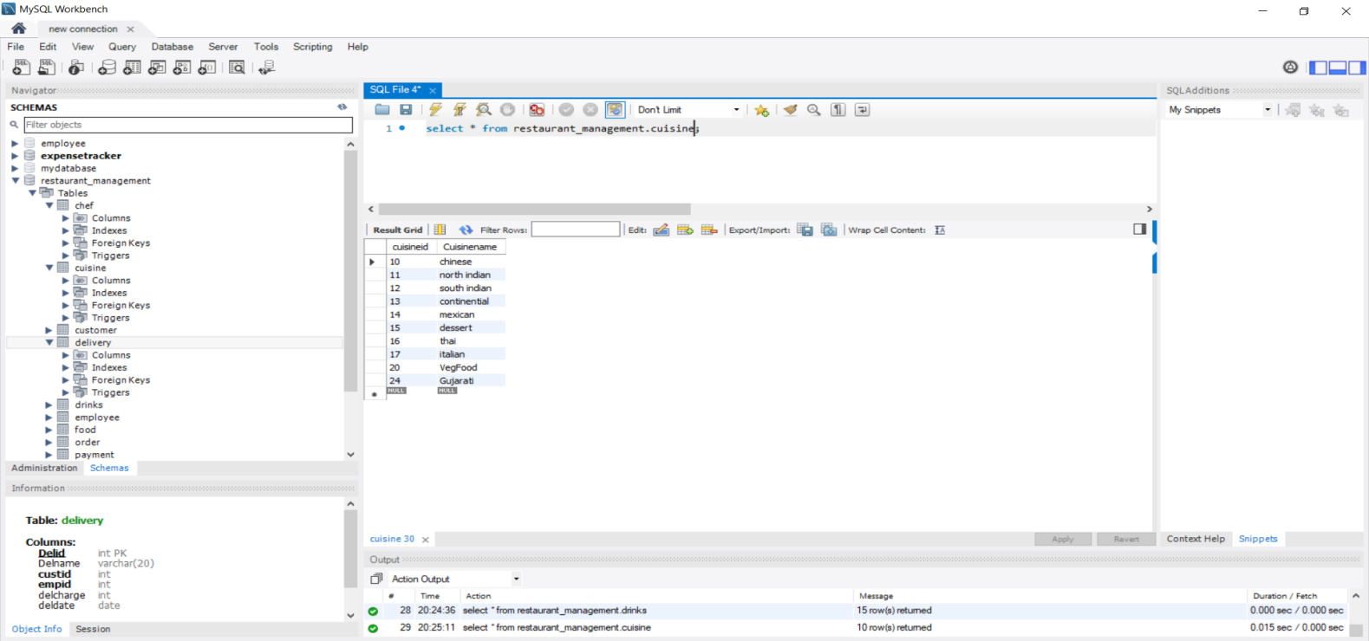

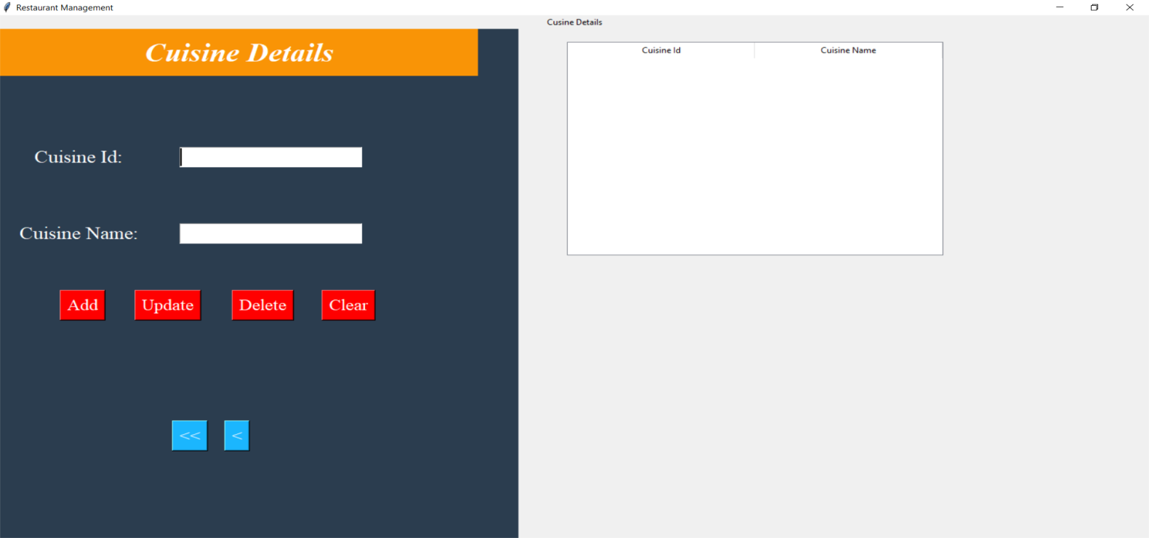

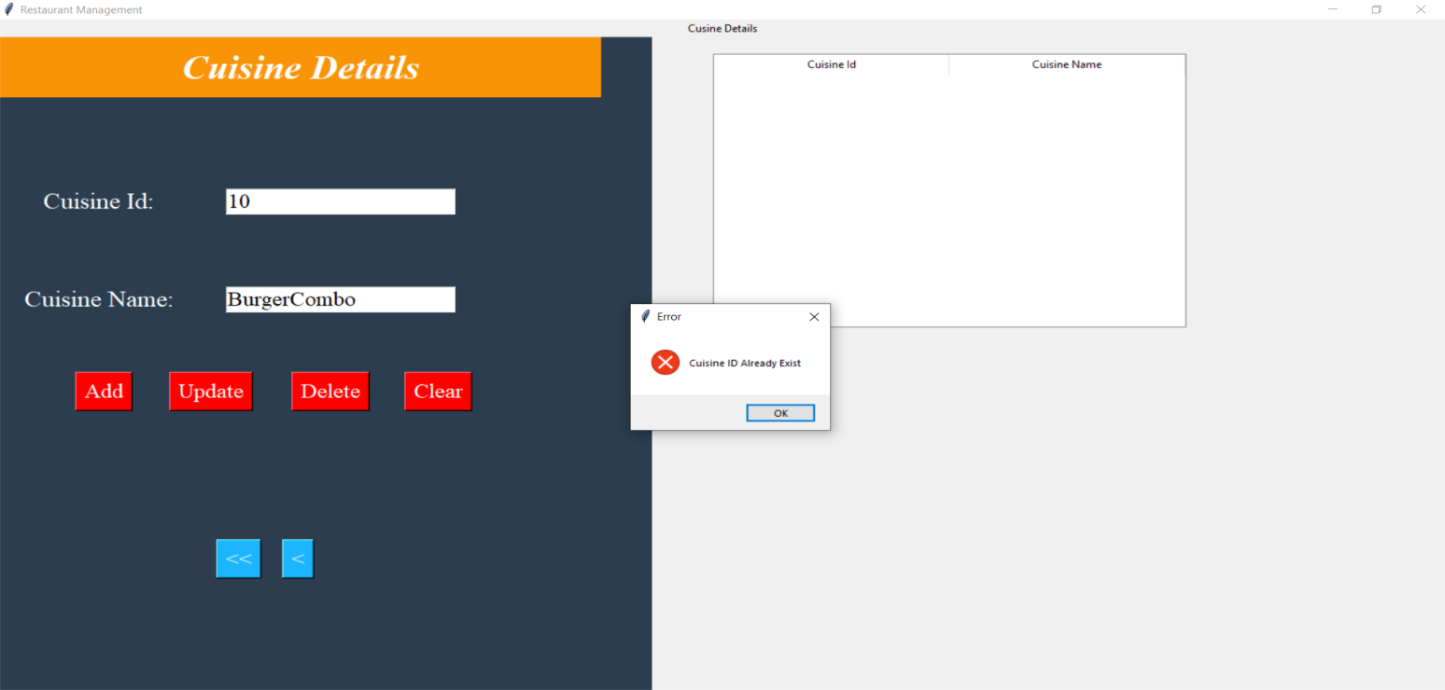

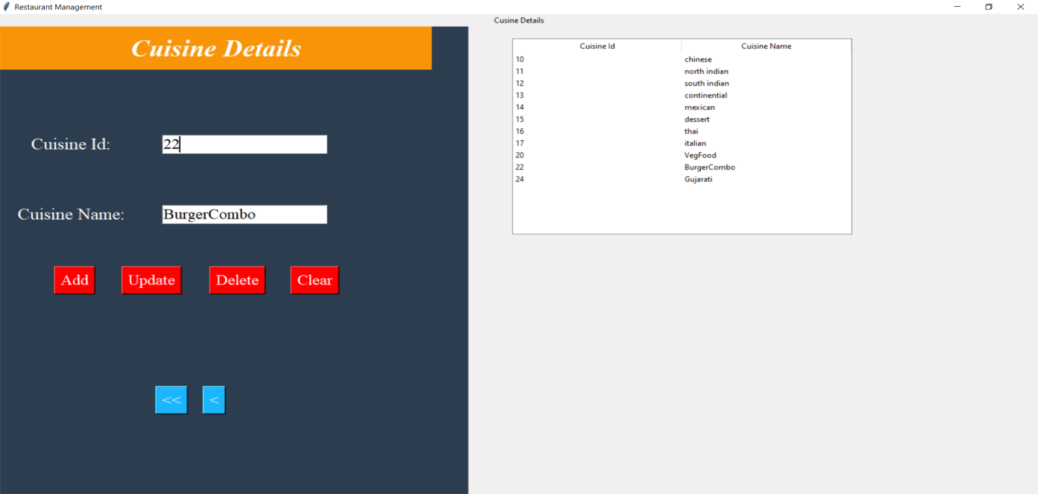

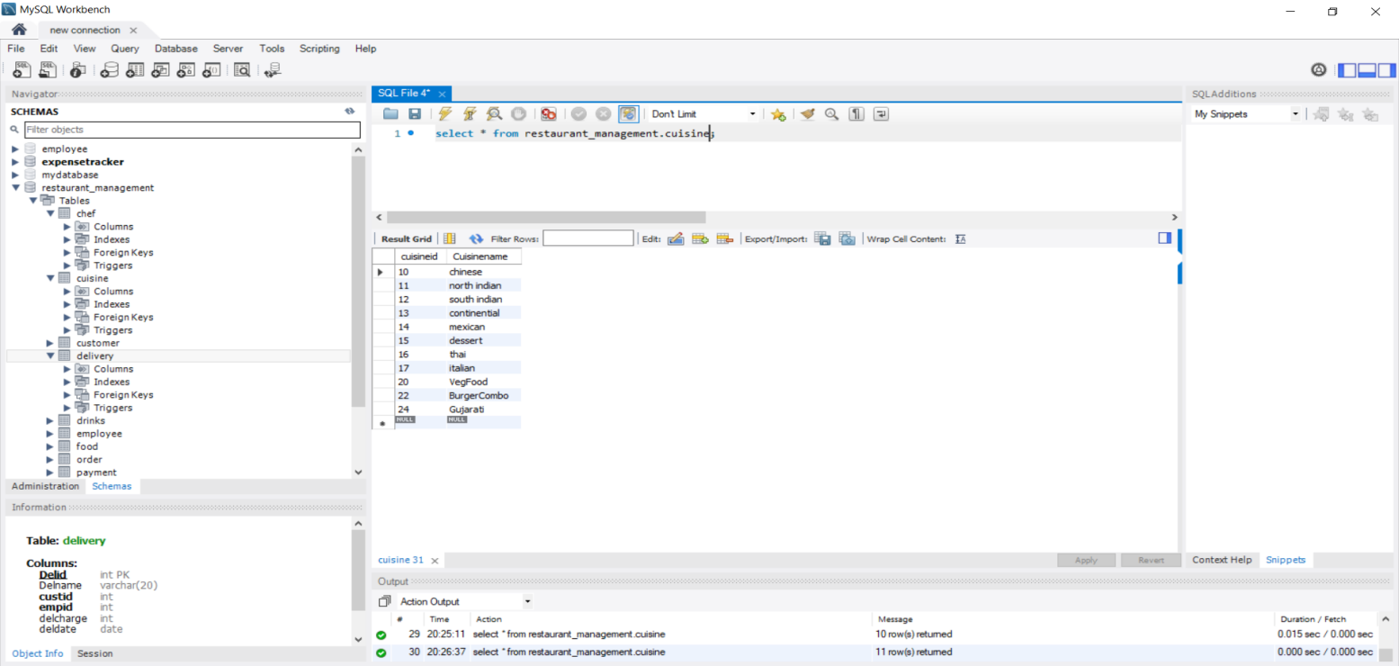

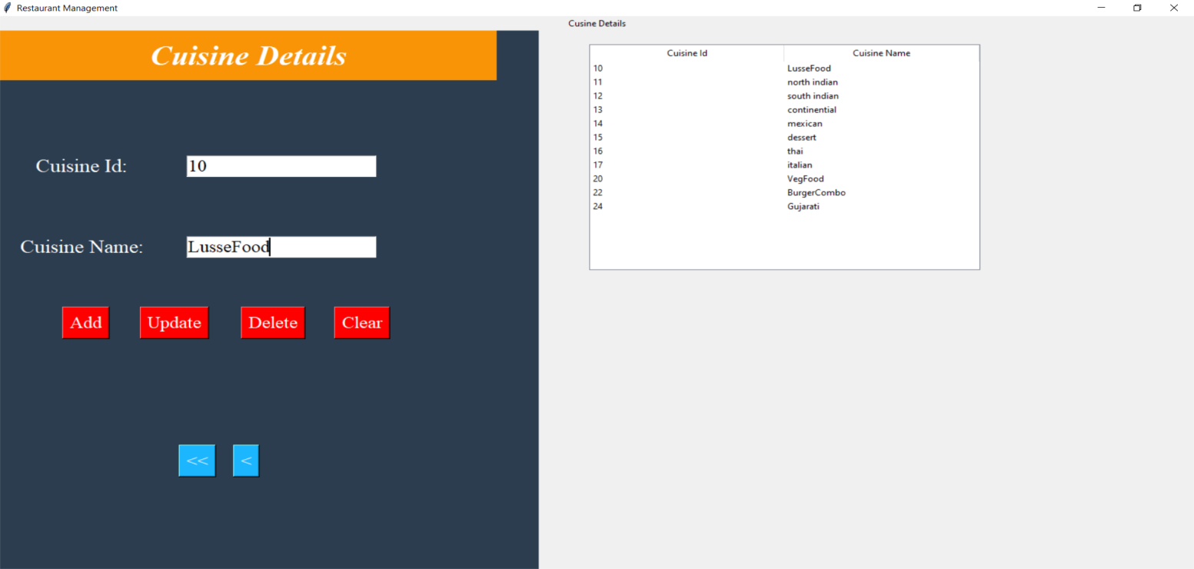

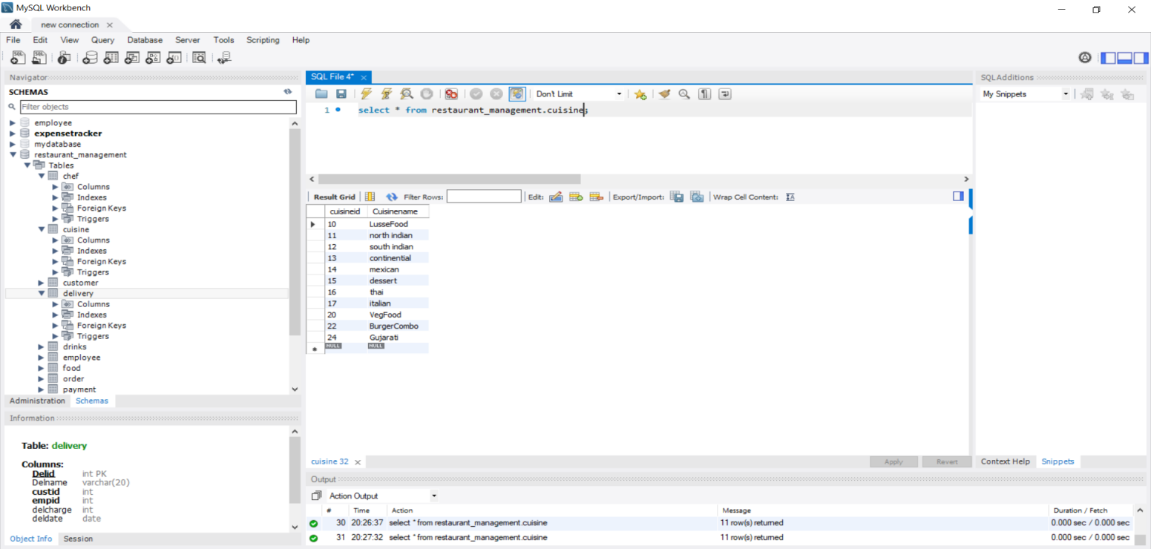

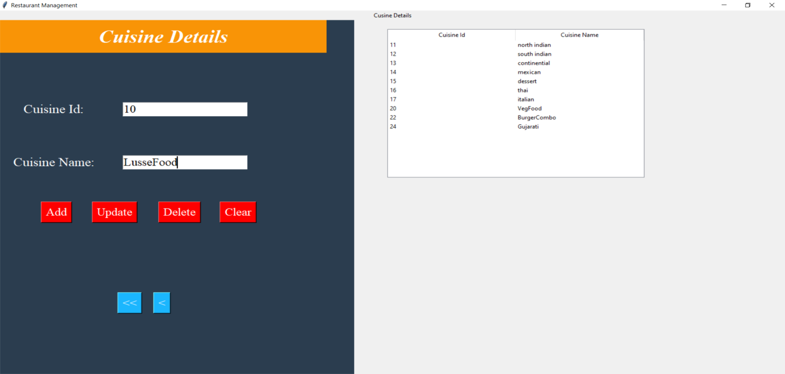

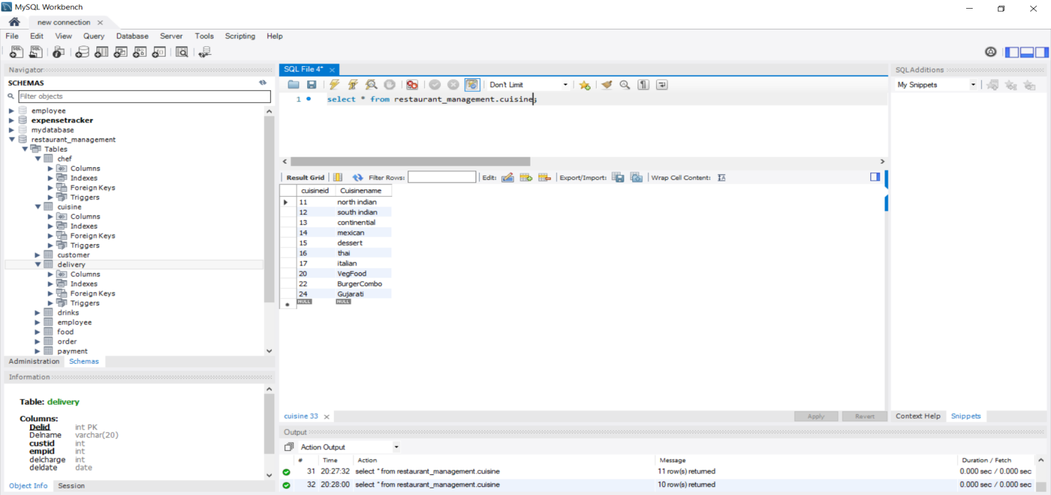

**ORDER:**

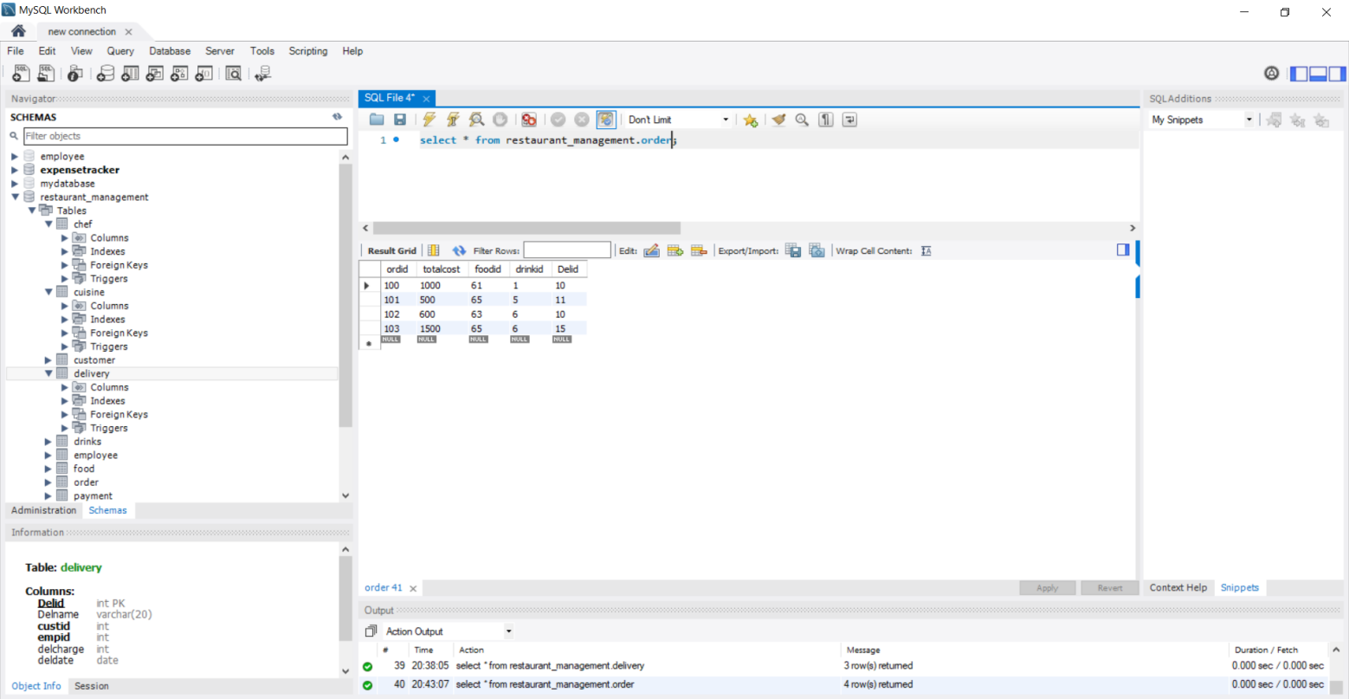

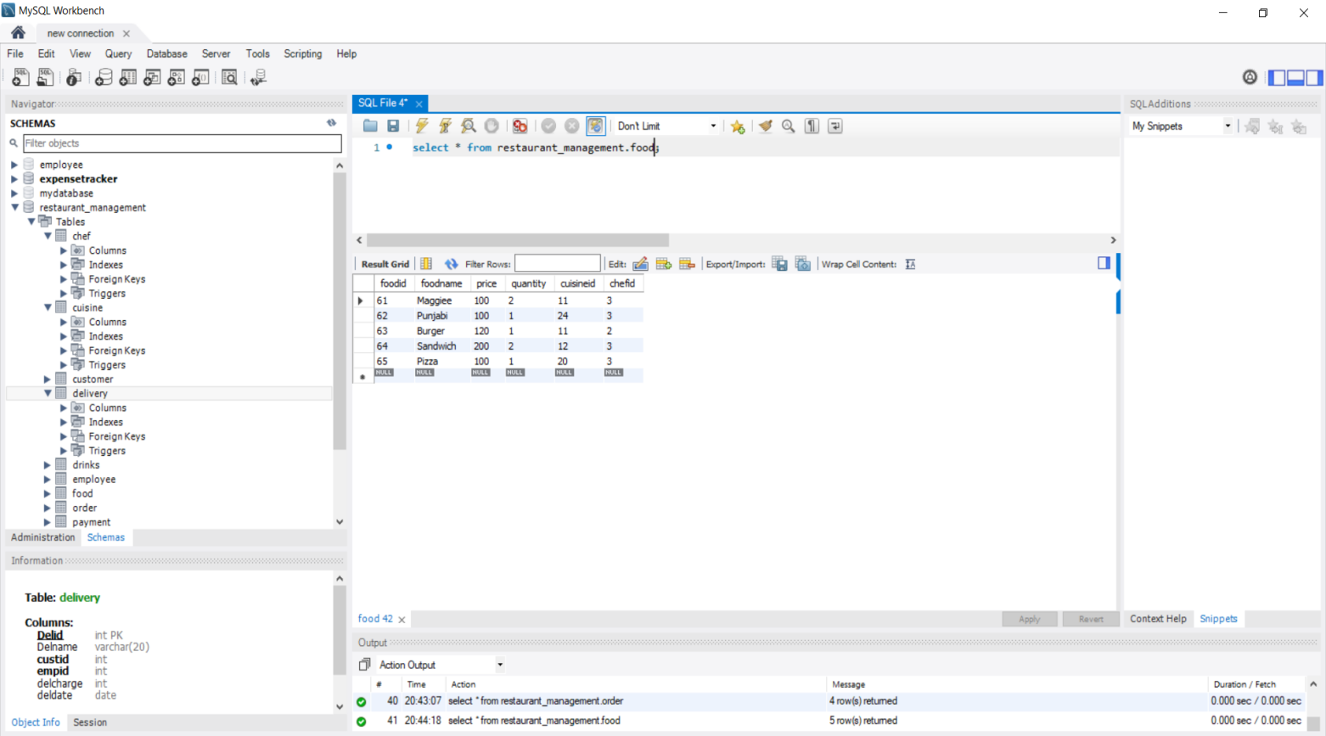

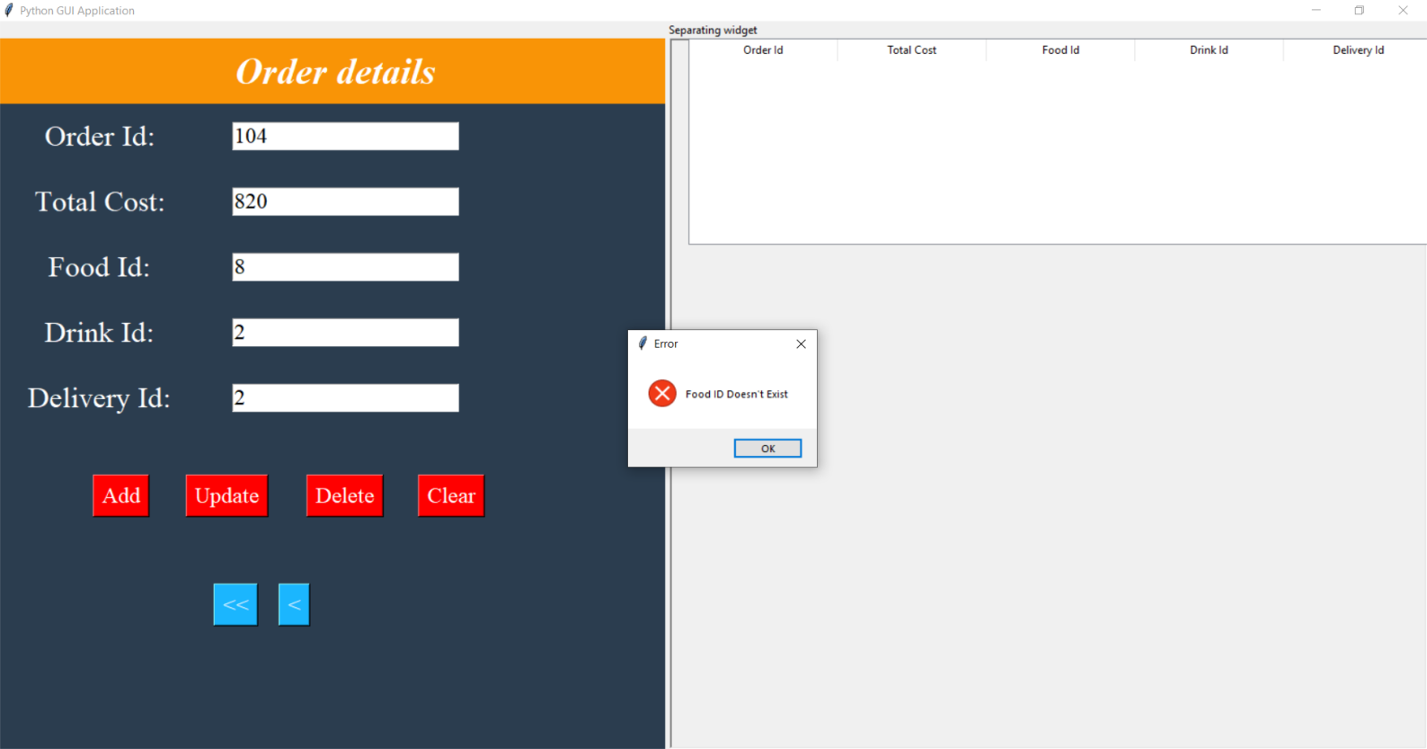

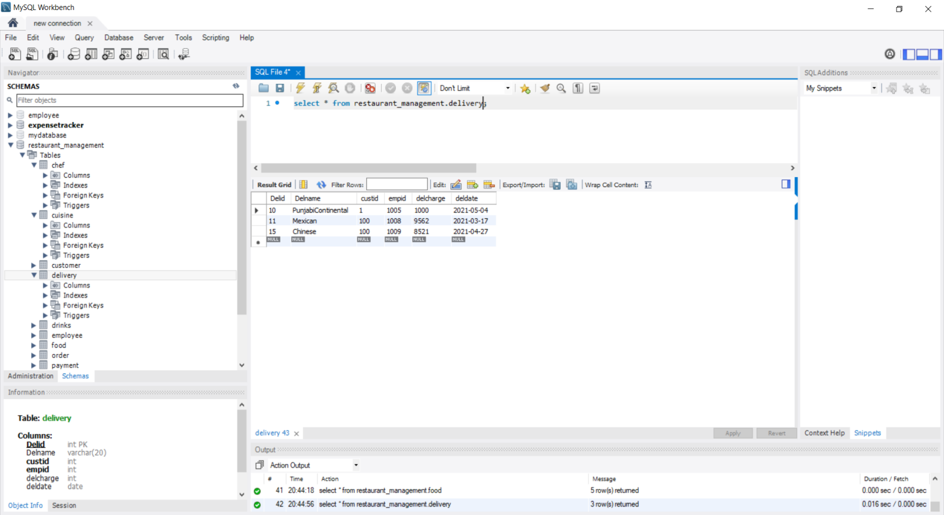

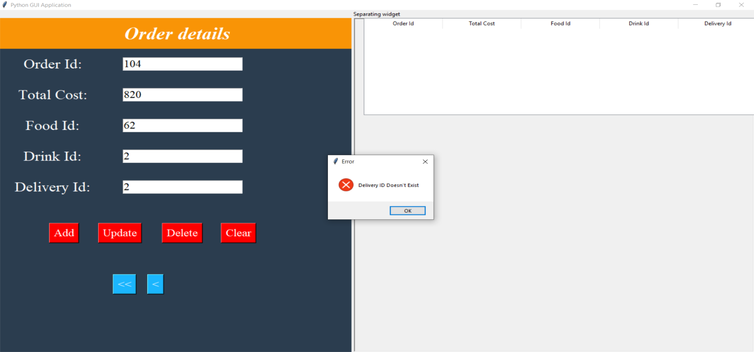

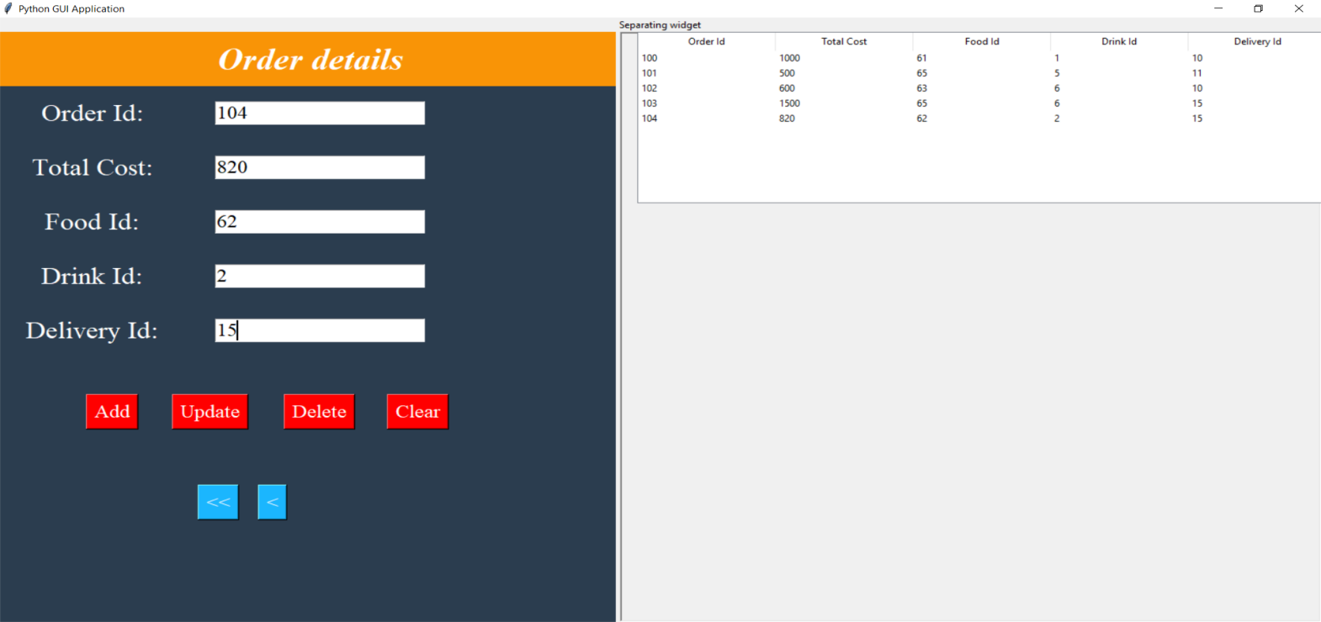

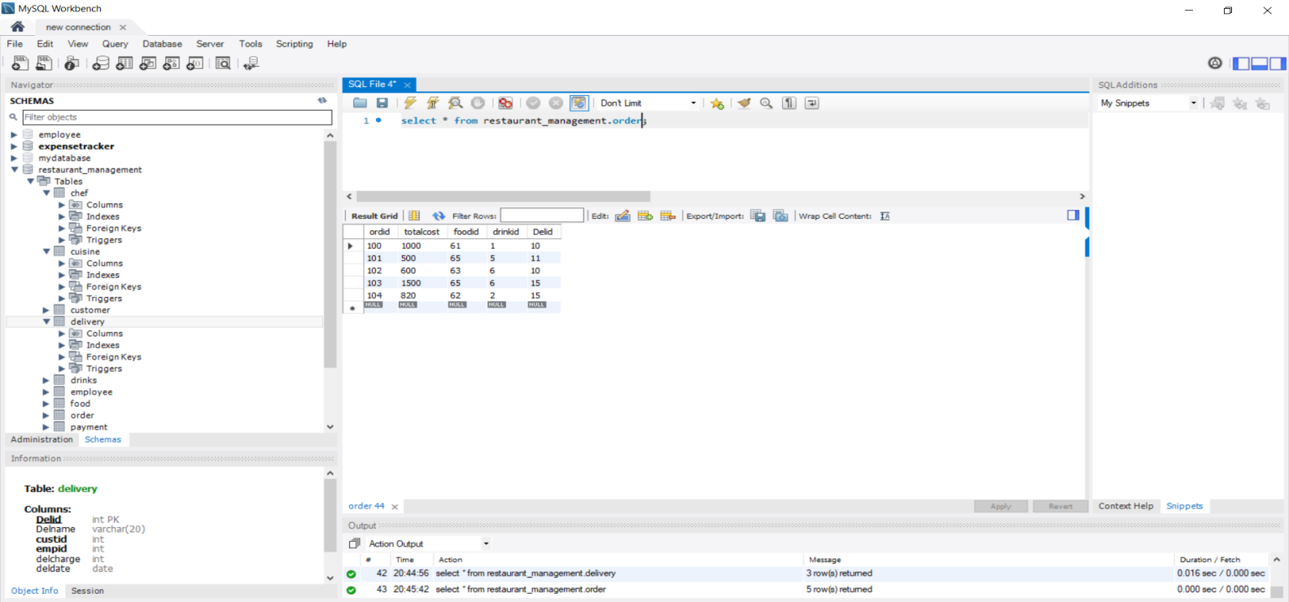

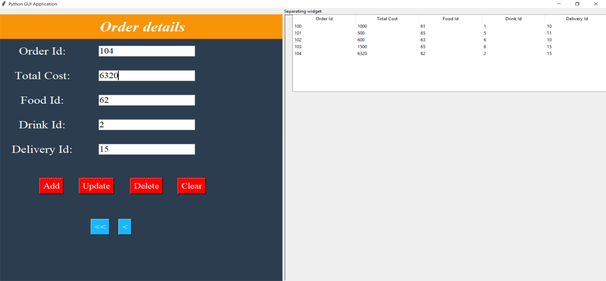

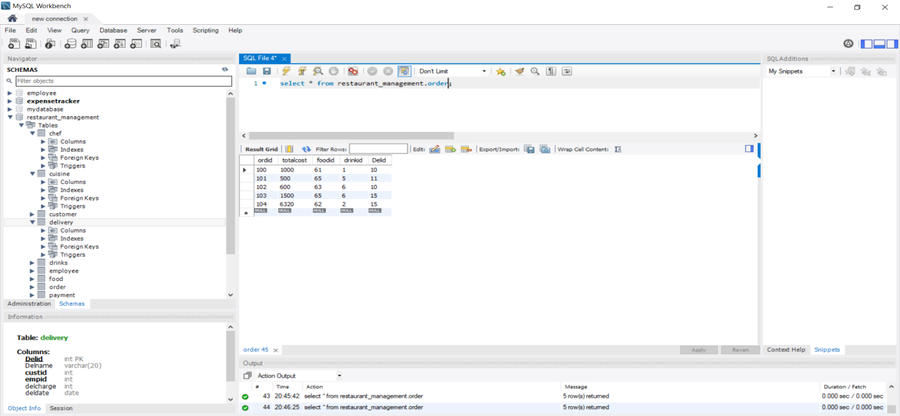

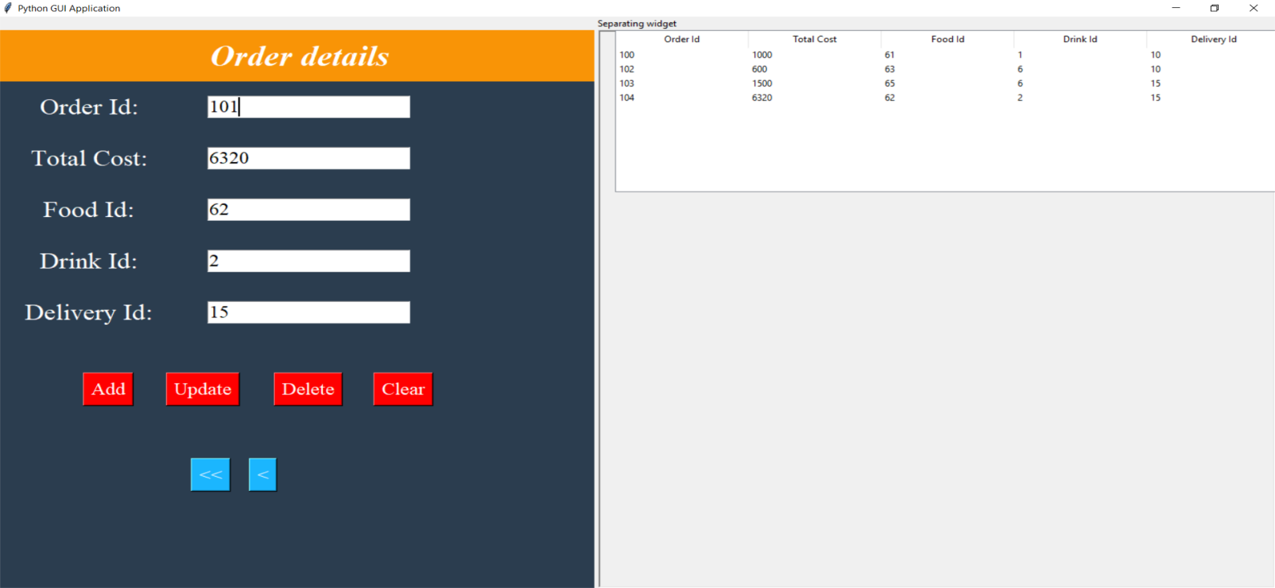

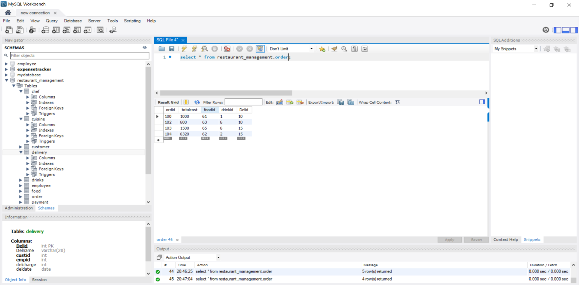

**PAYMENT:**

